IV World Planning Schools Congress
Track 15 - Transportation and Infrastructure Planning
Theoretical and methodological approaches to transport and infrastructure planning

Transcarioca BRT line in Rio de Janeiro - achievements and challenges for a sustainable city

Fabiana Izaga
Prof. School of Architecture and Urbanism (FAU), Federal University of Rio de Janeiro (UFRJ), Graduate Program on Urbanism (Prourb)

Key-words: transportation infrastructure, bus rapid transit, urban mobility, Rio de Janeiro.

On the pathway of urban transformations that are preparing the city to host the 2016 Olympic Games, Rio de Janeiro has been implementing a broad range of new transportation infrastructures. The four Bus Rapid Transit (BRT) lines named Transoeste, Transcarioca, Transolímpica and Transbrasil are the main investments in public transportation made by the City of Rio de Janeiro (Prefeitura), added by the demolition of the elevated viaduct of Perimetral, in the Port Area. Combined to the subway extension from Ipanema to Barra da Tijuca, and to the new expressway which rips through the metropolitan area in the north, entitled Arco Rodoviário (Highway Arch), in charge by the State Government of Rio de Janeiro.
These transportation infrastructure works, carried out in the last 5 years, have been the result of erratic planning inspired, most of times, in ideas formulated - and unrealized - in the 1960’s, which were removed from technocratic trays in the rush for preparing the city for big events. Nevertheless, this set of works will interfere in the development of the metropolitan city in the years to come.
Rio de Janeiro still does not have a metropolitan authority, although almost half of its population lives in the other twenty municipalities of its metropolitan area. In spite of the major demographic growth of the periphery in the last 25 years, it remains vastly dependent on the dynamics of the city of Rio de Janeiro, based mostly on the offer of qualified services. The transportation infrastructure interventions located in the city of Rio, therefore, could play an important role not only for the city itself, but also for the metropolitan city as a whole.
We intend to discuss the BRT network in the historical context of the city and its metropolitan growth, and especially situate the importance of BRT line Transcarioca. We also aim at discussing concepts and meanings of urban mobility, in order to further clarify its processes and its relation to urban environment and sustainable city principles. We’ll analyze BRT Transcarioca line from three main aspects: i) mobility and accessibility; ii) qualities of public space; iii) residential distribution as proposed in new legislation.

BRT Transcarioca line is the public transportation vector that most connects to major pre-existing mass metropolitan transportation. It is the only circumferential line in relation to the city center, and passes through old low-density historic suburbs, linking modern urbanization of Barra da Tijuca to International Galeão Airport. As a public investment in transportation infrastructure, it would be expected that BRT Transcarioca could be part of a strategy of concentrating residential stock along its line, inducing lesser use of cars. There is a new legislation (PLC 77/2014) proposed by the City of Rio de Janeiro that establishes changes in land use parameters along it, which is being discussed by the Chamber of Councilors, since April 2014.

The conclusions point out that although the functioning BRT lines have been able to improve the conditions of displacement, reducing times, two of them (Transoeste and Transolímpica) lack integration with urban growth vectors logic and the dynamics of the metropolitan area. In BRT Transcarioca line, the aspects concerning street design relations have, unfortunately, a preponderance of the functionality of buses as opposed to creating a good quality urban environment. Transportation nodes still lack a better-integrated design which could improve and add quality to transfers, that wait a second generation of electronic ticketing (Bilhete Único) that could really lessen costs to passengers between different modal operators. A spatial study of certain parts, based on the principles of promoting a better city accessible to all, on the parameters proposed by the new legislation, intends to collaborate with the ongoing discussion process.

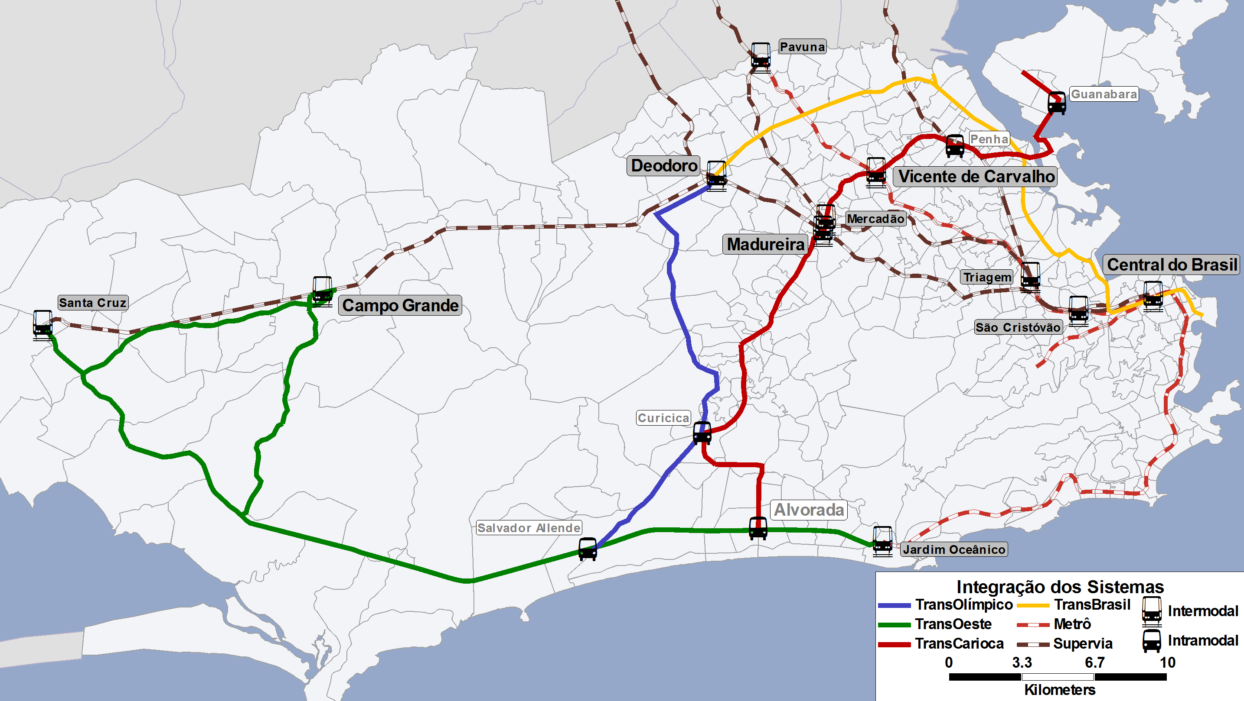
Fig. 1 – Rio de Janeiro BRT network. Source: SMTR, 2014.

Bilbiography
ABREU, Mauricio. Evolução Urbana do Rio de Janeiro. Rio de Janeiro: Prefeitura da Cidade do Rio de Janeiro, 1997, (1ª ed. 1987).
________. Estudo Geográfico da cidade no Brasil : Evolução e avaliação (contribuição à história do pensamento geográfico brasileiro). Revista Brasileira de Geografia, Rio de Janeiro, v.56, nº 1/4, 1994, p.21-122.
ASCHER, François. Os novos princípios do urbanismo. São Paulo: Romano-Guerra, 2010
CAMARA DE VEREADORES DA CIDADE DO RIO DE JANEIRO. Projeto de Lei Complementar 77/2014. Disponível: <http://mail.camara.rj.gov.br/APL/Legislativos/scpro1316.nsf/1ce2ce7b3cdf59b90325775900523a3f/7e403bbb4c14ee2603257cc90074610f?OpenDocument > Acesso: outubro, 2015.
CASTELLS, Manuel. A sociedade em rede. São Paulo: Paz e Terra, 1996.
GOVERNO FEDERAL MINISTÉRIO DO ESPORTE. Cadernos de Legado. Volume Legado Urbano e Ambiental. Brasília: Ministério do Esporte, circa 2011.
HERCE, Manuel. L’espai urbà de la mobilitat. Barcelona: ediciones UPC, 2007.
____. Sobre la movilidad en la ciudad. Barcelona: Editorial Reverté, 2009.
IZAGA, Fabiana. Mobilidade e centralidade no Rio de Janeiro. Tese de Doutorado. Prourb/ FAU-UFRJ, 2009.
MAREA, Carmen; ROJAS P, Thais. Acciones para el mejoraramiento de la movilidad urbana sostenible: caso Metro de Maracaibo. In: Revista dos transporte públicos – ANTP. Ano 36, 1ro quadrimestre 2014, no 136. São Paulo: ANTP, 2014.
MAGALHÃES, Sérgio; IZAGA, Fabiana; PINTO, André. Cidades: mobilidade, habitação e escala – um chamado à ação. Brasília: Confederação Nacional da Indústria, 2012. Disponível em: <http://www.cni.org.br/portal/data/files/FF808081394933EC013977401A5B486D/CNI%20-%20Cidades%202012_web.pdf>. Acesso: junho, 2014.
SECCHI, Bernardo. La città del ventesimo secolo. Roma-Bari: Editori Laterza, 2005
SHANNON, K.; SMETS, M. The landscape of contemporary infrastructure. Rotterdam: Nai Publishers, 2010.
SUZUKI, Hiroaki; CERVERO, Robert; IUCHI, Kanako. Transforming cities with transit. Transit and land-use integration for sustainable urban development. Washington: The World Bank, 2013. Acesso em: junho, 2014.
TIRY, Corinne. Les mégastructures du transport – typologie architecturale et urbaine des grands équipements de la mobilité. Lyon: Éditions du Certu, 2003.
UNHABITAT. Planning and design for sustainable urban mobility. Global Report on human settlements. New York: Routledge, 2013.

