**THE URBAN EXPANSION FORMS AND THE DIRECTOR PLAN – THE CASE OF MACEIÓ, ALAGOAS, BRAZIL BETWEEN 1980 AND 2000**

The urban expansion is a process related with population growth, considering that more the population increases, more space is needed to accommodate it. Despite that, the result of this process is reflected at the urban tissue at territorial dimension, in other words, it physically increases the tissue of the city. Because of that, at this paper, this process will be nominated urban territorial growth. The urban territorial growth process can be happened by three different forms: (i) by urban perimeter extension, (ii) by land subdivision and (iii) by built stain extension. The first and second forms are extensive processes, namely the principal characteristic is the extension of urban land use and occupation, nominated here extensive urban territorial growth. On the other hand, the third form is an intensive process, which intensifies the urban land use and occupation, nominated here intensive urban territorial growth.

The urban territorial growth by urban perimeter extension (picture 1) consists in a modification of the official limits of the city, by the conversion of rural areas at new urban areas (NASCIMENTO e MATIAS, 2011, p.70). The urban land subdivision (picture 2) consists at the division of not occupied lands in smaller lots, usually for the commercial finality. This is the principal form of urban expansion (SILVA, OLIVEIRA, SOARES, 2011, p.7). The urban territorial growth by built stain extension is related with the density increases inside urban perimeter. When the urban area still have vacate lands and this lands are occupied, there is an urban built stain extension (COPQUE, 2011, p.706) without modification of the urban perimeter.

|  |  |
| --- | --- |
| Picture 1: Urban territorial growth by urban perimeter extension scheme. | Picture 2: Urban territorial growth by land subdivision scheme. |
|  |  |
|  | |
| Picture 3: Urban territorial growth by built stain extension scheme. | |
|  | |

From these three forms are derived seven types of urban territorial growth: (i) extensive growth by new areas sum to the urban stain and (ii) extensive growth bt concentric rings derived from urban territorial growth by urban perimeter extension; (iii) extensive growth by urban dispersion, (iv) extensive growth by urban diffusion and (v) tentacular extensive growth are derived from urban territorial growth by lands subdivisions; (vi) central intensive growth and (vii) peripheral intensive growth are derived from urban territorial growth by built stain extension.

The extensive growth by new areas sum to the urban stain (picture 4) characterized for the addition of new areas to the existent urban tissue, principally by the transition of rural lands to urban (NASCIMENTO e MATIAS, 2011, p.68), by modification of urban perimeter (NASCIMENTO e MATIAS, 2011, p.71) or creation of new districts (SANTOS, 2012, p.265). The extensive growth by concentric rings (picture5) represents a radial growth as from center (PORTELLA, et al, 2013, p.7), in which a new ring is only occupied when the last one would be saturated. The extensive growth by urban dispersion (picture 6) characterized by propagation of different dimensions urban centers by urban territory (BENTES, 2010, p.1) and that have relative independence of the urban center. The extensive growth by urban diffusion (picture 7) characterized by propagation of urban agglomerations just residencial, that’s depends of urban centers. The tentacular extensive growth (picture 8) characterized by occupation according to roads system, in which the roads are urban territorial growth vectors (BRITO e SOUZA, 2005, p.54). The central intensive growth (picture 9) characterized by density increases at the urban center. The peripheral intensive growth (picture 10) characterized by density increases at marginal areas.

|  |  |
| --- | --- |
| Picture 4: Extensive urban territorial growth by new areas sum to the urban stain scheme. | Picture 5: Extensive urban territorial growth by concentric rings scheme. |
|  |  |
|  |  |
| Picture 6: Extensive urban territorial growth by urban dispersion scheme. | Picture 7: Extensive urban territorial growth by urban diffusion scheme. |
|  |  |

|  |  |
| --- | --- |
| Picture 8: Tentacular extensive urban territorial growth scheme. | |
|  | |
|  |  |
| Picture 9: Central intensive urban territorial growth scheme. | Picture 10: Peripheral intensive urban territorial growth scheme. |
|  |  |

Every city can has its urban territorial growth process according to one or more forms and/or types of growth. In function of the form/type of growth the result in terms urban space organization would be different.

The urban territorial growth must be regulated by the municipal Director Plan (PD), the principal urban legislation that plans the urban land use and occupation of the cities. It’s the urban development and expansion basic instrument.

The PD have established like obligatory for cities with population more 20.000 habitants by article 182 of Brazilian Federal Constitution of 1988 (CF/88) and strengthened by *Estatuto da Cidade[1]* (EC) in 2001. Other conditions of obligatory have been included, like that: cities belonging to metropolitan areas and urban agglomerations; touristic cities; cities that wants use the instruments defined at §4º of art. 182 of CF/88 and cities located in areas of developments influence or significant environmental impact activities at regional or national level.

So, considering that the PD is the legislation responsible for regulate the urban land use and occupation, its territorial growth and development, the forms and types of territorial growth must be, even implicitly, defined at its text.

Maceió, capital of the state of Alagoas at northeast of Brazil and empiric referencial of this paper, has a PD date of 1981, actualized just at 2005, named *Plano de Desenvolvimento de Maceió* (PDM/81). O PDM 81 was designed at the aim of to be a planning instrument to guide the development process through actions that lead the urban occupation, the productive activities development adapting and expanding the urban services and equipments (MACEIÓ/COMPLAN apud LINS, 1999, p.229).

The objetive of this pape ris describe the urban territorial growth predicted by PDM/81 from 1980 to 2000, using as base the forms and types discusses, resulting at a graphic representation of the planning urban territorial growth.

The PDM/81 presented its proposes for the city based at the urban area zoning (picture 11), compound by 22 urban zones: one Commercial and Services Central Zone (ZCCS), one Commercial and Services Zone (ZCS), eleven Residences Zones (ZR), five Multiple Activities Zones (ZAM) and four Special Zones (ZE).

Figura 11: Zoneamento urbano de Maceió, 1981.

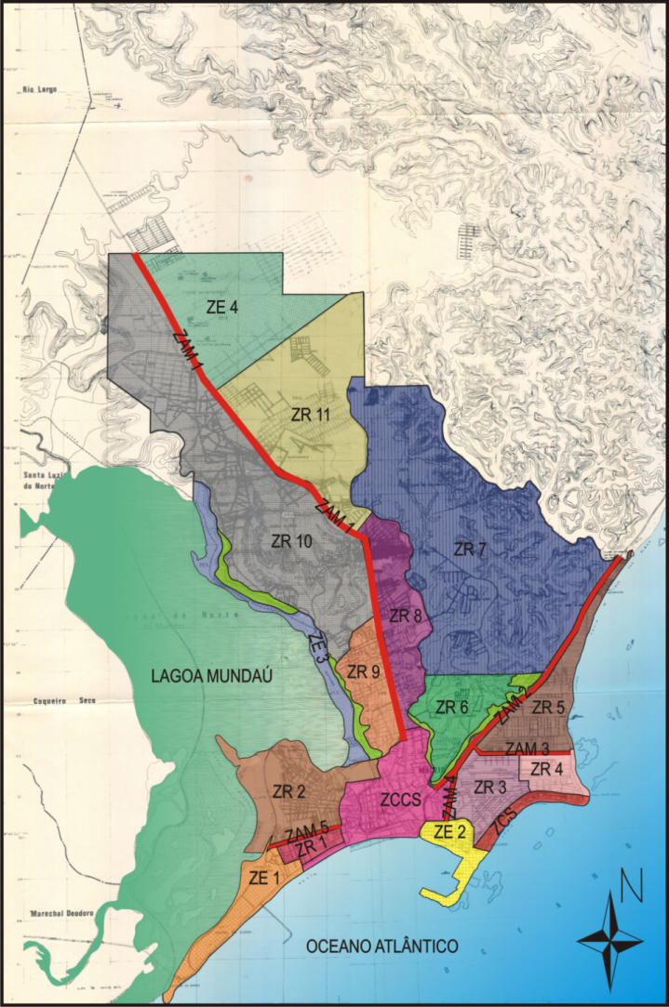

Fonte: PDM, 1981, adaptado pela autora.

For the ZCCS, it have not been suggest modifications, therefore it would not be predict none forms/types of urban growth at this zone. For the ZCS, it have been recommended the implantation of productive activities and verticalization process incentive, so it would be predict the extensive territorial growth by urban dispersion, consequently the form by land subdivision, and peripheral intensive growth, consequently the form by built stain extension.

For the ZR 1, 2 and 6, it dad been suggest the density control, implying at a limited growth. For the ZR 3, 4, 7 and 8, it would be suggest the densification by verticalization, implying at a peripheral intensive growth, consequently the form by built stain extension. For the ZR 5, 10 and 11, the suggestion was an horizontal occupation, implying at a extensive growth by urban diffusion, consequently the form by land subdivision. At the ZR 9, the recommendation was densify by verticalization process, implying at a central intensive growth.

For the five ZAM, the general recommendation was the implantation od productive activities, implying at a tentacular extensive growth. And at the four ZE, the recommendation was the occupation restriction, implying at a limited growth.

Therefore, even indirectly, the PDM/81 predicted two forms of urban territorial growth to Maceió between 1980 and 2000. One form was extensive: by land subdivision through of the types by urban dispersion, by urban diffusion and tentacular. And one form intensive: by built stain extension through of the central and peripheral types (picture 12)

Figura 12: Tipos de crescimento territorial urbano de Maceió previstos no PDM/81, para o período entre 1980 e 2000.



Use the forms and types is a way to look for the urban expansion, a manner that we could see the process graphically. An interest approach is compare the planning urban territorial growth with the urban territorial growth in fact and discusses the differences and similarities, to understand what extent the plan is usual.

**REFERÊNCIAS**

BENTES, J. C. G. (2010) **O processo de dispersão urbana no médio paraíba fluminense**. I Encontro Nacional da Associação Nacional de Pesquisa e Pós-Graduação em Arquitetura e Urbanismo, Rio de Janeiro.

BRITO, F. e SOUZA, J. (2005). Expansão urbana nas grandes metrópoles: o significado das migrações intrametropolitanas e da mobilidade pendular na reprodução da pobreza. **São Paulo em Perspectiva**, 19(4), 48-63.

COPQUE, A. C. S. M., et al. (2011) **Expansão urbana e redução de áreas verdes na localidade do Cabula VI Região do miolo da cidade do Salvador, Bahia**. Simpósio Brasileiro de Sensoriamento Remoto, Curitiba.

MACEIÓ, PREFEITURA DE. (1981a) **Plano de Desenvolvimento de Maceió**. COMPLAN, vol. I.

MACEIÓ, PREFEITURA DE. (1981b) **Plano de Desenvolvimento de Maceió**. COMPLAN, vol. II.

NASCIMENTO, E. e MATIAS, L. F. (2011) Expansão urbana e desigualdade socioespacial: uma análise da cidade de Ponta Grossa (PR). **RA´E GA – O Espaço Geográfico em Análise**, 23, 65-97.

PORTELLA, A. A. et al. (2013) **Segregação social e densidade urbana: o geoprocessamento como instrumento de análise**. X Encontro Nacional de Pós-Graduação e Pesquisa em Planejamento Urbano e Regional, Rio de Janeiro.

SANTOS, L. S. (2012) Expansão urbana, mercado imobiliário e conflitos de terra no Sertão Carioca (1940-1964). **Confluenze**, 4(1), 263-281.

SILVA, L. V. O.; OLIVEIRA, B. S. e SOARES, B. R. (2011) Regulação e expansão urbana: A urbanização acelerada e desordenada do entorno de Brasília- Valparaíso da Goiás. **Revista da Católica**, 3(5), 1-16.

BRASIL. (2012) **Constituição da República Federativa do Brasil**: promulgada em 05 de outubro de 1988. São Paulo: Saraiva, 46 ed. atual. e ampl.

LINS, R. D. B. (1999) **The Myth of Local Government Autonomy: Findings from the study od the Municipal government of Maceió in Alagoas, Brazil, from 1986 to 1988**. Thesis (Doctor of Philosophy). Urban Studies. University of Kent at Canterbury.

1. Federal law 10.257 that regulates the municipal Director Plan.