How public are they? Evaluating the public accessibility of privately owned public space (POPS) in Taipei city, Taiwan

*Hsin-Chieh Lu, **Tzuyuan Stessa Chao
* Master student, Department of Urban Planning, National Cheng Kung University
** Assistant Professor, Department of Urban Planning, National Cheng Kung University

In modern society, public space plays an important role of the environmental quality of high-density urban areas. The quality of city life highly depends on the quantity, quality, and accessibility of public spaces. There are two types of public spaces from property right perspectives, public-owned and private-owned. The first initiative of privately owned public space (POPS) was taken place in city of New York in the 19th century. The rapid emergence of skyscrapers in the New York City resulted in enormous pressure to the surounding environment. To encourage private developers to provid more available public space, the New York City Government implemented incentive zoning with the legislation the 1961 Zoning Resolution (Kayden, 2000). This law became the precedent for what is now called privately owned public space (POPS). Similarly, to combat the difficulties with obtaining adequate funding and land for public space, the Taipei City Government provided additional floor area bonus as incentives in exchange for more POPS (Hsia, C. J., 1983) in the early 1980s. This new incentive zoning tool created 537 POPS between 1983 and 2010. At the same time, city of Berlin, Tokyo, Santiago de Chile, Melbourne, Hong Kong, and Bangkok have also utilized similar incentive zoning to create abundant POPS which are provided, planned, and managed by private sectors. According to Webster, under the market operation of Capitalism, land has always been scarce resources, and public space will inevitably become a part the private sphere because of the territorial fragmentation and the shrinking of the “public realm” (Webster, 2007). Predictably, POPS have become considerable sources of public spaces in many cities.

Nonetheless, scholars and the public frequently question the effects of POPS. The common criticisms are: the restriction of social interaction, the exclusion of “undesirable” groups and the partiality for private benefits (Kayden, 2000; Mitchell, 2003). The most common critique is of their accessibility to the public. For instance, in 1997 there was a public dispute over a famous residential development in Taipei. The developers went against the incentive zoning agreement to provide the proposed area for public use, yet they had already received their bulk reward. The city government therefore removed the eligibility of residential applicants (Shie, Y. C., 2006). Moreover, in 2014, Taiwanese citizens held “Occupation of POPS” movements owing to protest the authoritarian ban on entering privately owned public spaces. Furthermore, in the “Time Square Protests” of 2008 in Hong Kong, the openness of POPS was called into question, in which they demonstrated the disappointment between public users, managers, and owners. In addition, Taiwanese Government lacks comprehensive measurements to evaluating the effectiveness of POPS and results in creating disputes amount space managers, owners, and the public.

Research on POPS traditionally tends to focus on different aspects of the issue: the legal approach discusses it in relation to floor area ratio incentive policies, and often cites New York City as a model of this system; from the perspective of Economics, the emphasis is on the shift of urban spaces from the public realm to private ownership; the Urban Design approach analyses the spatial arrangement of POPSs, and their relation to the built environment (Kayden, 2000; Webster, 2007; Wei, Z. C., 1994). In Taiwan, however, research on privately owned public spaces tends to be less complex, only discussing aspects of urban design, quality of the urban environment, and user behaviour when evaluating the ‘publicness’ of such places, and pays less attention to issues of supervision and property rights (Tung, Y. Y., 1999; Chiang, W. C.,1993). Besides, research is mainly based on observation of individual cases, hence lacking in objective, quantitative indicators derived from a large sample, which arouses doubts of subjectivity, and makes it impossible not only to get a full view of POPS, but also to use the results as a basis of evaluating the publicness of POPS in general. Furthermore, since user preferences and behaviour differ significantly in Taiwan and in other parts of the World, therefore it is not possible to use international indicators to evaluate the degree of public access to POPS in Taiwan (Wei, Z. C., 1994).

The crux of creating POPS in Taiwan is to provide open and usable spaces for the public. However, the citizens cannot participate in the process of the design, and setup of POPS. Because Taiwanese Government lacks effective control, and regulations to supervise the following uses and management of POPS, there inevitably exist huge gaps among the regulations, design of POPS, and reality(He, S. B., 1988). Without explicit evaluation indicators, POPS usually fall into the hand of private uses (Rou, R. H., 2004; CPAMI, 1991). The public in Taiwan frequently criticize the publicness and effectiveness of POPS. In order to gain a better understanding of POPS in Taiwan, and the nature and degrees of their publicity, this research aims at exploring the exisiting POPS from property rights, management and maintenance tools and users perspectives as the three important factors influencing uses of POPS. In order to establish a quantitative method for evaluating the openness of public spaces. Taipei’s Xinyi District is chosen as a research site, because this area has the greatest numbers of POPS throughout Taiwan. In 1980, the first initiative of urban design control in Taiwan was taken place in Xinyi District. With the erection of Taipei World Trade Center, Taipei City Government, and Taipei International Convention Center, Xinyi District became Taipei City Center since 1990s. Under the guidance of urban planning, Xinyi District is the first extensive developement area in Taiwan. It’s accessibility of public of POPS has indicative significance. Finally, suggestions will be made on the public space policies and public space regulations of the Municipality of Taipei for better POPS usage in the future.

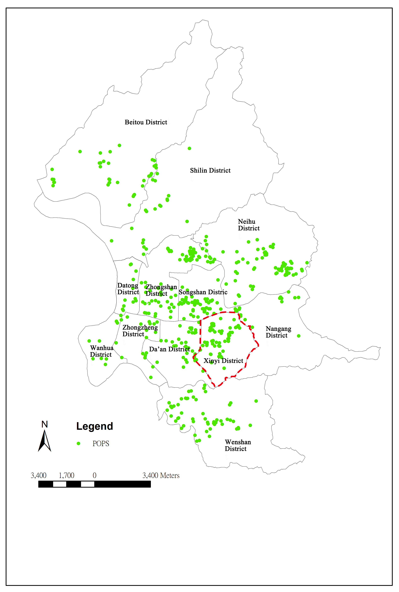
Figure 1. Location of POPS in Taipei city.

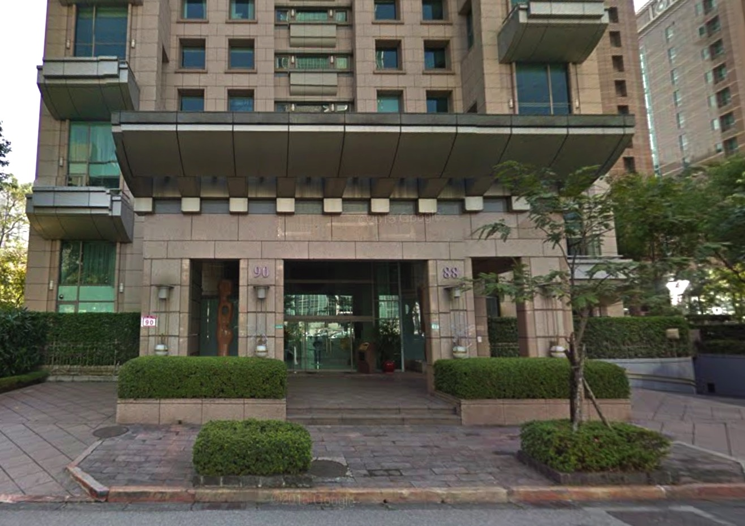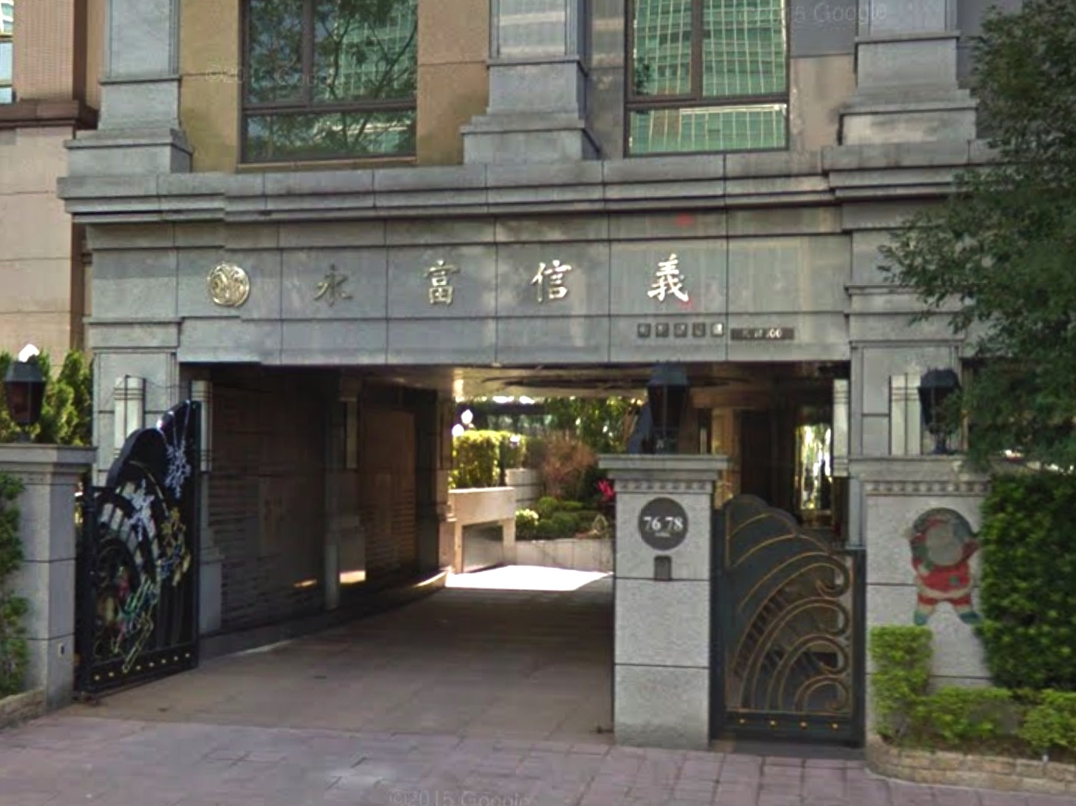
Figure 2. POPS located in front of high rise apartment buildings in Xinyi District , Taipei city.

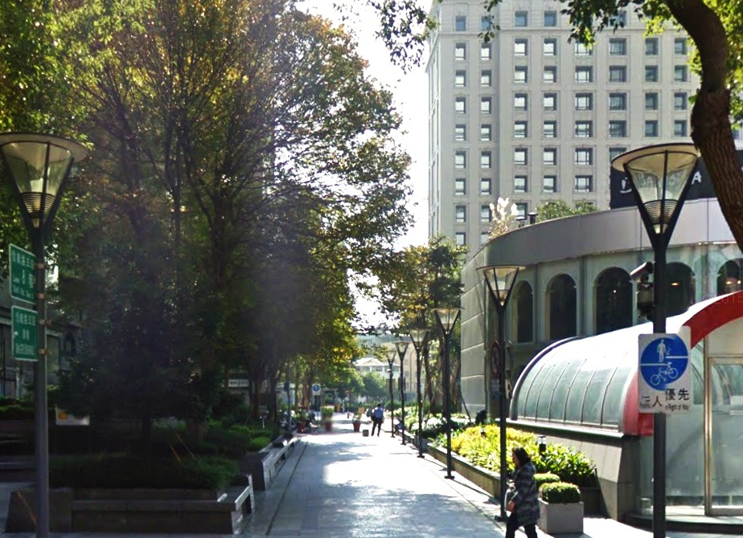
Figure 3 . POPS located in front of office buildings in Xinyi District , Taipei city.

Keywords: Privately Owned Public Space (POPS); Publicness; Evaluation Indicators

References：
- Chris Webster (2007). Property rights, public space and urban design. The Town Planning Review, 78(1): 81-102
- Chu-Joe Hsia (1983). The concept of urban open space and relating issues in Taipei city. Journal of building and planning, (2), 33-43.
- Jerold S. Kayden (2000). Privately Owned Public Space: The New York City Experience. USA: John Wiley & Sons, Inc.
- Mitchell, D. (2003). The right to the city: Social justice and the fight for public space. Guilford Press.
- Németh, J., & Schmidt, S. (2011). The privatization of public space: modeling and measuring publicness. Environment and Planning-Part B, 38(1), 5.
- Wei-Ching Chiang (1993). The Drafting On The Evaluative Method of Use Behavior In Respect to the Open Space of High-Rise Building: To Take the Office Building in Taipei City As Example. Unpublished master’s thesis, Tamkang University, Taiwan.
- Yuan-YuanTung (1999). A research on the molding effects of urban design control on the openness of open space -the case study of taipei city Hsin-Yi district. Unpublished master’s thesis, Tamkang University, Taiwan.
- Ya-Ching Shie (2006). An Evaluation of Environmental Quality of Comprehensive Design Area in Taipei City. Unpublished master’s thesis, National Taiwan University, Taiwan.
- Zhi-Chang Wei (2007). Studies on the subject for setting up open spaces of urban highrise buildings. Unpublished master’s thesis, National Cheng Kung University University, Taiwan.

