Modeling physical dimensions of human-environment systems: flood and urban growth in the cities of Kigali, Rwanda and Kampala, Uganda
Eduardo Pérez-Molina, Richard Sliuzas, Victor Jetten, and Martin van Maarseveen. Faculty of Geo-Information Science and Earth Observation (ITC), University of Twente
Urban flood problems have been increasing in Sub-Saharan Africa, with a clear social inequity dimension, due to external (e.g. climate change) and internal (urban development pattern) causes (Douglas et al., 2008). While interesting adaptation experiences exist, challenges remain to scale up community level actions to city-wide strategies (Lwasa, 2010), hence this paper’s emphasis on understanding impacts in space and across spatial scales. Further, although significant data gaps persist, both information and knowledge on the growth of Sub-Saharan African cities (e.g. Linard et al., 2013) is creating an opportunity to improve very deficient land use plans and systems (African Planning Association, 2014) with innovative, evidence based policy.
Aiming to explore the equity in the distribution of risk due to natural hazards, this paper presents the results of assessing floods caused by land cover change in the cities of Kigali, Rwanda and Kampala, Uganda. Two urban growth models, a spatial statistical model (e.g. Dubovyk et al., 2011) and a cellular automata model (originally developed by Pérez-Molina, 2014), were used to project future land cover scenarios for the cities of Kigali and Kampala, as well as for selected catchments within them; these were then inputted into a runoff-based flood model, openLISEM, for the selected catchments (an example for Kampala, Uganda, is reported in Habonimana, 2014). The results were overlayed with land cover patterns, to assess the impact for different land categories. In particular, we determine (1) if the impact on informal settlement areas is larger than for other urban land use categories and (2) spatial inequality derived from physical processes, by comparing which areas generate runoff and which are most impacted by flooding, and how these differentials interact with land use.
A comparison of modeling results, in terms of replication of the landscape for the calibration data, was performed to understand: (1) the impact of study area extent –i.e. simulating the city and extracting data for the selected sub-catchment vs. simulating only the sub-catchment itself (e.g. for the Upper Lubigi sub-catchment of Kampala)—on landscape patterns and the models’ capacities to reproduce quantitative metrics representing spatial patterns (2) the amount of information required for replicating landscape change (number and diversity of determinants and of land categories in the dependent past variable), and (3) the sensitivity of flood impacts to the magnitude of rainfall events, disaggregating effects spatially and per land category –with an exploration of potential climate change trends for the case studies.
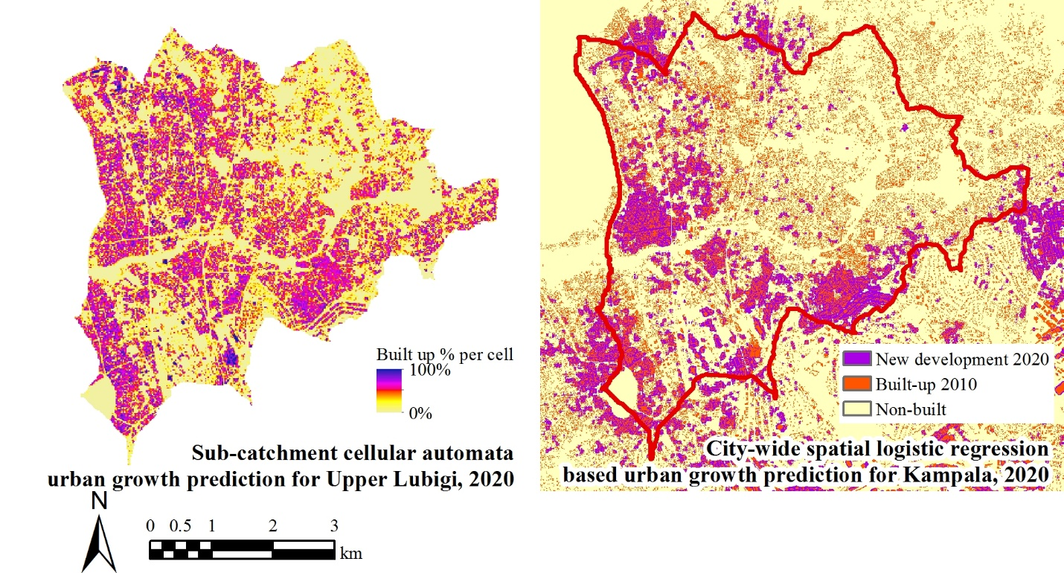
Figure 1. Urban growth model outputs for Upper Lubigi sub-catchment and Kampala, Uganda, 2020
These results are used to reflect on the policy formulation process from the perspective of evidence based land use planning. Recognizing the importance of values in policy formulation, problem identification and diagnosis in policy documents (the Kampala Physical Development Plan and the Kigali Master Plan) were contrasted with field surveys on the perception of flood as a problem (e.g. Mureithi, 2015 and Chereni, 2016). In this context, the discussion focuses on how model-generated knowledge could support the improvement of land use regulation instruments, their equity dimensions with regard to risk in informal settlements or slums, and potential unequal costs and risks introduced by different strategies to reduce future impacts (e.g. emphasis on upstream development controls vs. infrastructure in downstream impacted zones).
References
African Planning Association, 2014. The State of Planning in Africa. An overview. Nairobi, Kenya: APA and UN-Habitat.
Chereni, S. 2016. Determinants of in situ flood mitigation in Bwaise, Kampala. MSc Thesis in progress. Faculty of Geo-Spatial Information and Earth Observation (ITC), University of Twente, The Netherlands.
Douglas, I., Alam, K., Maghenda, M., Mcdonnell, Y., McLean, L., & Campbell, J., 2008. Unjust waters: climate change, flooding and the urban poor in Africa. Environment and Urbanization, 20(1), pp. 187-205.
Dubovyk, O., Sliuzas, R., & Flacke, J., 2011. Spatio-temporal modelling of informal settlement development in Sancaktepe district, Istanbul, Turkey. ISPRS Journal of Photogrammetry and Remote Sensing, 66(2), pp. 235-246.
Habonimana, H.V., 2014. Integrated flood modeling in Lubigi catchment Kampala. MSc Thesis. Faculty of Geo-Spatial Information and Earth Observation (ITC), University of Twente, The Netherlands.
Linard, C., Tatem, A. J., & Gilbert, M. (2013). Modelling spatial patterns of urban growth in Africa. Applied Geography, 44, pp. 23-32.
Lwasa, S. 2010. Adapting urban areas in Africa to climate change: the case of Kampala. Current Opinion in Environmental Sustainability, 2(3), pp.166–171.
Mureithi, I.N., 2015 Flash flood hazard and coping strategies in urban areas: case study in Mpazi catchment, Kigali, Rwanda. Faculty of Geo-Spatial Information and Earth Observation (ITC), University of Twente, The Netherlands.
Pérez-Molina, E., 2014. Modeling urban growth and flooding interactions with cellular automata in Kampala, Uganda. MSc Thesis. Faculty of Geo-Spatial Information and Earth Observation (ITC), University of Twente, The Netherlands.

