Designing the Spatially Integrated Policy Infrastructure for Planning and Flood Risk Management

Jing Ran¹, Zorica Nedovic-Budic²

¹School of Architecture, Planning and Environmental Policy, University College Dublin, Dublin, Ireland
Email: jing.ran@ucdconnect.ie

² School of Architecture, Planning and Environmental Policy, University College Dublin, Dublin, Ireland
Email: Zorica.nedovic-budic@ucd.ie

Integration of spatial planning and flood risk management at policy levels may help address the issues related to flooding (Howe and White, 2004, Kidd, 2007, White and Richards, 2007, Ward, 2013). Such integration requires a variety of facilitators from the political, financial, organizational, management, and cultural sectors (Stead and Meijers, 2009). Information, such as maps of flood risk and development potential, is among those facilitators, and if lacking or inappropriate, it could impede the progress of integration (Neuvel and Van Den Brink, 2009). Geographic Information (GI) and Geographic Technologies (GT) can play the role of ‘integration medium’ (Schuurman, 2003) because they can potentially improve a mutual understanding of issues, collaboration and communication between different policy fields and institutions (Pelzer et al., 2014).
Drawing on the established significance of GI and GT across many planning tasks (Pettit and Pullar, 2009, Chang et al., 2008, Van Haaren and Fthenakis, 2011, Oana et al., 2011, McCall and Dunn, 2012, Vukicevic and Nedovic-Budic, 2012) and flood management activities (Pradhan et al., 2009, Werner, 2001, Zhang et al., 2009, Nedovic-Budic et al., 2006, Bahremand et al., 2007), the research presented in this paper aims at developing an infrastructure for policy integration facilitated by such information and technology.
Among various dimensions of integration, such as spatial, policy and actions (Vigar (2009), we focus on the integration of spatial planning and flood risk management, particularly in terms of policy. Policy integration implies that the policy-making process is a joint process and that a policy reflects a combined and comprehensive consideration (Underdal, 1980). Comprehensiveness of policy input usually benefits from the development of comprehensive and easily accessible information in all the jurisdictions. Moreover, sharing geographic technologies and tools are valuable for supporting policy integration because it allows policymakers to evaluate alternative policies with comprehensive consideration of both flood mitigation and development objectives.
The first objective of this paper is to investigate whether existing GI and GT base could serve as a medium for policy integration of spatial planning and flood risk management. To this end, we first review existing studies and projects on GI and GT implementation for spatial planning and flood risk management. Following from this review, we suggest that current spatial data infrastructures could be improved if by including functions for sharing decision support and analysis tools and propose the development of Spatially Integrated Policy Infrastructure (SIPI). Thus, our second objective is to conceptualize SIPI in order to design and develop its prototype. Following our conceptualization, we apply a design research methodology to design and develop a prototype of SIPI. In this study, we use the River Dodder catchment in Ireland as our case study area and collect data from three sources: a) review of planning and flood-related policies, b) interview with key players and technicians, and c) desktop research on existing spatial planning and flood management geoportals. We use qualitative approach (Figure 1) to analyze our data and inform the design of SIPI, including its goal, functions and components. The analytical methods employed include content, thematic and descriptive analysis.

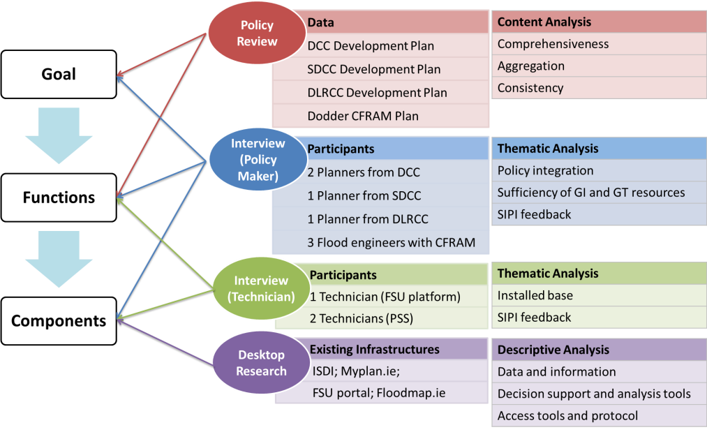

Figure 1. Data sources and analysis applied to inform the design of SIPI
Emerging from our data collection and analysis, we design the Spatially Integrated Policy Infrastructure (SIPI) to: (1) Provide easy access to flood and planning data, (2) provide tools to assess different development scenarios based on their impact on flooding, and (3) encourages more realistic development scenarios. To provide easy access to comprehensive policy input, SIPI should possess a function of database and web-portal to visualize and identify information in the database. In addition, SIPI should allow and encourage users to input alternative development and flood scenarios. SIPI facilitate the assessment of these scenarios by providing tools to overlay information, predict land use changes, and simulate flood events.
This paper also describes the components of the SIPI prototype. We identify the datasets to be shared by SIPI through a Web-GIS portal. Finally, we select a land use model and flood model to achieve the function of prediction, simulation, and evaluation. These components will be evaluated for their contribution to policy integration and comprehensiveness.
References

BAHREMAND, A., DE SMEDT, F., CORLUY, J., LIU, Y., POOROVA, J., VELCICKA, L. & KUNIKOVA, E. 2007. WetSpa model application for assessing reforestation impacts on floods in Margecany–Hornad Watershed, Slovakia. Water Resources Management, 21, 1373-1391.
CHANG, N. B., PARVATHINATHAN, G. & BREEDEN, J. B. 2008. Combining GIS with fuzzy multicriteria decision-making for landfill siting in a fast-growing urban region. Journal of Environmental Management, 87, 139-153.
HOWE, J. & WHITE, I. 2004. Like a fish out of water: the relationship between planning and flood risk management in the UK. Planning Practice and Research, 19, 415-425.
KIDD, S. 2007. Towards a framework of integration in spatial planning: an exploration from a health perspective. Planning Theory & Practice, 8, 161-181.
MCCALL, M. K. & DUNN, C. E. 2012. Geo-information tools for participatory spatial planning: fulfilling the criteria for 'good' governance? Geoforum, 43, 81-94.
NEDOVIC-BUDIC, Z., KAN, R., JOHNSTON, D., SPARKS, R. & WHITE, D. 2006. CommunityViz-Based prototype model for assessing development impacts in a naturalized floodplain—EmiquonViz. Journal of Urban Planning and Development, 132, 201-210.
NEUVEL, J. M. M. & VAN DEN BRINK, A. 2009. Flood risk management in Dutch local spatial planning practices. Journal of Environmental Planning and Management, 52, 865-880.
OANA, P. L., HARUTYUN, S., BRENDAN, W. & SHEILA, C. 2011. Scenarios and indicators supporting urban regional planning. Procedia - Social and Behavioral Sciences, 21, 243-252.
PELZER, P., GEERTMAN, S., HEIJDEN, R. V. D. & ROUWETTE, E. 2014. The added value of Planning Support Systems: A practitioner’s perspective. Computers, Environment and Urban Systems, 48, 16-27.
PETTIT, C. J. & PULLAR, D. 2009. An online course introducing GIS to urban and regional planners. Applied Spatial Analysis and Policy, 2, 1-21.
PRADHAN, B., SHAFIEE, M. & PIRASTEH, S. 2009. Maximum flood prone area mapping using RADARSAT images and GIS: Kelantan river basin. International Journal of Geoinformatics, 5, 11-23.
SCHUURMAN, N. 2003. The ghost in the machine: spatial data, information and knowledge in GIS. Canadian Geographer, 47, 1-4.
STEAD, D. & MEIJERS, E. 2009. Spatial planning and policy integration: concepts, facilitators and inhibitors. Planning Theory & Practice, 10, 317-332.
UNDERDAL, A. 1980. Integrated marine policy: what? why? how? Marine Policy, 4, 159-169.
VAN HAAREN, R. & FTHENAKIS, V. 2011. GIS-based wind farm site selection using spatial multi-criteria analysis (SMCA): evaluating the case for New York State. Renewable and Sustainable Energy Reviews, 15, 3332-3340.
VIGAR, G. 2009. Towards an integrated spatial planning? European Planning Studies, 17, 1571-1590.
VUKICEVIC, J. & NEDOVIC-BUDIC, Z. 2012. GIS based multicriteria analysis in integration of SEA process into planning, case study: south west region, Republic of Ireland. International Journal of Environmental Research, 6, 1053-1066.
WARD, P. 2013. On the use of tradable development rights for reducing flood risk. Land Use Policy, 31, 576-583.
WERNER, M. G. F. 2001. Impact of grid size in GIS based flood extent mapping using a 1D flow model. Physics and Chemistry of the Earth, Part B: Hydrology, Oceans and Atmosphere, 26, 517-522.
WHITE, I. & RICHARDS, J. 2007. Planning policy and flood risk: the translation of national guidance into local policy. Planning Practice and Research, 22, 513-534.
ZHANG, H., JIE, Y., ZHANG, X., JING, G., YANG, Y. & HE, B. GIS-based risk assessment for regional flood disaster. International Conference on Environmental Science and Information Application Technology (ESIAT), 4-5 July 2009. 564-567.

