Urban ecology of urban projects

DELABARRE MURIEL
University of Lausanne
Faculty of Geosciences and Environment
UNIL Mouline, bureau 3419 CH – 1015 Lausanne
SWITZERLAND
Muriel.delabarre@unil.ch http://igd.unil.ch/murieldelabarre/

Abstract - This paper launches a discussion about the implementation of a tool to support urban projects whose nature is an integral part. The development of this tool contains both elements of specific interventions in urban areas based on valuable choices from urban ecology and plural expertise (ecology, botany, hydrology, landscape, etc.) as well as normative thoughts extended to civil and decision-making spheres. A reference table has been developed to operationalize urban ecology and to objectify the minimum criteria to register a project in a transversal vision of habitability of urban spaces.
Key words - urban habitability, urban nature, urban ecology, assessment, urban project

1. Introduction

Amplification of environmental concerns - they involve major degradation affecting communities (loss of biodiversity, pollution, etc.), or the scarcity of resources distributed unevenly in space - we actually start thinking about interventions specific urban based on value choices, as well as normative reflections.
The landscaped some urban environmental conflicts and mobilizations express a new strategy to try to transform the public space. Beyond the purely aesthetic dimension, they also reflect an evolution of representations of habitability. Also a request for reconnection to the natural world, these conflicts and requests depict a growing awareness of environmental issues in the public arena and among those, that of nature in urban areas.
The site of the sustainable city is an opportunity to bring out new compositions reflecting these urban environmental sensitivities and experiment with methods of work and urban project design in line with the renewed urban ecology. It is not surprising that today various trades are challenged to help rethink the urban link. We think here landscapers, ecologists, planners, sociologists (...) which, by their bright knowledge legitimize their ability to seize these challenges and are trying to answer in cooperation with others. How, nature - and has convened in urban projects - participating in the definition and draw the contours of the contemporary urban livability?
The scientific development of the practice of original development of the metropolis of Lyon allows the clutch to approach these various knowledge and understand what directions in making public spaces were favored. Results from an experimental variation of the evaluation grid for water gardens project Lyon Confluence irrigate our thinking.

2. Principles heuristics
  - Ecology and city for a paradigm shift
Many research found a positive valuation on the theme of urban ecology. They embrace new problems ranging from urban pollution, the atmosphere, sustainable development, the principle of governance, to the urban metabolism, through industrial ecology or biodiversity. Although not clearly structured around this expression, the work involved in the construction of an approach whose originality is to explore the complex interactions at different spatial scales (local, regional, global) and temporal (short, medium and long term ) and suggest an interest to explore several dimensions of functioning and evolution of urban systems.

A paradigm change is perceptible in recent publications. What is a city environmental perspective ? This simple question has probably helped to change the perspective on urban operations and to significantly modulate this catastrophic vision somewhat unilateral. It is first the design of a city reduced to an ecosystem that has been the subject of criticism. This imposes a quantitative approach and technical processes, primarily studied from measurements of flows of materials and energy (and Emelianoff Theys, 2001). Also, it is a representation "dehumanized" the urban environment that predominates in this design: the responses to the urban nuisances fall action on productive and industrial dimensions of the city. So, and to resume the typology of Jacques Theys, technocentric a design that dominates, that is to say an approach that addresses the environment as a set of dysfunctions, risks and problems to be solved by management of artificial systems. In this logic, technical measures to reduce pollutant emissions, discharges and waste, better organization of material flow networks, reducing energy consumption through the use of new materials, dies of Production more appropriate, etc., would be sufficient in itself to produce a city that is more harmful to the planet. However, this design does not require the cooperation of humanities and nature to progress in knowledge and in action. It essentially mobilizes engineering sciences, that of measuring systems analysis, health sometimes. In this sense, it appears restrictive to the extent that it does not integrate social and economic, collective and individual behavior, modeling of urban processes.
Certainly the technocentric design often remains the dominant standard and widely involved in direct forms of intervention expected to act on the urban environment. But at the same time the vision of a city operating in autarky and harmful on its external environment is beginning to change. The emergence of new disciplines, coupled with an interest in the city by the oldest and constituted disciplines (hydrology, geology and meteorology, among others); and secondly to criticism on environmental action modes (Lolive and Soubeyran, 2007) involved in shoving the most entrenched convictions. Thus, without denying the alterations of urban activities on ecosystems, more recent work, take vis-à-vis distance of exclusive design of a city detrimental to nature, ecosystems and the biosphere, while offering a different view of the relationship between human activities and the natural and built environment in urban areas.
This trend appears very clearly in such work on the relationship between city and nature (Blanc, 2004). This research has shown that, under cover of modes of specific actions, urban space can also be a venue for creating fauna and flora (Clergeau, 2007). Work even emphasize forms of adaptation of certain wild animal species in urbanized areas. It is the human relationship with nature that has evolved bringing forth new societal expectations.

  - A successful query examine the complementarity between nature and habitability spaces
Large cities often appear as models of "over-nature" to that wipe living nature (Guéry, 1986). The latter denied this, instead leaving only a pseudo desired nature tamed, controlled; in short, an unnatural kind (Blanc, 1996; Hucy, 1997).
A first series of studies (Blanc, 1996; Hucy, 1997; Mathieu, 1996) confirmed that the question of the nature plays an important role in anti-urban representations and reports to the nature of city residents constitute a neglected dimension nevertheless essential for understanding the evolution of the idea of city as well as ways of living. This would also be a crisis of representation vis-à-vis residents of their living environment, the value of the premises in view the welfare they provide to individuals. The current debate on this subject is based on a questioning around the urban livability.
What does livability and what are the components of a livable city? How make more living space for all individuals? The term living place, a place that offers sufficient possibilities for creating and adapting individuals to appropriate it (Delabarre, 2013). We can not reduce such a large issue in the analysis of a sum of physical, without, for example, evading a necessary human creativity; we can not not reduced to a human invention, which would mean forgetting the natural foundations, materials and built for individual and collective actions. We will say that a habitable place is a place that provides adequate opportunities for creation and adaptation to individuals to take ownership; delicate interpretation and understanding such a process is, the appropriation of a place based on detailed knowledge of the living conditions offered there.

3. Assessment: structuring field and area of investigation
This paper undertakes a reflection on the development of a tool to support urban projects whose nature is an integral part.

  - Development of the tool: method and Construction
First element of the method: the choice of exploration in situ combined with the expertise of multiple actors
In situ reflects the diversity of situations space consisting of a sum of objects whose environments are all different and plural maintain relations with the user. It is also the diversity of situations and instability that participates in the temporal dimension of nature in the city expressions. These can not be confined in the immediacy of phenomena. The investigation conducted has generated an attitude of delay in the moment to seize the objects and their relationships to each other. From there, a necessity forced itself upon us: to combine several modes of data collection from the observation and evaluation.
Combined with the expertise of actors of urban production, this method has enabled us to create a database of the characteristics of nature in the city of expressions to evaluate the spatial arrangements that draw the contours of urban livability.
    - A reflection on engineering
The approach proposed here is intended as adapted to the contexts of their own constraints as well as operations, however, based on a more general methodology outcome of other existing approaches to scale of Urban Planning (HQE²R, AEU, ADEQUA), resting systematically on a performantiel cut into themes and target pane.
The grid is based on the ISDIS (Integrated Sustainable Development Indicators System): choice of 6 sustainable development principles throughout the project, which are then broken down into 21 targets and sub-targets into 51 and finally 61 essential indicators on a Sustainable Development (Valdieu and Outrequin, 2006) (see Figure 1 below "The HQE²R circles of sustainability").

Figure 1 - HQE²R circles of sustainability
Source : David Mowat for the neighborhood HQE²R
Community at Heart for the quarter, Bristol, UK

This approach addresses four themes are :
- Conservation and resource management,
- Improving the quality of the local environment,
- The integration of the project into its urban and natural environment as well
- Treatment of configurations developed to ensure their maintenance and durability.
From there, 14 subthemes intrinsically linked to four topics listed above were identified (see Figure 2 "The themes and sub-themes of the grid").

    - Definition of themes and sub-themes
To facilitate reading and harmonize the analysis methods selected areas, defining indicators will be broken down into the same "working list" 4 themes and 14 sub-themes, namely (see Figure 2).

THÈME N°3 –
Integrate the Project into
its Natural and Urban environment

SOUS-THÈME N°3.1 – Waste and their management
SOUS-THÈME N°3.2 – The movements
SOUS-THÈME N°3.3 – Biodiversity and green spaces

THÈME N°1 –
Protect and Manage the Resources

SOUS-THÈME N°1.1 – Energy: reduce the energy consumption and improve the management of the energy
SOUS-THÈME N°1.2 – Water: improve the management of the resource in water and its quality
SOUS-THÈME N°1.3 – Materials : optimize the consumption of materials and their management

THÈME N°2 –
Improve the Quality
of the Local Environment

SOUS-THÈME N°2.1 – Visual atmosphere
SOUS-THÈME N°2.2 – Acoustic atmosphere
SOUS-THÈME N°2.3 – Thermal atmosphere
SOUS-THÈME N°2.4 – Air quality
SOUS-THÈME N°2.5 – Soils quality

THÈME N°4 –
Assure the Maintenance,
the Durability of spatial configurations

SOUS-THÈME N°4.1 – Materials
SOUS-THÈME N°4.2 – Systems and equipments

Figure 2 - Themes and sub-themes of the tool
Source: Muriel Delabarre, 2013

  - Target selection
Choosing meaningful targets is a very delicate exercise. The complexity of the subject leads us to proceed in a deconstruction of the components from nature and its physical environment "elementary phenomena." The construction of the concept of habitability finally made by the reconstitution of a typology of figures to highlight the architecture of the phenomena through the combination and hierarchy of different elements.

Objective n°4 | TARGETS | INDICATORS
MANAGE TO THE SOURCE RAINWATERS | - Limit the volume of the collected rainwaters by proceeding to the retention of waters, in particular there:  - Favoring the infiltration most upstream possible of rainwaters through permeable surfaces ;  - Conceiving zones of storage-buffers of retention of rainwaters (by means of roofs terraces, of roads integrating a reservoir, well, side trenches, ditches, of set or of ponds ;  - Watching the implementation of surfaces waterproofed in the bare minimum, as far as they answer the qualities of use required in terms of influences and interview(maintenance) (car park, accessibility, collection of waste, etc.); | - Infiltrated volume of rainwater ( m3 ) towards pits of trees  - Debit(flow) of flight(leak)  - Volume of storable rainwater for re-use ( m3 )

Figure 3 -Example declination for the sub-theme 1.2 to manage water resources
Source: Muriel Delabarre, 2013

4. Aquatic gardens of La Confluence project to the test of experimentation
Designed by the Agency Michel Desvigne, all these made up a vast landscape gardens backing onto the Saône whose qualities evoke the richness of the aquatic environment (see Figure 4). This territory is treated as a landscape rivers where natural diversity is established in the immersed parts. This diversity of environments sparking some curiosity and appeal is sought by the public.
The agency has made Desvigne three basins back of the river Saône (one of the works being disposed upstream of the dock and two downstream).
Water gardens are carried out on embankments composed of former polluted soils. The earthwork excavation related to the development of these basins was designed and currency by the office of Sefco engineers.
These three basins are bordered by walls on three of their side (North-South), while their East side limit offers vegetated banks before a tree-lined meadow.
If the edge of the gardens is perfectly geometrical, physical configuration is inspired by the natural model. The aquatic vegetation belts, semi aquatic and terrestrial were implanted to specific coast against a water level. Consistent with a geographical location - sort of lagoon - this spatial configuration is the place of a strong expression of nature: ecology of river banks, sterilized by the presence of the boom grows here.

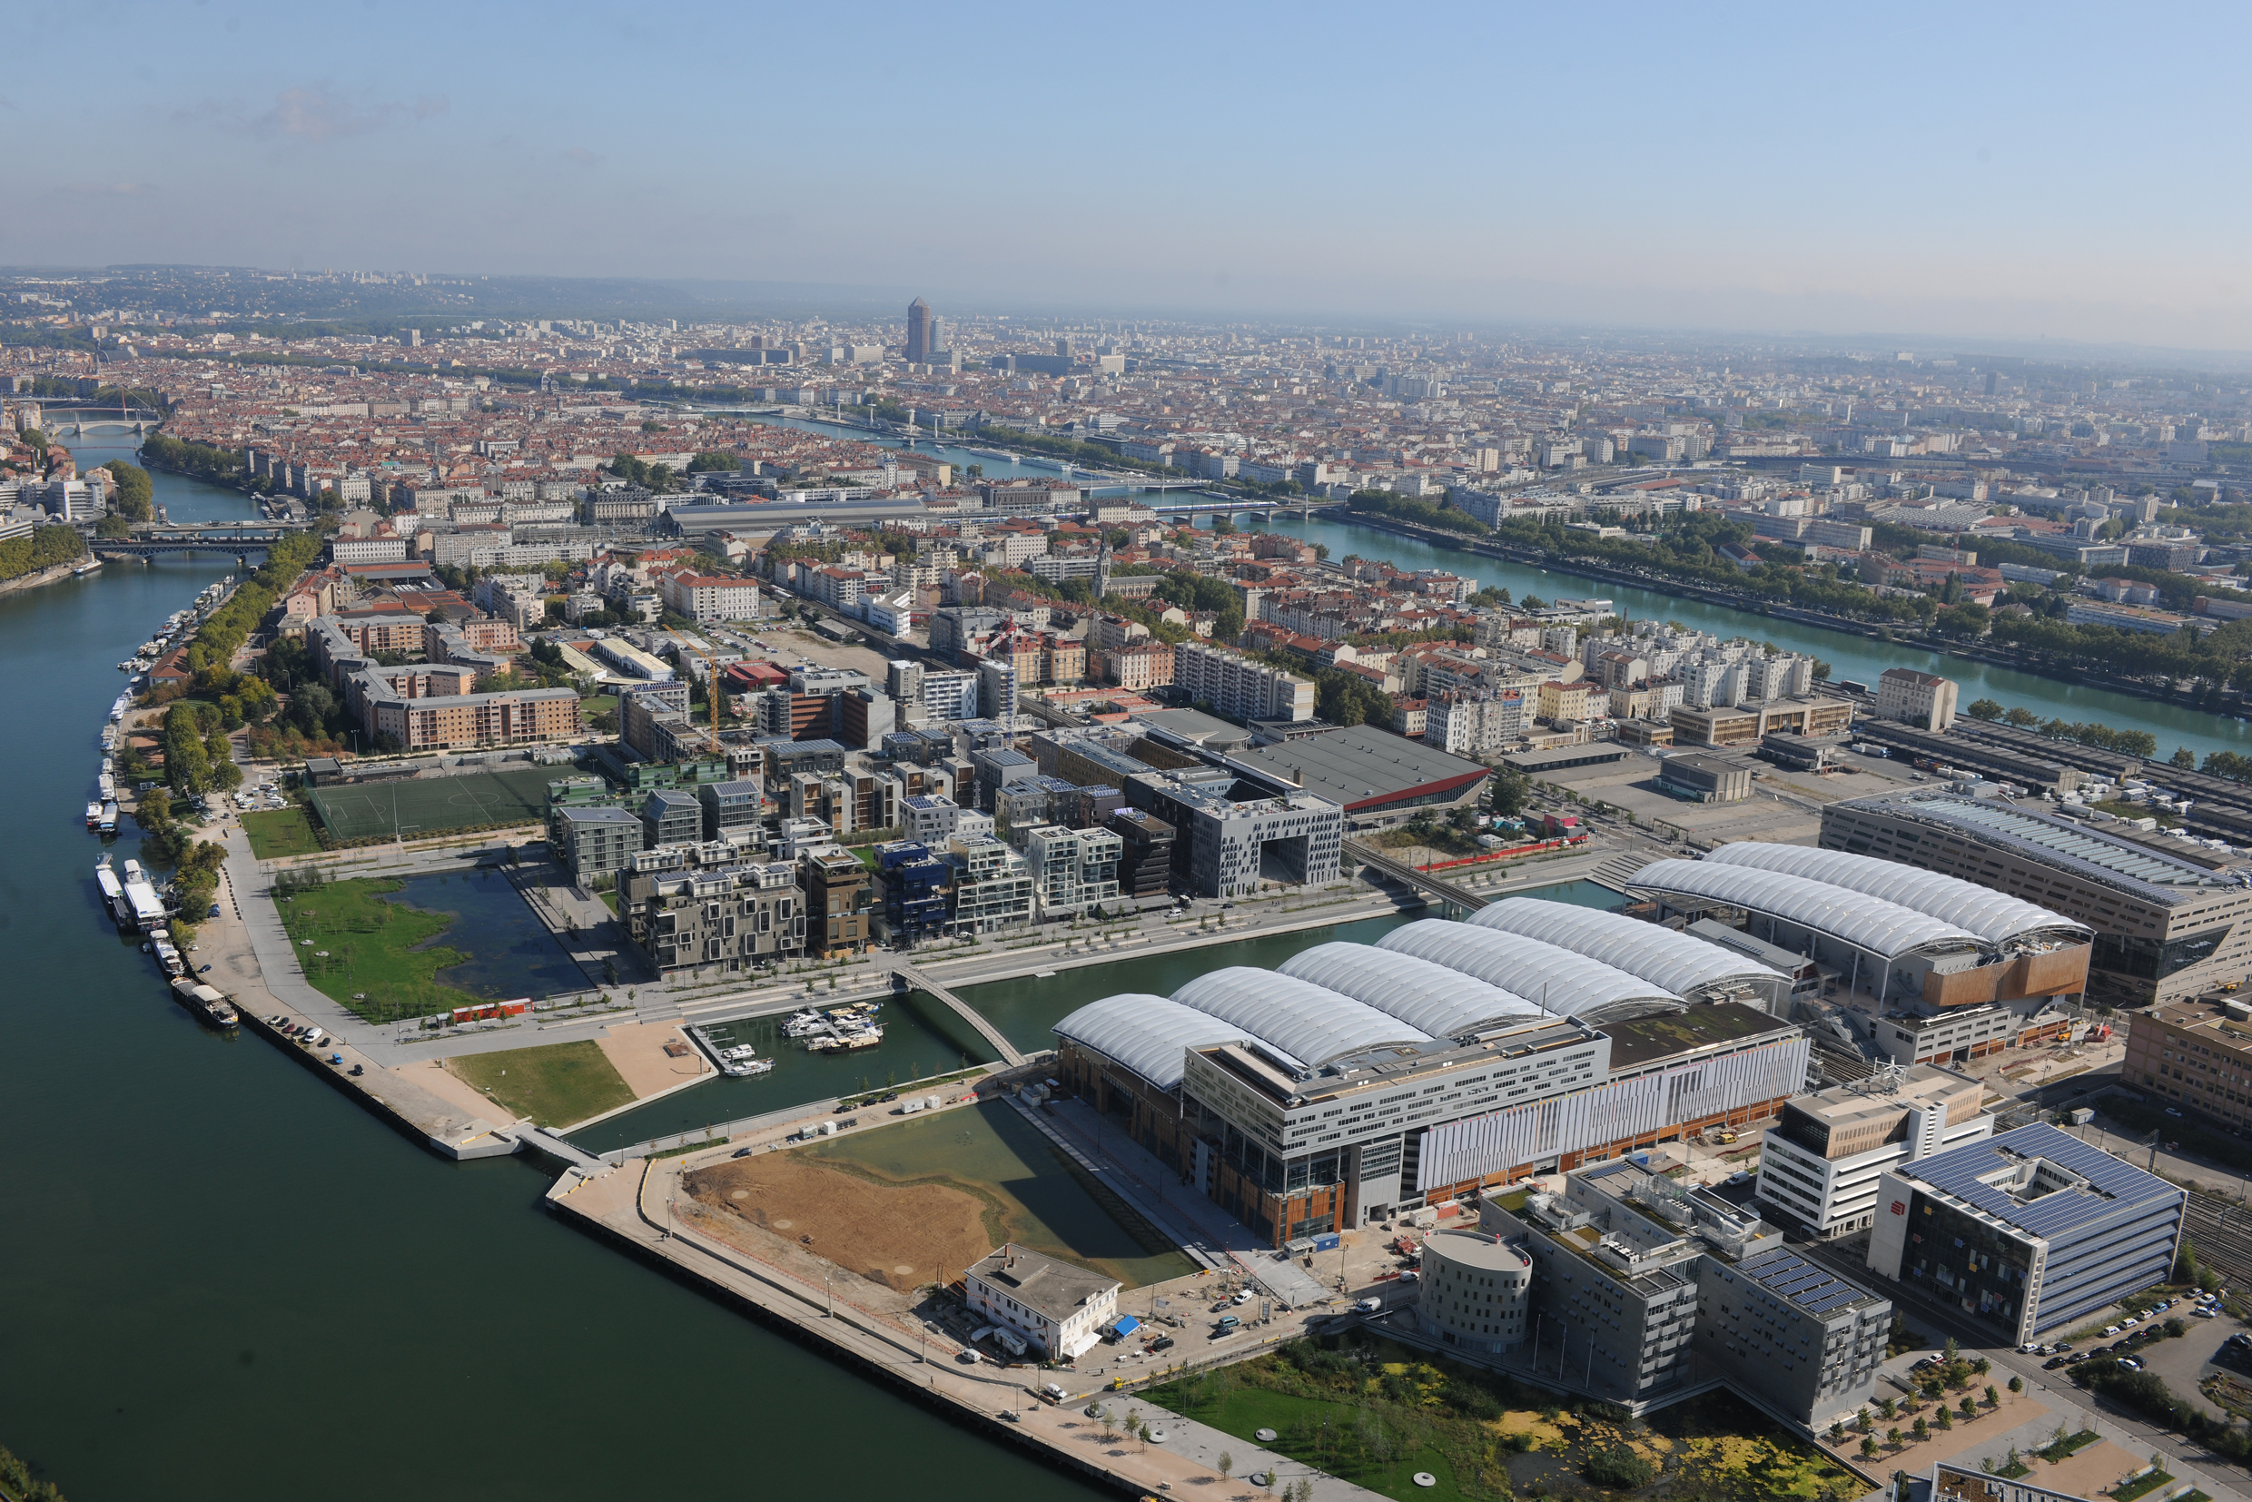
Figure 4 - Water gardens in the foreground
Source: Jacques Leone, Lyon 2013

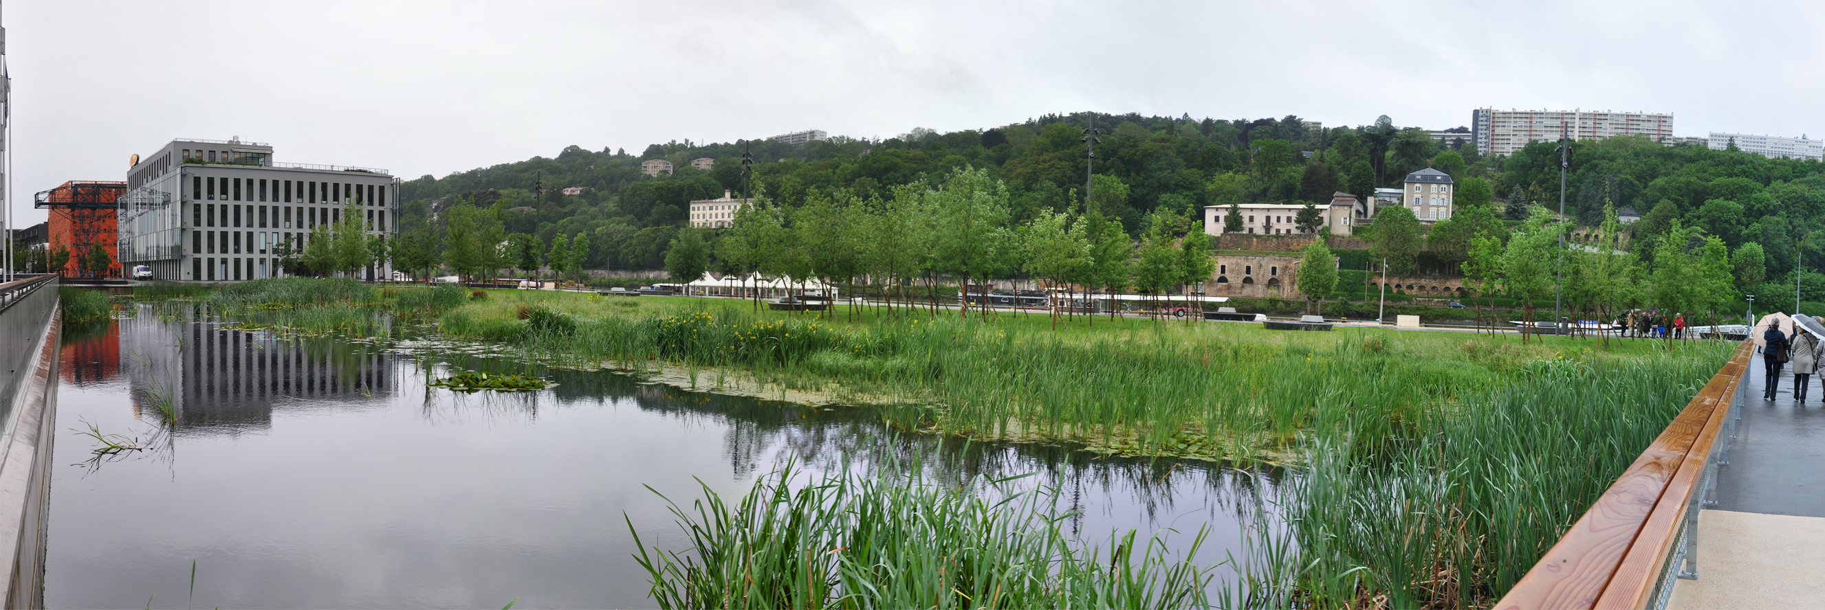
The evocation of nature necessarily involves an artifice, a construction. However, the "imitation" of nature implemented in the landscaped gardens, artificial appear today: these forms refer to the stereotype language of much more than the nature parks.
The designers used contemporary technical means: the proposed plan is a kind of computer graphics that uses real readings of wetlands (their terrain, vegetation and presence of water), to adapt to the constraints of graphical manipulations physical landscaped course.
The conditions created by this device are of great diversity like the natural conditions likely to cause the development of natural ecological processes.
The volume of water is limited and therefore its depth, including bank, thanks to the close proximity of the Saône which allows to consider the relatively large movements.

Figure 5 - photography, southern basin water gardens
source: Bazarurbain, 2012

A major concern of the management of water gardens is related to the definition of the volumes of water necessary to ensure not only the maintenance of a fixed water level taking into account the lack of rain during certain periods (compensation evaporation and evapotranspiration), but also to ensure the smooth functioning of biological basins.
It is indeed necessary to seek to minimize the development of undesirable algae by creating a more balanced biological environment possible. This biological balance research involves the optimization of several independent parameters, represented by :
- The depth of water;
- The nature of bottom substrates basins;
- Control of vegetation belts of development suited to the / terrestrial interface;
- The water renewal rights.
Although the analysis of the spatial configuration refers to several sub-themes of the tool (energy, materials, water, visual and acoustic environments, biodiversity etc.), we have chosen to present here evaluations conducted from three themes for this space.

  - Thematic water in its relation to the ground
From a landscape point of view, to establish a consistent depth of water does not matter much. Water management meets the problem of urban quality, quality of use and usability. In recent decades, water has often been erased in favor of the urban landscape of rivers or culverts buried, underground networks, wetlands drained or filled etc. The resurgence of water in the city allows both demineralise urban public space but also to animate the urban landscape, to strengthen this element from nature, to regulate the temperature of the city in summer, ( Water cools the overheated summer air) but also to respond to social needs (soothing vision of water). As soon as the water depth exceeds 20 to 30 cm, the image given is that of a reflecting pool (open water surfaces) and the landscape goal is then achieved. However, such depth (very low) promotes rapid warming of the water in place and by the same, allows undesirable algae. From a biological point of view, given more depth to the pool, the more "natural" environment is likely to be balanced.
The Desvigne agency and the SPLA Lyon Confluence wished to maintain a fixed level throughout the year. Only a physical constraint is imposed on them: gardens occupy a position "perched" above the Saône. Having a reasoning about the tightness of the tanks was therefore essential. The courses near water basins could be opportunities for variations in water level and indirectly from the neighboring groundwater. The project owner teams and mastery of work conducted at the basin bottom definition allowing maximum water depth of 1 meter. Also, they have opted for a complete renewal of the volume of water every two days functionally. Related to these concerns, various factors were taken into account in the design of the space such as soil treatment in place and the preservation of groundwater from pollution

  - The principle of establishment of vegetation on water gardens has been studied in order to stick to the best in various natural situations
The proposed species are native (not exotic) able to grow in Lyon conditions. This list was built exclusively for the context of the operation Lyon Confluence. Indeed, there would be a notable risk by the introduction of non-existent spaces on other websites that may cause ecological imbalances uncontrollable and irreversible.
The fact implement wetland plants triggers - it is a basic rule in ecology - colonization of the site by different species. Thus, the dynamics of colonization is beyond the control of the designer and react to biotic and abiotic factors. Monitoring and special maintenance are conducted to "maintain" the desired vegetation and located initially.
From the center of the water (the deepest point) to reach the highest point above water, there is different vegetation belts corresponding associations (phytoassociations).

  - The treatment of the landscape dimension
The desire for a new alliance between man and nature is expressed through the water gardens along the desire of urban intensity and transformation of lifestyles for the whole of the urban project Confluence. Hybridization of urban and natural spaces takes place in space redistributions present within this space, but also from the awakening of environmental consciousness. Thus, the techno-economic logic of territorial development have led to a rediscovery of nature as signifying both symbolic and dynamic cue for the actors s in developing appropriate balances and reconfigurations.
This revaluation that develops and takes different forms: from a domesticated nature parks, gardens and landscapes to the nostalgia of original nature. If one refers to the landscaping of this space, we can grasp the contours.

5. Conclusion
By crossing the specific fields convened as part of this study with the specialization fields of disciplinary technical knowledge (ecology, urban planning, landscape, etc.), operational and representations of the logic composition of public space, we were able to grasp the contours of a transverse argument: that of urban livability. Here, seen not as a dogma or a set of rules defining the objects in space, applicable in any context, but as an evolving and adaptive process that has importance for the discovery of its own rules. These landscaped water courses raise questions on how to produce and manage the space. Ultimately, urban livability is not so much given that it is "con-figure". This con-figuration takes shape in a sensitive relationship between the viewer and space, the referrer and the referred, content and form, the material given, action and perception.
The notion of habitability meeting the field of urban ecology in particular with the emergence of new environmental challenges in terms of developing and maintaining quality of life. Therefore, this concept introduces a new order, a symbolic order: it requires an integrated management of the living resources to meet the interactions of ecosystems including humans depends. However, this renewal of thought does not distance habitability perfectly technicist still producing a mass standards increasingly stringent and sharing between ecological and human standards. Yet it is in this direction, to meet the ways of living humans and non-humans, that the question of habitability seems today to be revisited.

References

Barles (S.), « Urban Metabolism of Paris and its Region », in. Journal of Industrial Ecology 13, 2009, pp. 898-913.
Barles (S.), Breysse (D.), Guillerme (A.), Leyval (C.) (éd.), Le sol urbain, Paris Anthropos, 2001, 146 p.
Berdoulay (V.), Soubeyran (O.), L'écologie urbaine et l'urbanisme. Aux fondements des enjeux actuels, Paris, La découverte, 2002, 274 p.
Berleant (A.), The aesthetics of environment, Philadelphia : Temple University Press, 1992.
Berque (A.), Ecoumène. Introduction à l’étude des milieux humains, Belin, Paris, 2007, 271p.
Berque (A.), « Qu’est ce que l’espace de l’habiter ? » in. Paquot (T.), Lussault (M.), Younès (C.) (dir.), 2007, Habiter, le propre de l'humain: villes, territoires et philosophie, Paris, La Découverte, 2007.
Blanc (N.), Les nouvelles esthétiques urbaines, Editions Armand Colin, Collection Emergences, 2014, 212 p.
Blanc (N.), « De l'écologie dans la ville », Ethnologie française, n° 4, Paris, Presses universitaires de France, 2004, pp. 601-607.
Blanc (N.), Les animaux et la ville. Paris, O. Jacob, 2000, 232 p.
Blanc (N.), « 1925-1990: l'écologie urbaine et le rapport ville-nature », L'Espace géographique, n° 4, 1998, pp. 289-299.
Clergeau (P.), « Écologie urbaine et biodiversité », in. Coutard O., Lévy J.-P., Écologies urbaines, Paris, Economica, 2010, pp. 154-165.
Clergeau (P.), Une écologie du paysage urbain, Rennes, Éditions Apogée, 2007, 137 p.
Couic (M.C.), Delabarre (M.), Roux (J-M.), Regards croisés sur la nature en ville, Retours d’expérimentations de parcours sur sites dans l’agglomération lyonnaise, Grand Lyon, 2012, 159 p.
Delabarre (M.), Marry (S.), «Habitabilité et Nature urbaines », in VertigO - la revue électronique en sciences de l'environnement, Volume 2 Numéro 12, http://vertigo.revues.org/12683?lang=en 2012
Delabarre (M.), Natures plurielles, pour une contribution à l'habitabilité de l'espace public contemporain, Thèse en Urbanisme et aménagement de l’espace, Institut d’Urbanisme de Grenoble, 2013, 608 p.
Guillerme A., Bâtir la ville : Révolutions industrielles dans les matériaux de construction, Collection Milieux, 1995, 320 p.
Levy (J.), Viard (J.), La ville dans la nature. Quelle problématique pour l’environnement urbain ! REED, Sretie info, 1991, pp. 25-21

Morin (E.), Introduction à la pensée complexe, nouvelle édition, Paris, Seuil, Collection Points et essai, 2005, 144 p.
Paquot (T.), Demeure Terrestre. Pour une philosophie de l’architecture et de l’urbain, Ecole Polytechnique Fédérale de Lausanne, Département d’architecture, 2000.
Paquot (T.), Younès (C.) (dir.), Philosophie de l'environnement et des milieux urbains, Editions la Découverte, 2010, 183 p.
Serres (M.), Hominescence, Paris, Le Pommier, 2001, 378 p.
Younès (C.), Ville contre-nature. Philosophie et architecture, Paris, La découverte, 1999, 282 p.
Zepf (M.), Delabarre (M.), Natur in der Stadt, Stadt am Wasser, Recherche pour le compte de l'European Landscape Contractors Association, 2014, 78 p.

