Planning and Peri-urban spaces – a case study

The current Brazilian urban landscape is not very attractive, be it because of the high costs of living associated with housing, as well as transportation between cities, or because of the worsening quality of life. Due to these negative circumstances and the presence of a strong regional network of highways, rural spaces are becoming more and more attractive for people who live and work in metropolitan areas, creating regional decentralization among people and operations, allowing new forms of living in rural areas that are more and more urban.

The urban diffusion or metropolization of territories (INDOVINA, 1998) is relatively new to Brazil, as exemplified by medium-sized cities (AMORIM 2007, AMORIM, RIGOTTI, CAMPOS 2007) as strategic players in this phenomenon, due to the high adaptability of the individual characteristics of each region (CONTI, 2013).

These new processes transform and redefine transportation patterns, housing options, as well as the localization of the productive, commercial and service sectors, in addition to the reasons and tendencies associated with the territorial distribution of peri-urban areas (CICCOLELLA, 2012).

In this new reality, there’s a gap between the urban diffusion of the territory, and the instruments of local and regional planning and land use. These tools have not yet succeeded in assimilating the changes in course that have presented themselves in the absence of urban strategies that take into account both the transformation of this space, as well as the absence of regulatory instruments.

The hypothesis of this study argues that the main tendency of the process of urban growth in peri-urban areas is tied to the logic of the very market that takes advantage of the pressures of urbanization, and above all, of the inadequacy of the regulations as well as urban and regional planning at a regional scale.

These processes should be explored in order to foster the elaboration of development and land use plans that are capable of establishing territorial control, and to update and adapt standard urban instruments on a local level.

The case study is located between two of the three cities that belong to the cluster composed of the cities of Ouro Preto, Mariana, and Itabirito, which compose the central sub-region of the east/ southwest region of the perimetropolitan region of Belo Horizonte. This space is framed by the 356 road and has an ample amount of urban settlements in this 29 kilometer stretch. On this stretch, 7 significant urbanizations are found, belonging to the cities of Ouro Preto, Itabirito, as well as another 20 smaller municipalities.

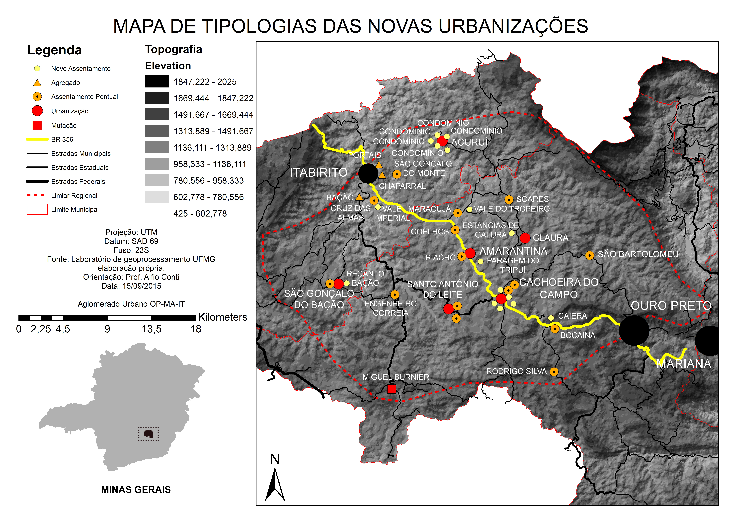
Figure 1- typology map of new developments. Source: Own Elaboration

To implement this study, an all-encompassing body of fieldwork was used, facilitated by Google Earth, by ArcGIS software, and by the database made available by the GIS Laboratory of the Department of Urban Planning at the School of Architecture of the Federal University of Minas Gerais.

This space that was studied is of huge importance because it represents the urban growth area of the cities of Ouro Preto and Itabirito. Due to certain physical and geographical conditions present in Ouro Preto that are difficult to overcome, the expansion of its urban area is restricted, and the surrounding settlements covered in this case study meet the needs of the city’s population demands. Itabirito, for instance, has opened itself up to the population segment looking for weekend country houses.

The settlements that have stood out as the settlements with the best urban conditions are the districts, having grown faster and become attractive spaces for emerging real estate ventures led by inhabitants with medium to upper class socioeconomic status.

Among the most significant urbanizations, Cachoeira do Campo and Amarantina play the important role of multifunctional centralities, polarizing close urbanizations such as Santo Antônio do Leite and Glaura, which are both classified as residential hubs.

Cachoeira do Campo and Amarantina together, due to their central and accessible location, as well as favorable physical and geographic conditions, garner higher degrees of growth compared to other urban centers in the cluster.
Further away from the aforementioned urban centers, due to the relevance of certain qualities of their landscape, Acuruí and São Gonçalo do Bação stand out for their land subdivision and blending ventures, forming residential centralities.

Analyzing the planning instruments adopted by the cities of Ouro Preto and Itabirito, it is clear to see how advantageous it would be to adopt a zoning policy that would incorporate these new urban centers, which currently do not possess a general vision of the entire region together. This significantly limits the control and efficacy of these instruments.

This growth process has been gathering both popular and economic support alongside services and urban infrastructure, altogether improving the accessibility of the geographical space and reinforcing its importance to this urban cluster.

These spaces, however, are not complete and autonomous, as they still depend on services such as education, health care, recreation, as well as sources of employment offered by medium-sized cities in the cluster, generating waste that should be minimized with the establishment of, firstly, communal areas, which will strengthen these new hubs, and then the implementation of productive activities.

The tendency is a city model that is even more diffuse and extensive. The hypothesis, based on this study, is showing itself to be more and more true in peri-urban areas, demonstrating that this should be faced by local management organizations by regulating influential players that control this growing space, mainly the real estate market, which see these areas as a territory to be conquered or purchased, as long as urban features like shopping centers, infrastructure, and access roads, continue to be areas of expansion (CICCOLELLA, 2012).

There is, therefore, an urgent need for the creation of urban planning instruments on a regional scale which can incorporate peri-urban spaces into territorial policies, otherwise they will very likely turned into merely strategic spaces for market appropriation.

BIBLIOGRAPHY

AMORIM FILHO, O. B.; SENA FILHO, N. A morfologia das Cidades Médias. Goiânia: Editora Vieira, 2005.

AMORIM FILHO, O. B.; CAMPOS, J.; RIGOTTI, J. I. R.. Os níveis hierárquicos das cidades médias de Minas Gerais. Revista RA ‘E A. Curitiba: Editora UFPR, 2007.

CICCOLELLA, P; VECSLIR, L. (2012) Transformaciones territoriales recientes y reestructuración metropolitana en Buenos Aires. In riURB - Revista Iberoamericana de Urbanismo nº8.

CONTI, A. (2013). A zona perimetropolitana de Belo Horizonte - Uma análise exploratória. Belo Horizonte, São Paulo: Editora Livre Expressão.

INDOVINA, F. (1998): Algunes consideracions sobre la “ciutat difusa”», Documents d'Anàlisi Geogràfica.

