"Socio-spatial segregation in Antofagasta, northern Chile: the impacts of mining capital"
Authors: Emilio Thodes & A/Prof. Simon Batterbury

The problem
Few countries have been left unaffected by global mining boom. While the direct impacts of large scale mining are felt most strongly in regional areas where mines are directly located, the residual effects of mining are observed in rural and urban landscapes located further afield. In less-developed economies, mining has been one of the major drivers of economic growth and of urban development. Stimulated by the arrival of 'Big Mining', and the influx of capital that comes with it , new sources of development have appeared, particularly through rapid urbanization, the focus of this study (Humphreys & Bebbington 2012). Despite these outcomes, it has been widely acknowledged that mining not only provokes environmental struggles and problems in host regions but it also exacerbates social and economic disparities, transforming urban areas where money and actors circulate. These transformations are not only socio-economic in nature, as they also affect different physical environments and political systems.

As a consequence, governments have been pressured by popular, grassroots demands for a more equitable model of development and redistribution of mining revenues at a local level (Haarstad 2012). These new challenges are made on the grounds of equity and sustainability, and they question dominant thinking towards the development of mining-affected cities. A more holistic approach is required to explore the interaction of mining and urban centres, with most of the existing literature giving little attention to the relationship between the benefits and impacts of mining revenues, its linkage with urban development, and its spatial distribution (Slack 2010; Buchardt & Dietz 2014).

This paper contributes to the understanding of these questions through the analysis of the nature and distribution of mining benefits and its relationship with uneven urban development in the city of Antofagasta in northern Chile. To do this, we focus on the implications of social disparities and the spatial distribution of wealth in the city.
The key research question are:
• Does mining influence the use of space and uneven urban development in Antofagasta?
• Who benefits from the mining boom, and how are these benefits spatially distributed?
Expanding knowledge of socio-spatial segregation in mining-affected regions is vital, and, Antofagasta illustrates this problem. Urban development is uneven, and mining wealth aggravates this.

Methodology
A mixed method approach was used, with research conducted in 2014. Relevant literature regarding mining and its implication for host regions was consulted. Common patterns of segregation and development were identified. Fieldwork in the city involved interviews with eight key participants triangulated with quantitative data in order to look for correlations. Finally data from the "OECD Territorial Reviews: Antofagasta, Chile 2013, (OECD 2013) was corroborated to check on the accuracy of the fieldwork findings.
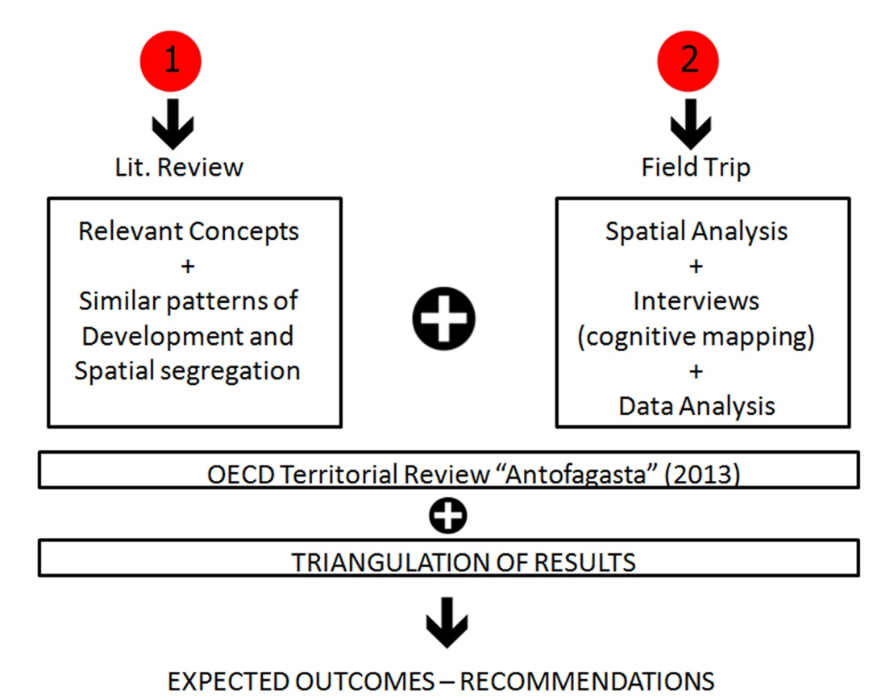
Figure 1 / Research design structure

Source: Authors' elaboration
Findings (main results)
The study illustrates how mining, though an influx of capital, mining related actors and economic migration, has changed the city of Antofagasta in unexpected ways. While the findings identify a relationship between uneven urban development and mining, a greater concern is the lack of governmental control over the city's changing landscapes and inequitable distribution of benefits among residents.
In addition, the government does little to address social equity, since, unwittingly, it privileges the interests of more affluent residents and land developers; sales of government land have transformed urban space into an exchangeable commodity. This process of the commodification of space correlates with altered locational patterns, particularly for housing, with new developments purchased by mining industry workers and investors, with little investment in affordable housing. The biggest concern for the future is the uneven distribution of mining revenues in Antofagasta, a major sink for surplus capital generated largely by mining and a pattern of private investment enabled by government land sales and urban planning.
One of the major driving forces of urban transformation and social changes was the early arrival of mining workers. Mining itself promotes the influx of capital and different actors who influence the process of urbanization, generating major changes of lifestyle, eventually transforming the city and the social environment through demand. Davey Harvey (2013) attributes this process to the current global economic state where the increase of capital surplus is absorbed by cities (in mining regions for example) thus, creating fundamental social inequalities as in the case of Antofagasta.
Antofagasta has been fragmented into valuable and non-valuable spaces which are spatially occupied by polarized social classes. Hence, in order to capture value from land, the government has released land at a price regulated by the market rules. Consequently, most actors cannot participate in the purchasing process, including the local council. As a consequence, land is then acquired and developed by private investors, who follow the market trends -consumer habits, demand and cultural forms- look for investment maximization and profits. This practice has shaped the city's structure by concentrating wealth in specific locations and displacing the poor towards less attractive areas. (See figure 1 below)
More egalitarian access to land requires consideration of ethics and justice within the city, especially in terms of the democratization of the urban landscape and space. In this respect, spatial disparities can be seen as, outcome and process, as distributional patterns that are unfair in themselves (Fincher & Iverson 2012). In this manner, the development of residential projects focus on a minority. In fact, as Harvey (2008) mentions, the right to the city is generally restricted to a reduced number of people who are in a position to shape cities as they wish and then benefit from this in terms of increased property values or business opportunities.
Figure 1 / Top: socio-spatial segregation - Bottom: real estate development trend 2013-14
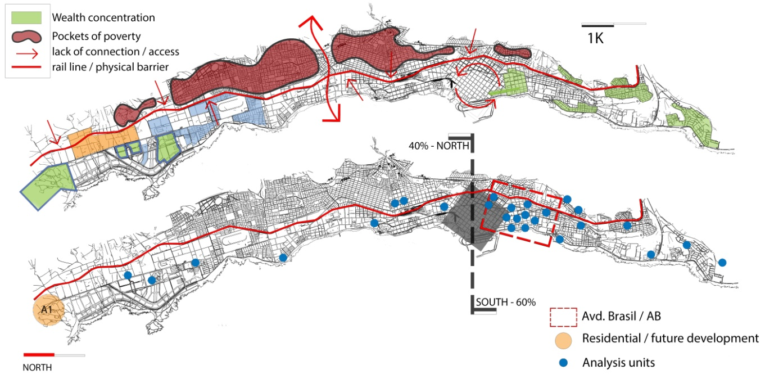
Source: Authors' elaboration.
Does mining influence the use of space and uneven urban development in Antofagasta?
A worrying finding, is not that mining influences the use of space and the appropriation of better locations through the incorporation of high-paid workers to the city ,which increments real estate speculation, but the formation of ongoing socio-spatial processes that are likely to increase the level of segregation over time and thus worsen inequality among residents -a form of uneven development (Smith, 2011). In this respect, a process of value capture from land, through the displacement of some local residents, is likely to occur. Likewise, this process of surplus capital absorption (much of it gained in mining employment) through redevelopment - especially through residential projects- is what Harvey (2003) called process of "accumulation by dispossession" which certainly produces social conflicts and other disruptions in the long run, alongside a concentration of wealth by a minority.

Furthermore, the study infers that the production and segregation of the space has resulted in a housing market failure (in terms of adequate provision, control and regulation), because:
1. there is a lack of affordable and adequate housing provision (a supply side issue);
2. scarce supply of land has pushed up land prices, an adequate supply of land is essential to deliver an equitable housing provision in terms of its value and location (Haslam McKenzie and Rowley 2013), and
3. this scarcity of affordable housing limits economic diversification and the labour market (OECD 2013). This occurs, since non-mining workers cannot afford properties prices (buying or renting), due to real estate speculation.
According to Buchardt and Diets (2014), the material realities of change in urban morphology and demand requires a theoretical analysis. In instance, Antofagasta is a good case for the application of uneven development theories. The capital depreciation of some areas (especially the central area of the city) allows speculators and affluent actors in the urbanization process to create profitable reinvestment through the displacement of disadvantaged residents, which in this case occurs towards the city's north-east side, (see Figure 2 below). Thus, gentrification becomes a central node of capital accumulation through displacement of disadvantaged residents (David Ley 1994).
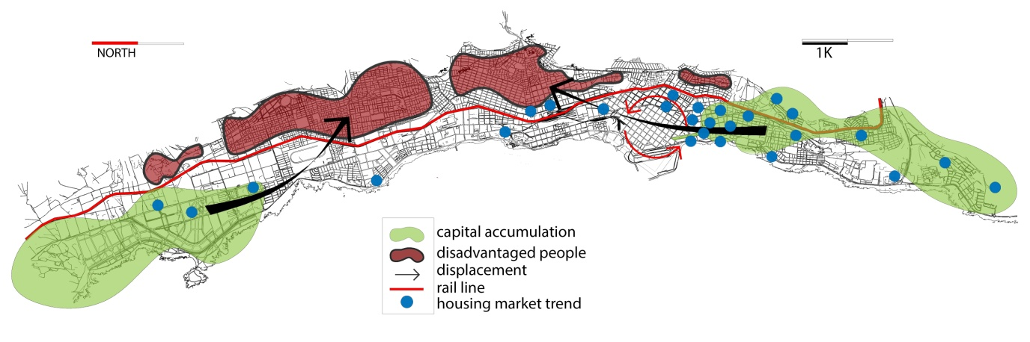
Figure 2/ cognitive map of socio spatial segregation & housing production trend.

Source: Authors elaboration
Who benefits from the mining boom, and how are these benefits spatially distributed?
The second question is partially answered through the explanation of gentrification process which follows a particular order in this case: (1) capital depreciation, (2) production of new capital (housing), (3) displacement of poor people, and finally(4) increase in socio-spatial segregation. This process not only involves social changes but, as it has been analysed, a physical change in the housing stock and variations in the land and housing market and prices (David Ley 1994 in Lees, L, Slater, T & Wyly, E eds).
The biggest winners in this process are mining-related actors and affluent residents who are favoured with premium locations and good accessibility to opportunities, as well as, developers that have found a niche, also related to the mining boom. Thus, housing supply is not very limited to the affluent, mine workers and others, since the private sector serves this demand very well. Conversely, the problem is the provision of affordable and social housing and access to opportunities and other facilities that may improve city resident's quality of life. Judith Yates (2012) mentions that this situation is exacerbated by the way in which the market operates and the unintended implications of government control.
Furthermore, there are complex set of socio-spatial processes correlated with labour patterns, influenced by mining activity. The effects of gentrification are likely to further increase the levels of segregation evident in Antofagasta. In such a way, gentrification partially explains the distribution of benefits through the city, through promotion of profitable reinvestment, especially in central areas and, the displacement of disadvantaged residents (Harvey & Potter 2009).Investors are benefiting through a circular pattern of "reinvestment / displacement" as well as mining actors who buy into the better locations and therefore have better access to services and opportunities. Those less positioned economically find themselves displaced.
Finally, it is important to explain that Antofagasta has been shaped by complex historic processes of urbanization that should be discussed in conjunction with the development of the natural resources industry in the region. Mining related infrastructure has increased segregation among residents thorough the appropriation and fragmentation of the urban landscape (the formation of gated communities for example). The rail line in particular remains the major physical and social barrier separating rich from poor. (east - west of the track respectively).
In conclusion, the place of residence in the city will most probably continue to reflect social status and access to opportunities, thus stigmatizing most of the residents in poorer areas, and entrenching poverty. Here, "living on the wrong side of the tracks" makes perfect sense, not only through its physical connotations, but it also invites urban planners to strive for better integration and inclusion through their control over land markets.
Contributions
The author hopes that the identification of inadequate mechanisms of distributive justice in Antofagasta can open the debate on the shifting role of the government in addressing social equity, and in turn contributing to existing literature on mining and urban planning.
Reference list
Burchardt, H & Dietz, K 2014,' (Neo-)extractivism a new challenge for development theory from Latin America', Third World Quarterly, Vol. 35, No. 3, pp. 468 - 486
Fincher, R and Iverson, K 2012,'Justice and Injustice in the City', Geographical research, Vol.50, No. 3, pp. 231-241.
Haarstad, H 2012,'Extracting Justice? Critical Themes and Challenges in Latin America Natural Resource Governance', in H, Haarstad (ed), New Political Spaces in Latin America Natural Resource Governance, Studies of the Americas, New York, pp. 2 - 16.
Harvey, D 2003, Towards a theory of uneven development, Uneven Development : Nature, Capital, and the Production of Space (3rd Edition) , University of Georgia Press, USA
Harvey, D 2008, The right to the city , New Left Review 53, pp.23-40.
Harvey, D 2013, Rebel cities: from the right to the city to the urban revolution, Verso, London UK.
Harvey, D & Potter, C 2009, The Right to the Just City, in Marcuse, P, Connolly, J Novy, J, Olivo, I, Potter, C and Steil, J (eds), Searching for the just city. Routledge, New York- London, pp 40-5.
Haslam McKenzie, F & Rowley, S 2013,'Housing Market Failure in a Booming Economy', Housing studies, Vol. 28, No. 3, pp. 373 -388.
Humphreys, D & Bebbington, A 2012,'Post-What? Extractive industries, narratives of development, and socio-environmental disputes across the (Ostensibly changing) Andean region, in H, Haarstad (ed), New Political Spaces in Latin America Natural Resource Governance, Studies of the Americas, New York, pp. 17 - 37.
Ley , D 1994,'Gentrification and the politics of a new middle class', in Lees, L, Slater, T & Wyly, E (eds), The gentrification reader, Routledge, London-New York, pp.134-155
OECD (2013a), OECD Territorial Reviews: Antofagasta, Chile 2013, OECD Publishing. <http://dx.doi.org/10.1787/9789264203914-en>
Slack, K 2010,'The Role of Mining in the Economies of Developing Countries: Time for a New Approach', in Richards J (ed), Mining, Society, and a Sustainable World, Springer Berlin Heidelberg, Germany, pp. 75-90
Smith, Neil 2011,'Uneven Development Redux', New political economy, Vol.16, No.2, pp. 261-265
Yates, J 2012, Australia's Unintended Cities: The Impact of Housing on Urban Development, CSIRO, Collingwood, Vic

