Infrastructure x urban precariousness:
a case study on the transformation of the physical environment in living space

The urban sprawl pattern in Sao Paulo was based on the allotment of scattered nuclei, more or less distant from the centre, connected to scarce axes where the modal infrastructures and urban services were concentrated. The growth of these nuclei generated extensive urban fabrics, predominantly residential and precariously urbanized, characterized till today by the shortage of public facilities and open spaces. In these fabrics, urban infrastructure was partially settled over public land, while the remaining properties were occupied in an informal and fragmented manner, subjected to their owners’ individual resources.
This process was specially harmful in Sao Paulo’s portion of urban sites characterized by the river plains of its originally meandering main rivers, because the transformation of the wet physical environment into urban settlement – and then later industrial settlement – was made individually, through uncontrolled landfills in parceled plots, causing a series of environmental and urban issues related to the changed hydrological regimes, flooding points, soil contamination, discontinuities in the urban fabric and land irregularities.
The urbanization works of Tiete’s floodplain, inside Sao Paulo’s municipal borders and launched at the end of the 19th century, could be seen as an exception in this course, because the rectification of a large stretch of Tiete River (1938 to 1968), together with urban land structuring, should have enabled the occupation of the new sanitized areas, which comprised 3300 hectares.
However, the purpose for this paper is to prove how the sequence of plans, projects, works and public resources invested for more than 130 years in a significant parcel of Sao Paulo’s territory weren’t capable of changing the city characteristic sprawl pattern, in which the urban infrastructure axes are juxtaposed to poorly urbanized areas. It hopes to demonstrate that, despite the construction of the metropolitan infrastructure – Tiete’s canal and marginal avenues –, the occupation process of Tiete’s floodplains by private agents was similar to the one practiced in numerous subdivisions in the city, worsened by the individual burden of adapting the physical environment to the technical industrial needs, with amplified impacts on the most vulnerable settlements, established between the larger built plots.
Therefore, it intends to analyze, in a comparative basis, the process of transformation of two stretches of Tiete’s banks, in the municipality of Sao Paulo, where there are innumerous precarious settlements with high social vulnerability indexes and flooding and contamination problems: Jardim Helena and Parque Novo Mundo.
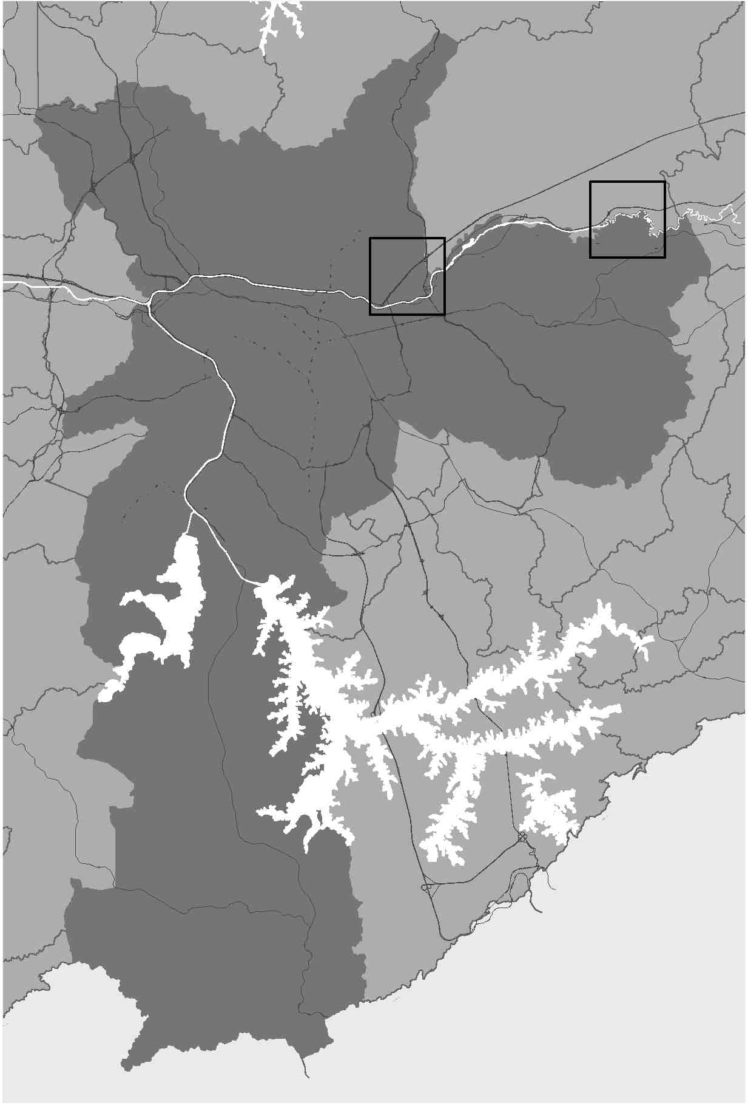
Figure 01:
Municipality of Sao Paulo: Parque Novo Mundo (Center) and Jardim Helena (East).

Jardim Helena corresponds to a swampy area in the Far East of the city, on the left bank of the non rectified Tiete`s stretch, which had its occupation propelled by the installation of an industry in the beginning of the 20th century. Parque Novo Mundo is a relatively central area, on the right bank of Tiete’s rectified canal, close to the meeting of two important national highway axes: Via Dutra and Marginal Tiete, which had its occupation enabled only after the rectification works and the execution of these roads.
The paper is supported by cartographic analysis, in distinct moments: 1930 (Sara Brasil topographic survey), 1972 (Gegran topographic survey) and 2004 (Orthophotography and MDC topographic survey). These graphic pieces will be manipulated so to highlight the occurred physical alterations (contour lines, hypsometry, water bodies, wetlands and dry lands), in comparison to the evolution and characterization of the urban occupation (urban infrastructure, land subdivision and land use). This analysis will be collated with data and official statistics, particularly in what refers to vulnerability, urban legislation and eventual plans and incidental projects.
Some of these pieces have already been prepared [see Figures 02 to 08] to formulate the issues discussed in this text and the images attached tries to illustrate, succinctly, some of the points to be considered.

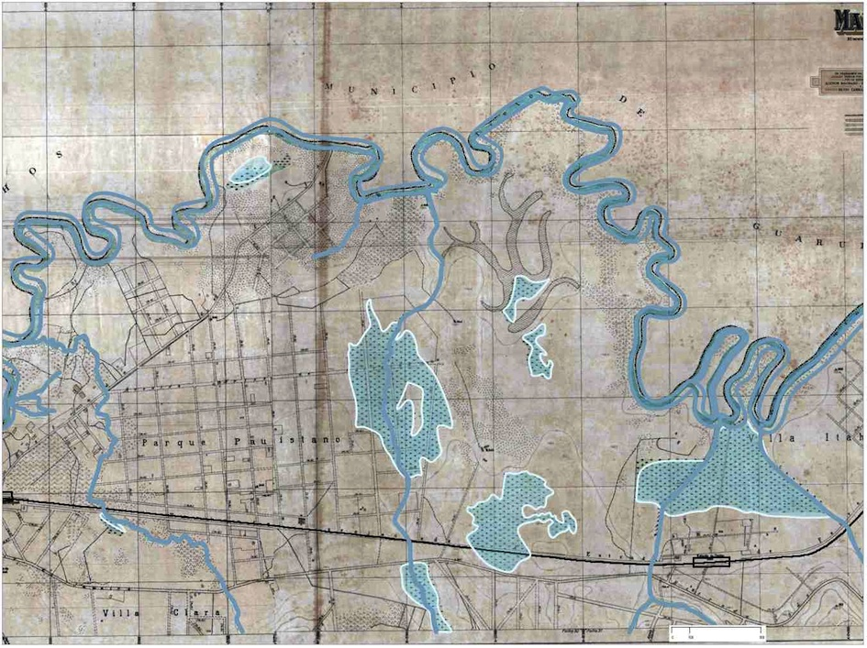
Figure 02:
Jardim Helena in 1930. At the center of the picture one can see the areas drenched along the stretch of the Agua Vermelha Stream.
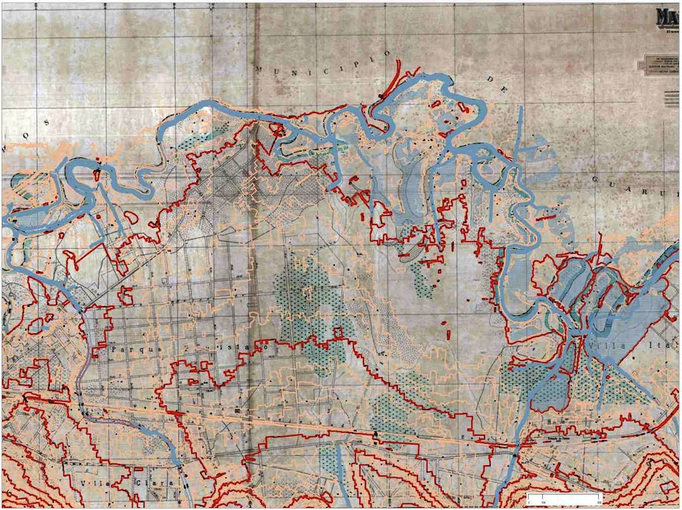
Figure 03:
Jardim Helena: overlap of today’s contour lines (2004) to the 1930’s base. Observe how the Agua Vermelha Stream axis conforms to the area’s watershed.
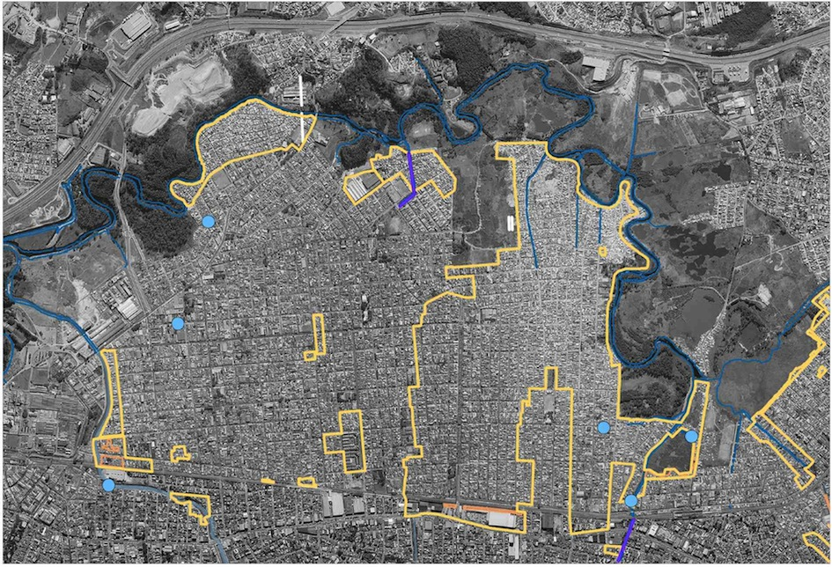
Figure 04:
Jardim Helena: the highlight areas correspond to the Social Interest Special Zones (ZEIS, in Portuguese), areas under flooding risk, in 2004.
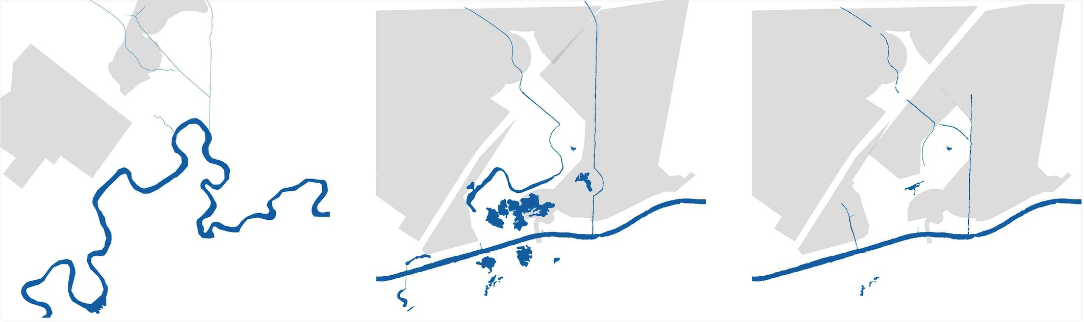
Figure 05:
Parque Novo Mundo: sequence of urban evolution in three moments: 1924, 1958 and 1972. See the radical decrease of surface water.
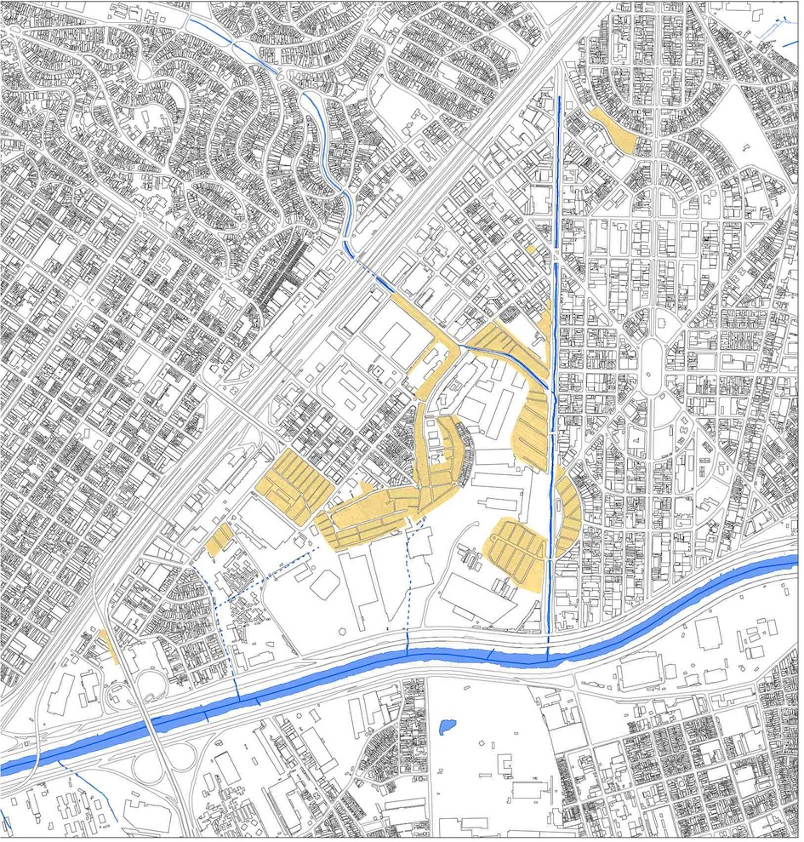
Figure 06:
Parque Novo Mundo: informal settlements in 2004.
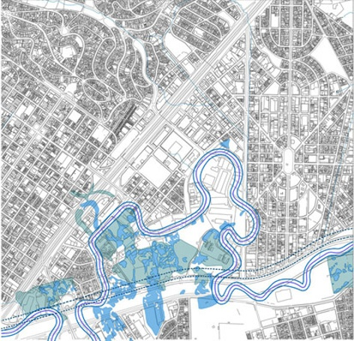
Figure 07:
Parque Novo Mundo: overlap of 1930’s hydrography over today’s base. See the correspondence between the original Tiete River riverbed (1930) and the informal settlements in 2004.

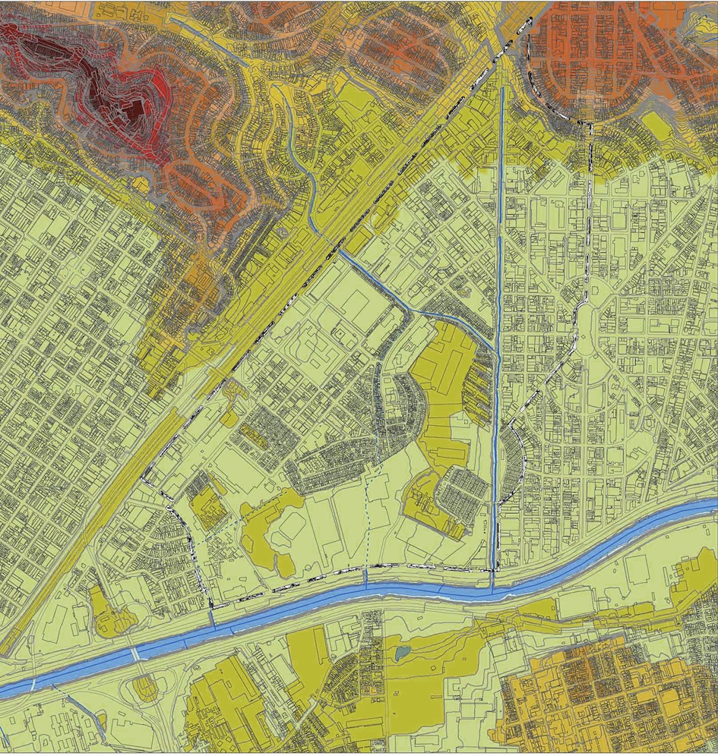
Figure 08:
Parque Novo Mundo: hypsometry in 2004.

Seventy-seven years after the beginning of the rectification works of Tiete River, the recurrence of non-executed works for Tiete’s urban axis points as one of the main interventions for the organization of Sao Paulo metropolitan space, not succeeding completely in this goal, despite the scale of the works and the resources used. By investigating these model stretches in detail, it is intended to amplify the alternative interventions repertoire, counting on the fact that these surveys and verifications can complement similar studies in the pursuit for new elements and purposeful ways that consider the desired relation between physical environment, construction of urban infrastructure and living space.

REFERENCE BIBLIOGRAPHY

AB`SABER, A. N.. Geomorfologia do sítio urbano de Sao Paulo. Cotia: Ateliê Editorial, 2007.
ARENDT, H. A condição humana. Rio de Janeiro: Forense Universitária, 2005.
AZEVEDO, A. A cidade de Sao Paulo: estudos de geografia urbana.- Vol. 1 – A Região de Sao Paulo, por um grupo de geógrafos sob a direção de Aroldo de Azevedo. Sao Paulo: Companhia Editora Nacional,1958.
BRITO, F. S. R. (1864-1929). Obras completas de Saturnino de Brito. V XIX. Rio de Janeiro : Imprensa Nacional, 1942.
DAEE. Terceiro Plano Diretor Macrodrenagem da Bacia do Alto Tietê - PD- MAT 3. Sao Paulo, 2014.
DEAK, C., SCHIFFER, S.R. (Orgs.). O processo de urbanização do Brasil. Sao Paulo: EDUSP, 2004.
DELIJAICOV, A.C.P. Os rios e o desenho da cidade: proposta de projeto para a orla fluvial da Grande Sao Paulo. 1998. Master dissertation presented at the Faculty of Architecture and Urbanism of the University of Sao Paulo. Sao Paulo, 1998.
DEILIJAICOV, A.C.P.; DIAS, C. J. D e ELWING, M. Projeto Tietê. Documento IAB-SP. Sao Paulo: PINI Editora, 1991.
FRANCO, F.M. A construção do caminho: a estruturação da metrópole pela conformação técnica das várzeas e planícies fluviais da Bacia de Sao Paulo. 2005. Doctoral thesis presented at the Faculty of Architecture and Urbanism of the University of Sao Paulo. Sao Paulo, 2005.
HOLANDA, S. B. Caminhos e Fronteiras. Rio de Janeiro: J. Olympio, 1957.
LANGENBUCH, R. A Estruturação da Grande Sao Paulo. Instituto Brasileiro de Geografia e Estatística. Rio de Janeiro, 1971.
MARX, M. Cidade no Brasil, terra de quem? Sao Paulo: EDUSP/Nobel, 1991.
NERY JR., J. M. Um século de política para poucos: O zoneamento paulistano1886 – 1986. Doctoral thesis presented at the Faculty of Architecture and Urbanism of the University of Sao Paulo. Sao Paulo, 2002.
OHTAKE, R. M. Parque Ecológico do Tietê. Sao Paulo: Ecourbs, 1976.
ROLNIK, Raquel. A cidade e a lei: legislação, política urbana e territórios na cidade de Sao Paulo. Sao Paulo: Fapesp, 1997.
SANTOS, M. A Natureza do Espaço: técnica e tempo, razão e emoção. Sao Paulo: EDUSP, 2004.
SEABRA, O.C.L. Meandros dos rios nos meandros do poder: Tietê e Pinheiros - valorização dos rios e das várzeas na cidade de Sao Paulo. 1987. 323p. Doctoral thesis presented at the Faculty of Philosphy, Letters and Sciences/ Geography Department of the University of Sao Paulo. Sao Paulo, 1987.
SILVA, L.P. Relatório apresentado pelo engenheiro chefe da Comissão de Melhoramentos dos Rios Tietê e Tamanduateí, ao Secretário de Obras da Prefeitura Municipal de Sao Paulo, compreendendo os estudos e os trabalhos realizados até 1 de janeiro de 1950. Sao Paulo: Comissao de Melhoramentos do Rio Tietê, 1950.
_____________. Sobre a rectificação do Rio Tieté em S. Paulo in Boletim do Instituto de Engenharia no. 127/ Volume 25, January to April 1.937 (pages. 10 to 15). Sao Paulo: Edições Técnicas Brasileiras, 1.937.

