The historical re-significance of the regional planning of the Vale do Paraiba and Litoral Norte of Sao Paulo state: the institutionalization of the metropolitan region and the action plan from the Sao Paulo state Macro Metropolis.

Every planning problem is first a problem of history. The historical revisions of the process planning are therefore important to recognize, over the time, the changes of situations and urban-regional issues in a given socio-spatial context, the evolution of theoretical contributions that explain and rules, guidelines and instruments for action and also to evaluate the actions planned effectively implemented.
This re-significance of the meaning of history of urban-regional space will be elaborated in this paper, through the pursuit of elucidation of the relations between the Vale do Paraiba (Sao Paulo region) transformation and the different times of the urban and regional planning process that concern, marked from 40-50 years of the twentieth century to the present day.
By means of this retrospective foray, it is intended to reach a more detailed understanding of the path that will lead to the institutionalization of the Vale do Paraiba and Litoral Norte Metropolitan Region (RMVPLN) as a "missing piece" of the territorial mosaic of Sao Paulo Macro Metropolis for validation of the Action Plan of Sao Paulo Macro Metropolis (EMPLASA, 2013) which now considers this complex socio-spatial structure as the main planning unit of the state government.
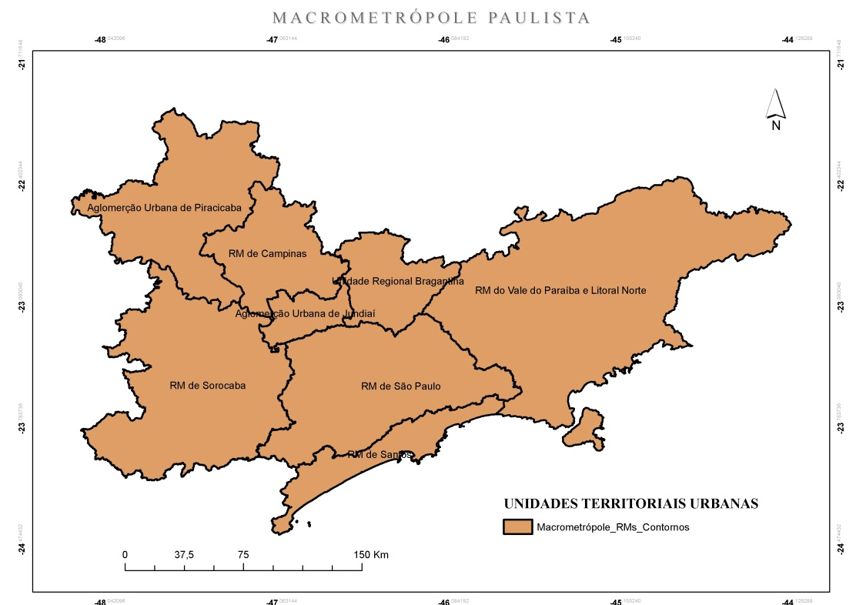
The Sao Paulo Macro Metropolis is formed by five metropolitan areas (Figure 1): Sao Paulo, Campinas, Santos and recently Paraiba Valley and Litoral Norte and Sorocaba, besides Urban Agglomeration of Jundiai, Piracicaba and Bragantina Regional Unit.

Figure 1. Sao Paulo Macro Metropolis
Source: The authors (2015)
The choice of the theme so outlined is justified by the need and importance of the construction of new basis and arguments that can support the understanding of metropolitan and urban-regional phenomenon, as well as the active participation of the university and the PLUR-UNIVAP in discussions about development of RMVPLN and its planning, considering above all the regulatory guidelines of the Estatuto da Metrópole (Brazil, 2015) in order to elaborate the integrated urban development plan, according to the principles of inter federative governance.
Is the plan of action of the Sao Paulo Macro Metropolis (PAM) only a re-translation of politic guidelines and of urban and regional planning developed throughout history by Union and Sao Paulo State?
If the formation of Sao Paulo Macro Metropolis of Sao Paulo dates back to the 50’s of the 20th century and befits an expansion and restructuring of the metropolitan space of Sao Paulo capital oriented by irradiation of the industrialization process through the main roads leading to the interior and the coast of Sao Paulo State (Sales, 1999), kept specificities of the successive historical transformation and characteristics of urban-regional space at different periods, we would not be today, once again, in front of the same political-territorial project creator of privileges and socio spatial inequalities even greater?
Given the instrumentality of the metropolitan process of space to sustain economic and technological globalization, the wicked globalization (Santos, 2000) of our days, by means of the technical and economic integration (Silva Neto, 2002) of the territory and the acceleration of socio territorial transformations to the market, what real perspectives for reversal of the historical process can be expected in the process of planning and management of RMVPLN, given the constitutional or normative premises of wide participation of society and articulation and cooperation among federal entities and with them (Moura, 2006)?
Which clashes and conciliations PAM raise during the elaboration process of Integrated urban development plan of RMVPLN?
One of the assumptions of this article lies in the tendency toward remodeling of the urban-regional space of Vale do Paraiba and Litoral Norte, enlighted by general guidelines of the macro metropolitan plan, without consideration about the global-local dialectic, meaning the indispensable economic leadership of Sao Paulo, in the detriment of precisely the construction of a social nation and territorially comprehensive project (Reschilian and Uehara, 2015); and thus a priority focus on selectivity locations and favoritism to large enterprises projects for the region, in the scope of a strategy of sectoral and ad hoc interventions fostered by the “guerra dos lugares” (War of places by Santos 1999 meaning the degree of competitiveness between them) and perpetuation of a corporate social spatial organization and fragmented model (SANTOS, 1988), segregationist and unequal.
Now, on the other hand, and paradoxically, it is understood that one cannot assume the absolute supremacy of the single thought (Santos, 2000) inherent in the design of economic globalization, trying at all costs to impose "top-down" and, nor underestimate the local order, that is, the dynamic nature of local social space systems, intelligence and local autoregulation capacity (Bicudo, 2009) processes and social practices intrinsic to the site. In that case, said the hypothesis of the progressive trend to the rise of new forces micro socialization and expression of citizens, more comparable to the state itself forces.
Required discussions, previously outlined, around this contradiction of the current movement of history will be based on bibliographic and documental theoretical contributions, such as those found in other literature on the history of the social spatial organization and economic of the Vale do Paraiba and Litoral Norte region, as well as major plans and diagnostics that came to succeed pioneering regional plan - the economic reconstruction plan of the Valley (1941). Namely: Characterization and assessment of existing knowledge on the Vale do Paraiba region and Resulting Diagnostics (CODIVAP, 1971); São Paulo Regional Plan of the Macro Axis (State Government of São Paulo, 1978), in its close link with the National Development Plan II (1975-1976) and Urban and Regional Development Politics in 1976, elaborated by the Economy and Planning Secretariat of São Paulo State (Coelho, 1998); and yet, the Macro zoning the region of the Vale do Paraiba and Litoral Norte of São Paulo State - MAVALE (Kurkdjian et al 1991.) and the most current Sao Paulo Macro Metropolis Action Plan (EMPLASA, 2013).

References

BICUDO, M. M. Padrões e singularidades. In: REIS, N. G. (Org.) Sobre dispersão urbana. São Paulo: Via das Artes, 2009, pp. 247-257.

BRASIL. Projeto de Lei no 13.089/2015. Estatuto da Metrópole, 2015. (2015). Disponível em: http://www.camara.gov.br. Acesso: 16 de out. de 2015.

CODIVAP. Caracterização do conhecimento existente sobre a região do Vale do Paraíba. Pindamonhangaba, 1971.

COELHO, L. T. K. F. Estudo Analítico das Propostas para o Desenvolvimento Regional do Vale do Paraíba-SP, de 1971 a 1991. Dissertação de mestrado, Universidade do Vale do Paraíba, São José dos Campos, 1998.

EMPLASA. PAM Macrometrópole Paulista Leitura do território.(2013). Disponível em: http://www.sinaenco.com.br/downloads/Rovena.pdf . Acesso em: 13 de nov. de 2014.

GOVERNO DO ESTADO DE SÃO PAULO. Plano Regional do Macro-Eixo Paulista. SEP-CAR, São Paulo, 1978.

KURKDJIAN, M. L. N. O. et al. Macrozoneamento da Região do Vale do Paraiba e Litoral Norte do Estado de São Paulo. INPE, São José dos Campos, 1991.

MOURA, R. et al. Institucionalização de Regiões Metropolitanas: qual o sentido? Revista Paranaense de Desenvolvimento, 111. (2006). Disponível em: http://www.ipardes.gov.br/biblioteca/docs/rev_pr_111_ponto_vista.pdf. Acesso em: 02 de dez. de 2014.

RESCHILIAN, P. R. e UEHARA, A. Y. Arranjos institucionais no Brasil – Paradoxos de riqueza e déficit social: O estudo da dimensão territorial para o planejamento e a macrometrópole paulista. ANPUR. 2015.

SALES, P. M. R. de. Santos a relação entre o porto e a cidade e sua (re) valorização no território macrometropolitano de São Paulo. Dissertação de Mestrado - Universidade de São Paulo. 1999.

SANTOS, Milton. Metrópole Corporativa Fragmentada. São Paulo, Hucitec, 1988.

_____. Por uma outra globalização: do pensamento único à consciência universal. Rio de Janeiro – São Paulo, Record, 2000.

SILVA, M. L. A interação técnico-econômica do território paulista. In: 2º Encontro Brasileiro de Estudos Regionais e Urbanos, 2002. 2º Encontro Brasileiro de Estudos Regionais e Urbanos - Anais. São Paulo: Associação Brasileira de Estudos Regionais, 2002.

