Reusing Dublin: Evaluating the utility of a crowd-sourced / web mapping tool for addressing underutilization of spaces in Dublin

Aoife Corcoran
School of Architecture, Planning and Environmental Policy
University College Dublin
aoife.corcoran.1@ucdconnect.ie

Prof. Zorica Nedovic-Budic
School of Architecture, Planning and Environmental Policy
University College Dublin
zorica.nedovic-budic@ucd.ie

Global trends such as recession (UN, 2013), climate change (IPCC, 2013), urbanization and population growth and migration, as well as increased demands on food, shelter and security (UN, 2013) are causing many economic, social and environmental problems in cities. The challenge for planners is to provide suitable, effective and timely solutions to these problems with tools to support more proactive decision making and ensure urban resilience. However, interdisciplinary exploration between resilience thinking and planning theory and practice is in its infancy (Wilkinson 2012); similarly, the application of geospatial information and communication technologies (G-ICT) to building urban resilience has been only sporadic. While literature on resilience recognizes the need for socially robust data which is locally embedded, historical and socially contingent (Weichselgartner and Kasperson, 2010), the practical examples are lacking. In addition to traditional geographic information systems (GIS) and decision support and visualisation tools, crowd sourcing, locative social media, geotagging, and geospatial analytics carry the potential to aid the planning process. Once adjusted to fit the needs of planning practice, these tools can empower a city with knowledge and intelligence by helping to identify relevant patterns and relationships and enabling citizens and planners in the process (Steenbrugen et al, 2014). This paper / presentation focuses on the development, implementation and evaluation of a prototype crowd-sourcing and web mapping application Reusing Dublin for inventory and communication about underutilized urban spaces in Dublin, Ireland.

The research objective is to examine if Reusing Dublin can support the identification of economic reuse and redevelopment opportunities that are operationalized in terms of diversity as one of the key resilience principles (Wardekker et al. 2010). The application facilitates an inclusive and interactive crowd sourcing process that gathers information on underutilized spaces and raises awareness and knowledge of this issue while engaging citizens with their locality and with one another. Methodologically, this research is based on prototype application development, implementation and evaluation. Dublin was chosen as a case study for its pronounced problem of building and site vacancy and dereliction in some of the central city areas, especially following the most recent economic crisis. The application design was based on interviews with focus groups consisting of the council planners. These were used to identify the system requirements in terms of functions, interface and relevant information that the tool will help collect.

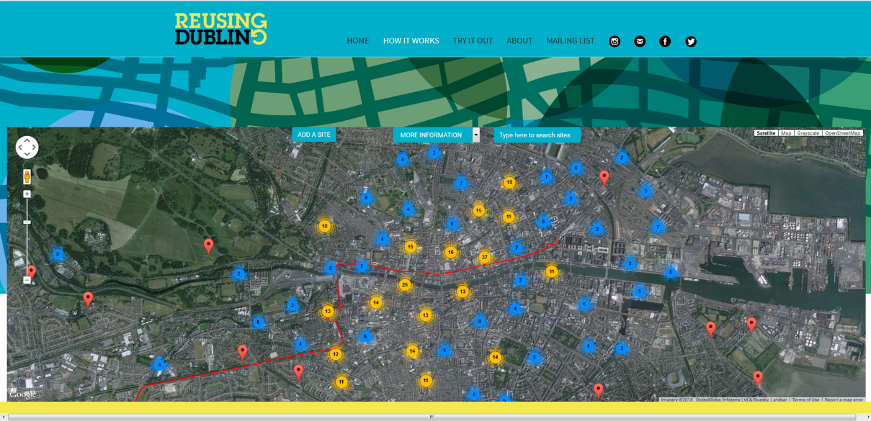

Reusing Dublin has six main functions: Discover information, Add information, Connect with others, Data layers, Search and Links to social media. Reusing Dublin was developed by Future Analytics Consulting based on a tool design concept involving a web mapping server, application and interface which allowed both data viewing and data input by the users. The software included: MySQL - Database management system; php - Web scripting language connecting the application to database; HTML - Hypertext markup language, used to develop web pages; CSS - cascading style sheet, formats design of web pages; and Javascript - web scripting language. Reusing Dublin has been operational for the past 6 months and sufficient data is collected from the local communities to enter the evaluation phase, which is currently under way, with final results expected by the end of 2015 / early 2016.

The evaluation is administered as a controlled pre-test post-test experiment, with the pre-test carried out in the design phase via semi-structured interviews and a questionnaire with local planners. The post test is carried out in a second round of focus group interviews and questionnaires following the implementation of Reusing Dublin. The data are analysed by coding and statistical analyses in order to determine if there is a significant difference in the ability to identify opportunities for resilience before and after the introduction of Reusing Dublin. The technique used to assess the change in the type and nature of opportunities identified is based on the concept of ideation suggested by Muller and Ulrich (2013). The authors discuss how using information systems can support ideation by creating virtual environments or by implementing other forms of computerized creativity support, such as brainstorming for the purpose of allowing employees and groups to explore new ideas together. Muller and Ulrich use Cougar’s (1996) creativity model to define creativity (ideation) within the IS literature. From the IS perspective creativity (ideation) can be facilitated by IS through four media: environment, person, process or product. The results of evaluation phase will show if Reusing Dublin as a product has the capacity to facilitate creative planning for underutilized urban spaces.

Reusing Dublin is an output from the EU FP7 TURAS project, which seeks new adaptive and flexible approaches to urban planning that can build social-ecological resilience in response to the convergence of crises. TURAS stands for Transitioning Towards Urban Resilience and Sustainability (http://www.turas-cities.org).

References
Couger, J. (1996c) “A Framework for Research on Creativity/Innovation in IS Organizations”, Proceedings of the 29th Hawaii International Conference on System Sciences, Maui, HI
IPCC 2013. CLIMATE CHANGE 2013, The Physical Science Basis: Working Group I Contribution to the Fifth Assessment Report of the Intergovernmental Panel on Climate Change. . In: STOCKER, T. F. (ed.). Cambridge: The Intergovernmental Panel on Ciamte Change.
Muller, S.D., and Ulrich., F. 2013. Creativity and Information Systems in a Hypercompetitive Environment: A literature Review. Communications of the Association for Information Systems, Volume 32, Article 7.
Steenbruggen, J.,Nijkamp, P., and van der Vlist, M.2014. Urban traffic incident management in a digital society: An actor–network approach in information technology use in urban Europe, Technological Forecasting and Social Change, Volume 89, Pages 245-261,
UN. 2013. The Millennium Development Goals Report. New York.
WARDEKKER, J. A., DE JONG, A., KNOOP, J. M. & VAN DER SLUIJS, J. P. 2010. Operationalising a resilience approach to adapting an urban delta to uncertain climate changes. Technological Forecasting and Social Change, 77, 987-998.
WEICHSELGARTNER, J. & KELMAN, I. 2014. Geographies of resilience: Challenges and opportunities of a descriptive concept. Progress in Human Geography.
Weichselgartner, J., and R.E. Kasperson. 2010. Barriers in the science-policy-practice interface: Toward a knowledge-action-system in global environmental change research. Global Environmental Change 20, no. 2: 266-277.
WILKINSON, C. 2012. Social-ecological resilience: Insights and issues for planning theory. Planning Theory. 11: 148-169.

