AESOP World Planning Congress 2016 in Rio de Janeiro
Abstract for Track 12: Climate Change, Resource Management, Sustainability and Environmental Justice
Authors: Botero, MEM, MPA, Detlef Kurth, Prof. Dr., Anna Sauter, Dipl.-Ing.
University of Applied Sciences Stuttgart, Germany
Schellingstr. 24, Stuttgart 70174
Lisa.botero@hft-stuttgart.de/ Detlef.kurth@hft-stuttgart.de/ Anna.sauter@hft-stuttgart.de

Living Lab “Climate Neutral Campus Stuttgart” – Transdisciplinary research for a carbon neutral inner city campus
Key words: living lab, university sustainable development, carbon-neutral campus, energy efficient campus

Climate change mitigation strategies for energy efficient cities pose a significant challenge to urban planning as a comprehensive discipline (Barker 2007; Eicker 2012, Umweltbundesamt 2012). To implement mitigation strategies, the state institutions, inclusive of Higher Education Institutions, have a special responsibility to act as a blueprint for communities. Universities in particular should not only carry out research on climate change, but also implement their research on their own university campus in the areas of energy efficient buildings, renewable energy, climate change as a topic in teaching and interdisciplinary projects, and the integration of sustainable operations and management. Such a ‘Living Lab’ can be a model for a comprehensive transformation process toward a carbon neutral city. (Schneidewind 2014)

In 2014, the state of Baden-Wuerttemberg in Germany announced its plan for so-called “Reallabore” (Living Labs) for universities to implement their research on climate change under the real conditions of municipalities (Ministerium für Wissenschaft, Forschung und Kunst 2015). The University of Applied Sciences started the Living Lab Campus Project in 2015 to create and implement a carbon neutral university. Founded in 1832 in Stuttgart’s inner city, the university campus is located only a few minutes’ walk to the main station, city centre, hospitals and libraries. The project’s approach is not only interdisciplinary but transdisciplinary in that it combines all disciplines related to climate change action, together with the members of the university and the residents and stakeholders of the neighbourhood. The following disciplines are working on a comprehensive climate protection plan for the university: Urban Planning, Architecture, Psychology, Building Physics, Geo-Informatics, Finance, Sustainability, Organizational Management.

They are are comprehensively working together to achieve the following research objectives:
- To create an energy masterplan for the campus, integrating energy, design, social and economic aspects (Oberste Baubehörde Bayern 2011)
- To integrate the university as a neighbour in the inner city, using synergies of renewable energy use, improving urban design, enabling walkable and dense neighbourhoods through use of common infrastructure in a compact city (following the model of Leipzig Charta) (EU 2007)
- To modernize campus energy systems from various construction periods
- To install or integrate renewable energy
- To implement and optimize innovative and renewable supply systems such as solar cooling and geothermal
- To monitor and improve energy management incorporating user interaction
- To develop innovative financial and participation models to finance energy refurbishment
- To transfer results into the teaching and curricula planning
- To allow for the participation of all stakeholders within the university and the surrounding neighbourhood

Climate protection planning and implementation efforts not only refer to energy efficiency, but also adequate ways of living and working in a compact and mixed-use city; thus the campus living lab project serves a potential model for combining efficiency and sufficiency in its approach. The campus has been opened to the neighbourhood and the students and employers shall be the embodiment of a sustainable working model. As the campus consists of buildings from various construction periods such as historicism (1890), modernism (1950 – 1960s) and postmodernism (1980s), the development of examples for different energy refurbishment models, combined with design protections and functionalities, are possible. In teaching, a new type of transdisciplinary project has also been established, where professors and students of different study programs work in mixed groups, supporting the research projects from the diverse disciplinary perspectives.

The first implementation steps of the Living Lab will be presented as intermediary results. Following the concept of Kevin Lynch’s “The image of the city”, an interdisciplinary studio was started to analyse the network of circulation pathways and the perception of the built environment of students from different study programs. The students created “mind maps” and prioritized certain connections. The architecture students experienced the district much more in terms of landmarks and design elements than students from informatics, which had a more metric recognition of the environment. Thus, in the next step, approaches will be developed on how to deal with these distinctive perceptions, encourage various demographics (e.g. students, employees) to use public transport and value building design, and increase compactness of the surrounding urban form.

After a design study for all campus buildings, different refurbishment scenarios based on multi-disciplinary criteria, including insulation and installation of renewable energy, are established. For some buildings, historical façades must be maintained and interior insulation must therefore be installed. Other buildings may require external insulation, which could serve as an occasion to improve the design of the façade.

The modernisation concepts for the buildings are connected with new communication strategies. New “apps” are developed that allow students and employers to understand the current energy demand of the buildings and receive recommendations for energy demand reduction. Another app allows users (e.g. students, employees) to report technical or building performance problems directly to facility management.

Through this Living Lab project, the University is an active member of the International Sustainable Campus Network, which provides further exchange of information, ideas, and best practices for achieving sustainable campus operations and integrating sustainability in research and teaching. This paper will not only present the intermediary results of the Living Lab in Stuttgart, but also give some recommendations for climate neutral campus development on campuses under similar conditions elsewhere in the world.

Bibliography
- Barker, T. et al. 2007. Mitigation from a cross-sectoral perspective. In Climate Change 2007: Mitigation. Contribution of Working Group III to the Fourth Assessment Report of the Intergovernmental Panel on Climate Change, Cambridge University Press, Cambridge, United Kingdom and New York, NY, USA
- Eicker, Ursula, 2012. Polycity: Energy Networks in Sustainable Cities.
- European Union, 2007. Leipzig Charter for Urban Development Policy
- Ministerium für Wissenschaft, Forschung und Kunst 2015: Reallabore. https://mwk.baden-wuerttemberg.de/de/forschung/forschungspolitik/wissenschaft-fuer-nachhaltigkeit/reallabore/
- Oberste Baubehörde Bayern 2011: Leitfaden Energienutzungsplan, Oberste Baubehörde im Bayerischen Staatsministerium des Innern, München
- Schneidewind, Uwe 2014: Urbane Reallabore – ein Blick in die aktuelle Forschungswerkstatt. In: Planung neu denken (pnd-online) III/2014, RWTH Aachen
- Umweltbundesamt 2012. Klimaschutz in der räumlichen Planung, Gestaltungsmöglichkeiten der Raumordnung und Bauleitplanung, Praxishilfe, Dessau-Roßlau

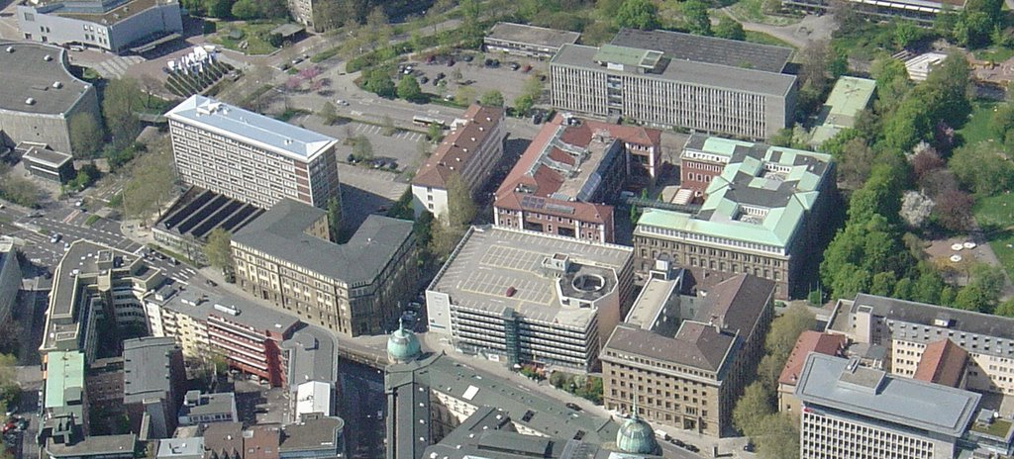

Picture: Aerial view of the inner city campus Stuttgart with different building types

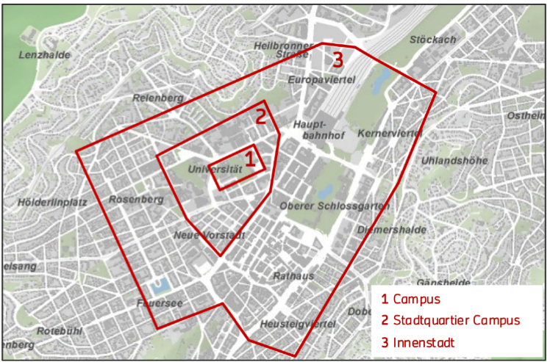
1. Campus
2. Campus City Quarter
3. Inner city

Picture: Location of the campus in city centre of Stuttgart

