CONVIVIAL URBAN SPACES: THE CASE OF SAKARYA STREET, ANKARA (TURKEY)

Res. Assist. Zeynep MURAT ÇOLPA (PhD Student), The Department of the City and Regional Planning, Middle East Technical University, Ankara. (zeynep.murat@metu.edu.tr)
Assoc. Prof. Dr. Emine YETİŞKUL ŞENBİL, The Department of the City and Regional Planning, Middle East Technical University, Ankara. (yetiskul@metu.edu.tr)
Res. Assist. Aylin ÇELİK (PhD Student), The Department of the City and Regional Planning, Middle East Technical University, Ankara. (celik_aylin@yahoo.com.tr)

This study focuses on the necessity of socio-spatial experiences of people, which are gained from public space specifically from streets that are subject to urban design approaches. Besides analysis of geographical, physical and managerial dimensions of the place, that are associated to urban design and planning processes, it reveals the deficiencies about including the psychological effects on the place on people via their senses, in other words, the information gathered through experiences to design process. By this way, it aims to explain the structure of the relationship between daily experiences of people and spatial formation of a street, and public life and public place. Hence, this research is structured with Convivial Urban Design approach, which brings together the emotions and psychology of people along with these kinds of urban design.

In this context, Sakarya Street which is located in the centre of Kızılay, Ankara (Turkey) is investigated. Kızılay has gained importance as a new bureaucratic and politic centre after proclamation of the republic, however, the period after 1980, covers the course which is determinant for consumer policy. Although, people were actively spending their time at Kızılay, car centred design approaches had changed it into a place where the main transportation type is transformed from pedestrian to motor vehicles. The Sakarya Street, which is the one of the main arterial of the city centre, has conserved its importance as being one of the limited pedestrian streets that appealing to people of various portions of city with respects to different age and gender from past to present. This importance of the change is analysed in terms of conviviality. With the help of the questionnaire developed with five different convivial criteria, and its results are examined in this study in detail. Adoptable convivial space recommendations are given at the end of the study to enlarge urban design approach to a new level.

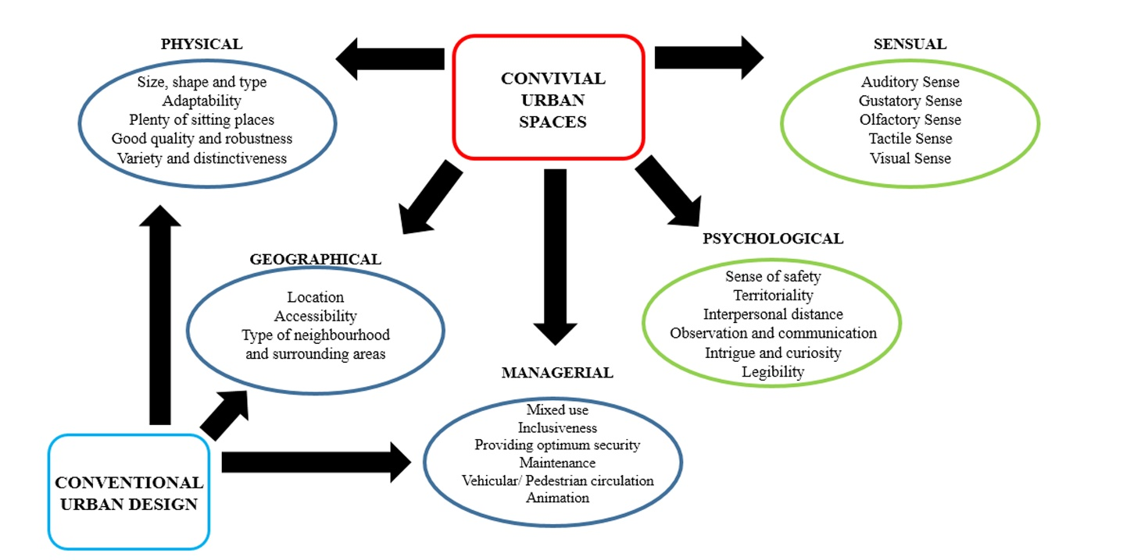
Criteria of a Convivial Urban Space

Study is constructed with a case study method which compose of observations, photographs, in-depth interviews, cognitive maps and questionnaires at the place. Sakarya Street, as a part of one of the most important and crowded pedestrian zones of Ankara, is selected as the sample area for the analysis to the field research. Sakarya Street is chosen for this study because it consists of both the historical and social background which has a great importance for citizens of Ankara.

This study analyses the conviviality of Sakarya Street (Ankara). In this manner, the research aims to develop an analysis method for evaluation of conviviality of the urban space. For this purpose, an extensive literature review has made according to theories’ and along with their backgrounds. As per the theoretical background of this study, approaches examine urban space with regards to five main dimensions has been adopted under the main headings of geographical, physical, managerial, sensual and psychological. In this manner, one of the main street of Kızılay is selected (Sakarya Street) as it has been changing since early 1800s in terms of urban development dynamics in line with modernization of Ankara. To better understand and analyse the changes Sakarya Street and how it has encountered during these changes, the method of interviewing is used.
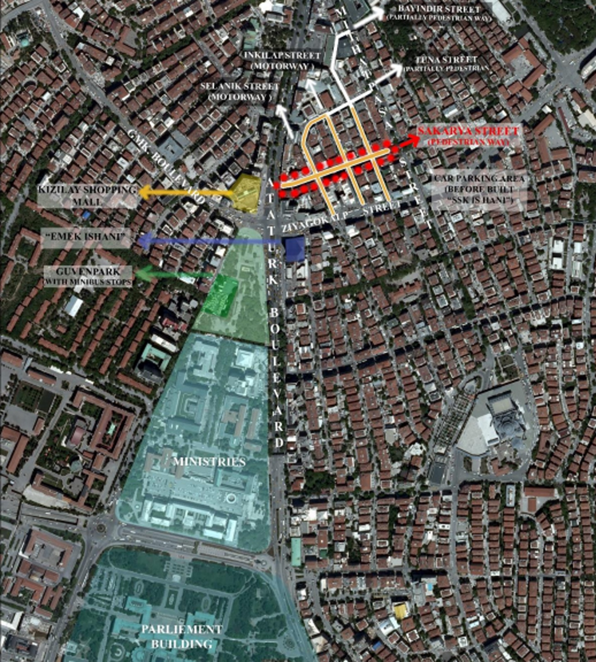

Although in the first plans made after Ankara became the capital of Turkey (Löcher Plan in 1924 and Jansen Plan in 1932), the street was planned as a green and pedestrian area, it took long time to actualize it. With Height Regulation of buildings made in 1960s, there were additions to the buildings around Atatürk Boulevard and Sakarya Street was also affected by these changes. These Height Regulation plans caused the buildings in Sakarya Street have average 6 floors. Pedestrianization took place at the end of 1970s. On the other hand, due to existence of various gastronomy units on the street. It was the most preferred place for eating and having a drink and spending their free time for citizens. There were scent smells and variety of colour due to the flowers in 1980s, which creates a distinctness from other streets. The street addresses different types of users with its fishers and doner shops (traditional food) in addition to other shops, which gives the street the value of today. At the end of 1980s, the centre moved towards Tunalı Street from Kızılay due to the increasing number of residences reaching out towards the borders of the city and the increasing shopping malls. In this period, Sakarya Street become a place for middle income users. The number of users and the variety of them has increased after 1997 with the subway coming into service. In today’s Kızılay, the number of pedestrian areas has decreased due to the car-oriented urban approaches. Even Sakarya Street has experienced some physical changes through its history, it maintains its conviviality thanks to its uses and activities it has and the place in peoples mind.

Sakarya Street has been continuously changed; however, its distinctiveness, arising from the customers looking for traditional taste, doner and special taste, fish, attracts people from past to present. Its identity on gastronomy becomes positively memorable and attracts new as well as old customers, which makes Sakarya Street a convivial space. A variety of opportunities to eat and drink and some performances and shows on the street give people the sense that they are in a unique place. Pleasant aromas of flowers on the flower shops affect the attractiveness of Sakarya Street. Different people are affected by different combinations. Some are drinking cafes and observing other people; some stops for a glass of beer. People attract people and streets with a lively environment are more likely to appeal to more people and new visitors. When users find a piece that belongs to themselves, then they adopt to place with their experiences and continue to use it. In this case, senses and psychologies of users are connected to the conviviality of the place, beyond the geographical, physical and managerial dimensions of the place.

It is not logical to expect that all of the elements mentioned above fit to a space to be convivial, but, a number of these elements will enough to contribute to this course. Furthermore, the route to be followed while combining these qualities to create a pleaser and healthier environment also does not come from a formula. However, there are some objectives to be fulfilled such as sufficient lighting, even pavements, adequate locations for seating and chatting. Although people have different choices of combinations, there are some basic characteristics as indicated above that will be welcomed by mostly everyone. In conclusion, this study aims to analyse the conviviality along with its identifying elements of Sakarya Street by examining the effects of the street of users in terms of senses and psychology of the people. As being the primary pedestrianized place of Ankara through its history, the research showed that the street has a well-defined structure and identity as per its social dimensions as of today. At this juncture, the conviviality criteria that are composed in the scope of this study can be used for further urban design studies.

References: Murat Çolpa, Z. (2015). Convivial Urban Spaces: The Case of Sakarya Street, Ankara. (Master’s Thesis). Middle East Technical University, Department of City and Regional Planning, Ankara.

