Reflections on the Ideas of the ‘Occupy Estelita’ Protest in Brazil

Abstract
The purpose of this paper is to shed light on one of the many faces of the public protests in Brazil –Ocupe Estelita (Occupy Estelita), an urban occupation movement in the city of Recife whose focus centres around an urbanization model that its citizens desire for the city.
In 2013, Brazil was rocked by numerous protests in at least 11 major cities. The protests, also known as Manifestações dos 20 centavos (20 Cent Demonstrations), first began in June when the city and state of São Paulo increased transportation fares by 20 centavos (roughly USD$0.09).
The protesters’ cause erupted and expanded to include other issues, and Brazilian streets flooded with hundreds of thousands of protesters, especially after heavy police repression was used against them. They protested on a host of issues, out of frustration with government policies, and it was out of these public demonstrations that a new slogan "It’s Not Just 20 Cents" emerged.
Brazilians took to the streets demanding more from their government – better public services, urban transit, education, health care and security -- instead of overspending on the 2014 FIFA World Cup and prioritizing a mega-event over the basic needs of its citizens.
These demonstrations constitute the largest collective action of ordinary citizens in the country since the impeachment of President Fernando Collor de Mello in 1992; they led to major national and international repercussions, with similar public demonstrations being held by Brazilians living abroad in countries such as Portugal, France, Germany, and Canada.
Furthermore, as equally relevant as the movement organizers is the role of social networks like Facebook and Twitter in organizing the outcry, in keeping protesters in touch with one another, and in providing real-time updates.
Of all the major and ever-growing protest movements, one in particular has caught the attention of social media all over Brazil – Ocupe Estelita, an urban occupation movement in the city of Recife, which focuses on urbanization and cityscapes, and on creating a model of social planning based on the wishes of its citizens.
Ocupe Estelita is a public demonstration around the José Estelita Pier, a 100,000 square-metre area in the Historic Centre of Recife, which is threatened by the construction of a large high-rise project called Novo Recife. The pier included lands belonging to the federal railway. The now-abandoned structures – storage sheds, office buildings, storage silos, former staff residences, railway tracks, and trains – bear witness to the rise and fall of the port’s industrial life. In addition to these buildings, which belonged to the now-defunct Rede Ferroviária Federal Sociedade Anônima (RFFSA) (the Federal Railroad Network), this strategic area is surrounded by historical buildings such as the São Thiago das Cinco Pontas Fort, the Church of São José do Ribamar, and the Church of São José.
In 2008, this area belonging to the Federal Railroad Network was auctioned off to the private sector and purchased by a consortium of four large real estate companies in Recife. The consortium developed a high-rise project for the area called Novo Recife (New Recife). Broadly speaking, the Novo Recife project consists of an enormous grouping of about twelve 40-storey towers with multiple uses, including residential, office, commercial and hotel.
People from Recife decided to oppose the proposed project and protect the historical buildings by camping out in the area and fighting for a better proposal for the city, and especially for the need for discussion and clarification around the project. Ocupe Estelita (Occupy Estelita) emerged as a large-scale, peaceful resistance movement and a cultural manifestation, which is growing in size and cultural importance. It became massive, exposing important information and ideas about the proposed project and spreading its message of "the Right to the City." Since then, the proposed project site has became the centre of a series of discussions regarding not only the proposal but also the entire city, culminating in a series of protests.
The intent of this paper is to examine the Ocupe Estelita movement, one of the many faces of the protests in Brazil: to explain how it became Resiste Estelita, a resistance movement spurred by the violent expulsion by police of protesters from the José Estelita Pier; to explore the tactics used by the movement to spread its message and strengthen its ability to share relevant facts and ideas; and to discuss the importance of "the Right to the City."

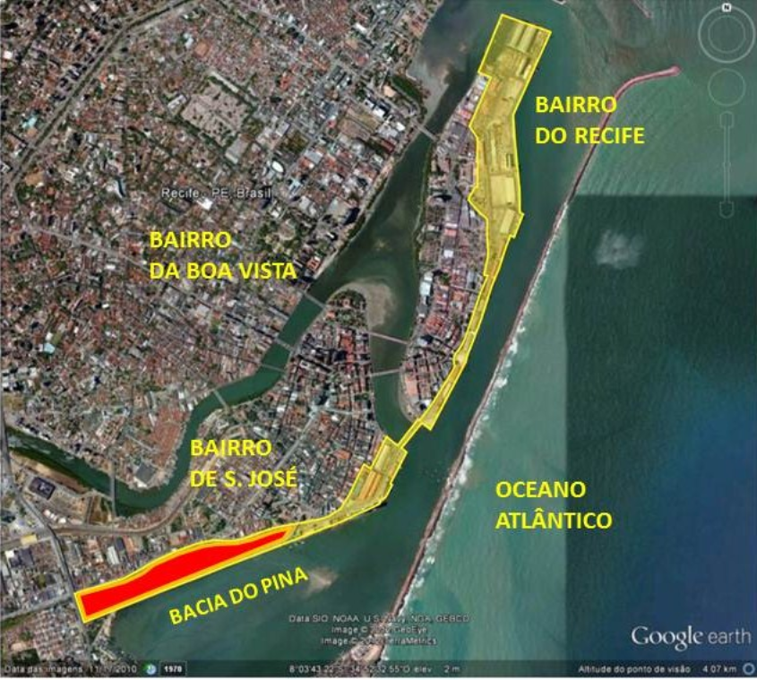 | 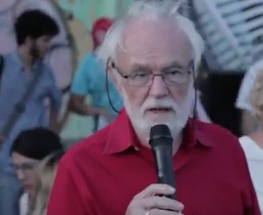
Figure 1: Aerial view of Recife's central area. In yellow is the old port area, and in red is the José Estelita Pier.  Source: Author's drawing based on Google Earth image (2015) | Figure 2: The geographer David Harvey at the #OcupeEstelita site on November 16, 2014.  Source: David Harvey @ #OcupeEstelita. In https://www.youtube.com/watch?v=DxW- lnT8XHk

"The right to the city" is an idea and slogan that was first proposed by Henry Lefebvre in his 1968 book Le Droit à la ville – espace et politique (Paris: Editions Anthropos, 1968). It refers to the demand and the right for a transformed and renewed urban life, a right to change ourselves by changing the city.

