Spatial planning and information technology: An ontology-based approach.

Miltiades Lazoglou, Demos C. Angelides
Department of Civil Engineering, Aristotle University of Thessaloniki, Thessaloniki, Greece
*Corresponding author: E-mail: mlazoglou@civil.auth.gr, Tel +30 2103220045

EXTENDED ABSTRACT
Over the last three decades, the development of computer-based technologies has open unprecedented opportunities for knowledge building, design, evaluation and decision-making support in spatial planning. Spatial data technologies (e.g., geographic information systems, geographic positioning system) increased the availability of spatial information.
Modern spatial planning approaches require integration, interpretation and representation of knowledge (Zhu et al., 1998). These needs can be addressed by computer-based systems, which are becoming an important tool for the decision-making process in spatial planning. Amongst the most popular research area of computer-based systems are the Spatial Decision Support Systems (SDSS). These systems aim to facilitate both experts and stakeholders throughout decision-making processes (Zhu et al., 1998) by taking into consideration varying parameters (e.g., institutional, urban, social, economical). However, traditional SDSS fall short of dealing with spatial problems that may be either semi-structured or may contain parameters that are difficult to be modeled due to uncertainties (Jankowski & Nyerges, 2001; Sikder, 2009).
Integrating the above systems with systems that use state of the art tools and new resources is a direction towards overcoming the above problems (Fischer, 2006; Sikder, 2009). This integration leads to Knowledge-Based Decision Support Systems (KBDSS) and constitutes a dynamic research area that has acquired impressive importance during the last three decades (Sikder, 2009). KBSDSS are based on artificial intelligence methods and techniques to: (i)specify the problem, (ii)select the appropriate data, (iii)evaluate the solutions, (iv)assess the reliability of results (Huang, 2009).
A KBSDSS comprises four parts: a set of ontologies, an ontology editor, an ontology engine and a web-portal (Figure 1). The web-portal offers a wide range of services, the most important among them is the provision of the means for the users to communicate with the KBSDSS. Publishing and annotating, geographic information services online require the design of a registry named Ontology editor, which increases the semantic interoperability of the proposed KBSDSS. Ontology engine includes a reasoner used to facilitate solving the spatial problems. The core of KBSDSS is represented by the ontologies, which have the role of both knowledge repositories and semantic reference systems.
The term ontology was introduced by Aristotle at 340 BC to represent physical entities through concepts, relations and rules (Kohli et al., 2012). Variations exist in defining the term ontology, but the common idea has been to create a “shared perception of the domain of interest to facilitate information exchange” (Winter, 2001; Kohli et al., 2012). Key characteristics of ontologies are that they (i)represent semantically already existing knowledge, (Boskovic et al., 2010), (ii)facilitate knowledge sharing, geospatial interoperability and information acquiring (Fonseca et al., 2002; Viktoratos et al., 2015), (iii)provide the means to model the workflows of problems examined (Jung et al., 2013), (iv)are used as a vocabulary defining the exact meaning of specific terms (Kohli et al., 2012), (v)are used as the base where knowledge can be built (Kohli et al., 2012), (vi)are used to organize a concept at the level of knowledge and semantics; therefore, they could be reused, shared or extended easily (Viktoratos et al., 2015). The most popular language to design an ontology is OWL (Berners-Lee and Hendler, 2001). An OWL ontology is composed of a combination of classes, individuals, properties, and axioms.
This paper presents a methodology to organize into an ontology an institutional framework related to tourism land uses. The ontology proposed provides an interface that can be applied to support decision-making process in spatial planning, through assessing current institutional framework, environmental factors and infrastructure availability. The ontology considered in this investigation consists of six land-use categories that constitute the ontology’s classes (land use control areas, urban development control areas, infrastructure, housing areas, protected areas, tourism areas) (Figure 2). Each class can be analysed further into sub-classes. Specifically, the land use control areas class is considered to include twenty-one sub-classes, the urban development control areas class could consist of five sub-classes, the infrastructure class could include nineteen sub-classes separated in social and technical infrastructure, the housing areas class could contain fifteen sub-classes separated in formal and informal forms of housing, the protected areas class could consist of forty-four classes, and finally the tourism areas class could include six sub-classes (Figure 3).
The ontology proposed was designed in the Ontology Web Language (OWL) (Nardi & Brachman, 2003) using the Protégé, an open-source ontology editor developed on Java by the Medical Informatics Department of the University of Stanford (Noy et al., 2003).
Organizing the data related to the tourism activities could be a crucial matter for example in Greece, especially nowadays that the funds available are limited; therefore, the need to design a well formed spatial planning framework could be considered imperative. The ontology proposed here improves both reliability and effectiveness of tourism activities by facilitating the decision-making process. Consequently, a secure environment can be formed for investments under the priorities of sustainable tourism development.

ACKNOWLEDGEMENTS
This research was generously supported by ΙΚΥ Fellowships of excellence for postgraduate studies in Greece – Siemens Program.

REFERENCES
Berners-Lee, T., & Hendler, J., (2001). The Semantic Web. A new form of Web content that is meaningful to computers will unleash a revolution of new possibilities, Scientific American Magazine, 284(5), 1-5.
Boskovic, M., Bagheri, E., Gasevic, D., Mohabbati, B., Kaviani, N., & Hatala, M. (2010). Automated staged configuration with semantic web technologies. International Journal of Software Engineering and Knowledge Engineering, 20(4), 459–484.
Fischer, M.M., (2006). Expert systems and artificial neural networks for spatial analysis and modelling. Spatial Analysis and GeoComputation: Selected Essays, 61-76, Berlin Heidelberg, Springer.
Fonseca, F., Egenhofer, M., Agouris, P., Camara, C., 2002. Using ontologies for integrated geographic information systems. Transactions in GIS, 6(3), 231–257.
Huang, H. C. (2009). Designing a knowledge-based system for strategic planning: A balanced scorecard perspective. Expert Systems with Applications, 36(1), 209–218.
Jankowski, P., & Nyerges, T. (2001). GIS-supported collaborative decision making: Results of an experiment. Annals of the Association of American Geographers, 91(1), 48-70.
Jung, C.T., Sun, C.H., Yuan, M., 2013. An ontology-enabled framework for a geospatial problem-solving environment. Computers, Environment and Urban Systems, 38, 45–57.
Kohli, D., Sliuzas, R., Kerle, N., & Stein, A. (2012). An ontology of slums for image-based classification. Computers, Environment and Urban Systems, 36(2), 154–163.
Nardi, D., & Brachman, R. J., (2003). An Introduction to Description Logics. Description logic handbook, 1-40.
Noy, N. F., Crubézy, M., Fergerson, R. W., Knublauch, H., Tu, S. W., Vendetti, J., & Musen, M. A. (2003). Protege-2000: an open-source ontology-development and knowledge- acquisition environment. In AMIA Annu Symp Proc, 953.
Sikder, I. U. (2009). Knowledge-based spatial decision support systems: An assessment of environmental adaptability of crops. Expert Systems with Applications, 36(3), 5341–5347.
Viktoratos, I., Tsadiras, A., & Bassiliades, N. (2015). A context-aware web-mapping system for group-targeted offers using semantic technologies. Expert Systems with Applications, 42(9), 4443-4459.
Winter, S. (2001). Ontology: Buzzword or paradigm shift in GI science?, International Journal of Geographical Information Science, 15(7), 587–590.
Zhu, X., Healey, R., & Aspinall, R. (1998). A Knowledge-Based Systems Approach to Design of Spatial Decision Support Systems for Environmental Management. Environmental Management, 22(1), 35–48.

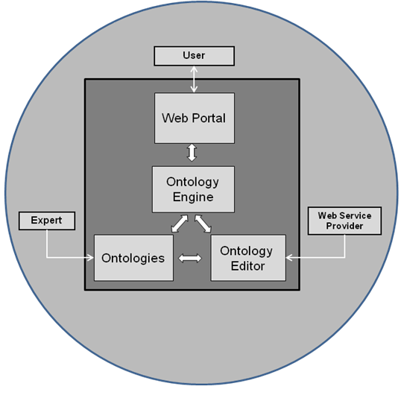
Figure 1. The main elements of a KBSDSS.

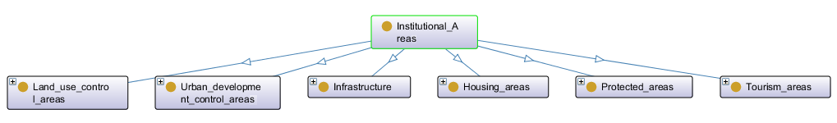
Figure 2. Classes of the ontology.

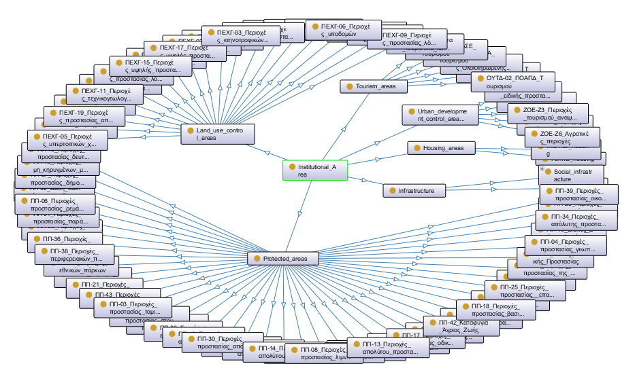
Figure 3. Classes and sub-classes of the ontology.

