As the largest city in China, Shanghai has witnessed a rapidly increasing floating population. Compared with the central city and the outer suburban area, the periphery of Shanghai has been the area with the fastest growth of floating population. Due to its location, relatively low housing prices, and job opportunities, the periphery of Shanghai has accommodated many migrant workers. As a vulnerable group with relatively low income, these migrant workers’ daily travel patterns are quite different from other city dwellers. This paper focuses on trip mobility of residents in migrant community on the periphery of Shanghai metropolitan area. The research tries to figure out: (i) to what extent the trip mobility of immigrants is deprived; (ii) what cause the deprivation; (iii) how can things be improved.
Seven migrant communities on the periphery of Shanghai were selected as case studies. In each community, the overall population is more than 10,000, the land area is more than one square kilometer, and the percentage of floating population in total population is more than 80%. In order to evaluate the deprivation level of the migrant’s daily travel, seven other local communities with similar locations and population sizes were selected as control groups. As opposed to the migrant communities, percentages of local hukou residents in these communities are over 80%(Figure 1).
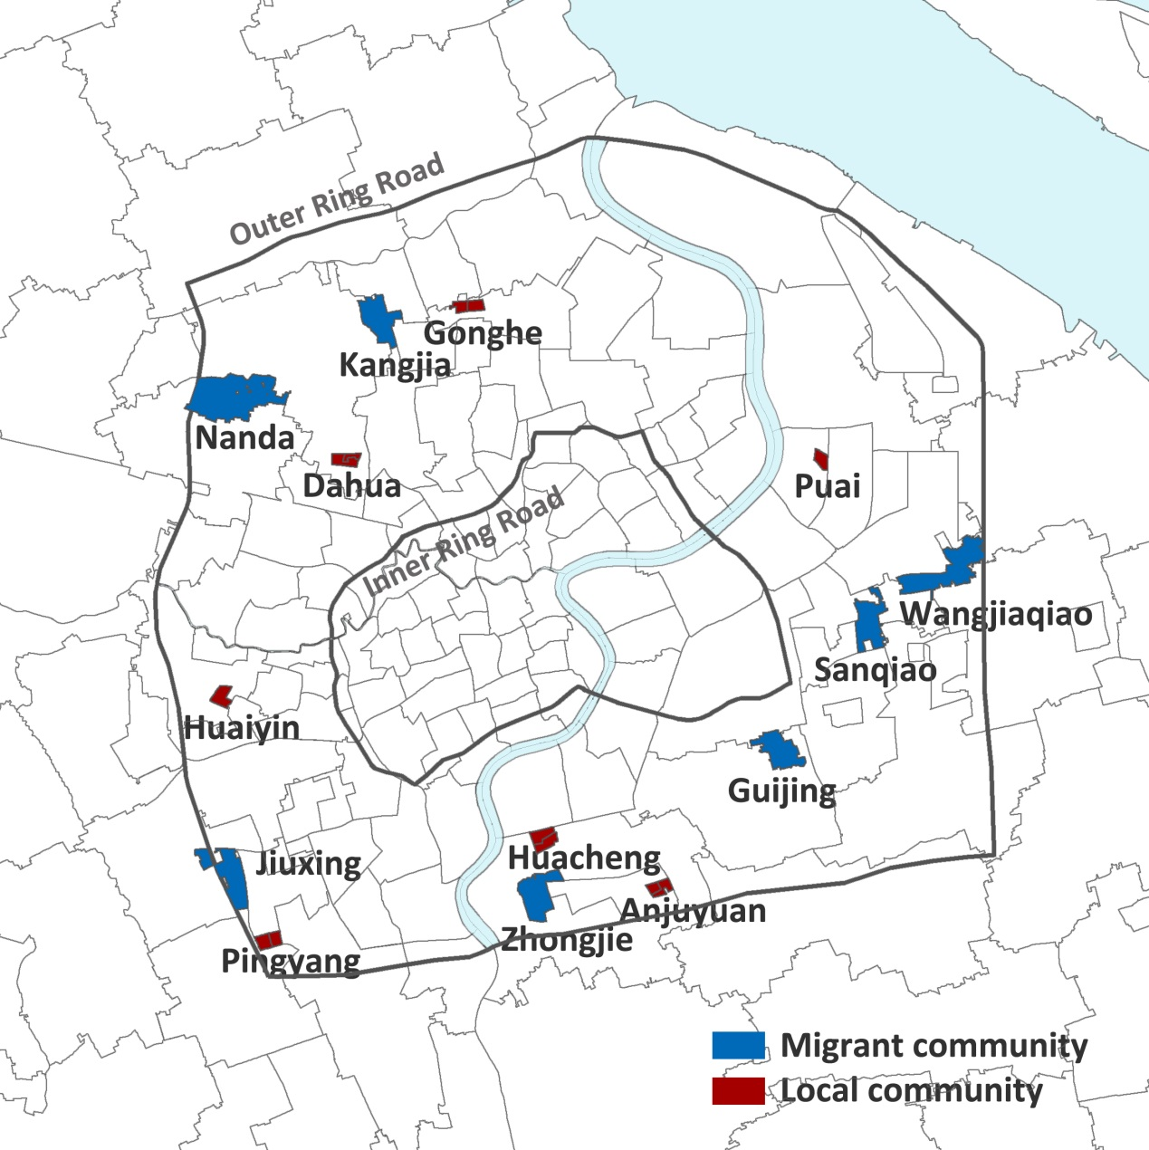
Figure 1 Spatial layout of selected migrant and local communities in Shanghai
Mobile phone signaling data, questionnaire survey data and the Sixth National Population Census data were adopted as data source in the research. This in-depth research of trip mobility deprivation of migrant community is conducted through a comparative research of migrant and local communities.
First, to evaluate the deprivation level of trip mobility, commuting distance, commuting area and commuting mode are selected as the main indicators. Mobile phone signal data and questionnaire survey data were analyzed. The results show that: (i) local people travel much further than immigrants each day and the average commuting distance for migrant residents is 2004.7m while 3522.6m for local residents. (ii) in total, the commuting area of migrants is much smaller than that of local communities (Figure 2), and the average area of the migrant communities is only 41.07% of the local. (iii) non-motorized vehicles and walking are the commuting mode chosen by 66.9% of the migrants while 87.8% of local residents choose public transit and private cars for commuting.
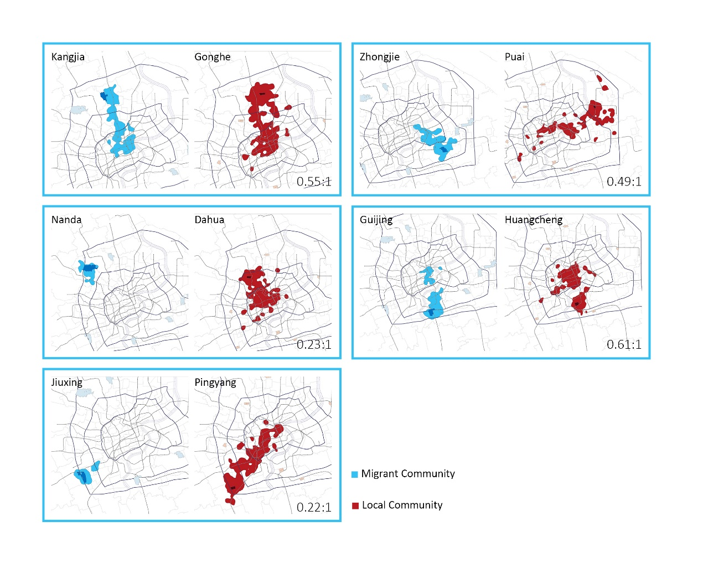
Figure 2 Comparison of commuting area of migrant community to local community

As for the cause of trip mobility deprivation, there are two categories of factors that affect residents’ daily travel patterns. Individual condition is one of the two categories. Residents’ individual conditions and their daily travel distance were inquired through questionnaire survey. Correlation analysis was conducted to figure out that age, hukou, education, vocation and income are the five individual condition factors that significantly correlated to residents’ daily travel distance. The second category is transportation supply level. In this category, road supply level and public transport supply level of all 14 communities were measured. The indicator of road supply is network density. And the result shows that the average network density with in 1km range of the migrant communities is only 74.1% of the local communities. The research on public transportation supply focuses on two domains, metro and bus. All the public transport stations within 1km range of the community were rated. There are three indicators to rate the public transport station: distance to the community, amount of lines that call at the station, and whether it is in the commuting areas. It is found that the number of bus stops around the migrant communities is 76.7% of that of the local ones nearby. Subway accessibility is generally low around migrant communities, and three of the seven migrant communities studied have no access to metro stations at all. The public transit supply score for migrant communities is only 59.4% of that of the local ones. Correlation analysis shows that metro supply level and road network density are significantly correlated to average daily travel distance of the residents in each community. The difference of transportation supply policy between different type communities clearly resulted in the deprivation of migrant workers’ trip mobility.
In the last part of this paper, several policy implications were derived. An inclusive transport system for migrants is suggested instead of an exclusive one, including a more biker-and-pedestrian-friendly road environment and a better engagement between public transport stations and immigrant settlements. Besides, subsidies for public transportation are suggested to encourage immigrants to take bus and metro. And the subsidies should go straight to residents in light of previous unsuccessful cases.

