Abstract
A Spatial and Longitudinal Analysis of Unmet Transportation Needs During Hurricanes Katrina and Rita
Kenneth Joh¹, Alexandria Norman² and Sherry I. Bame¹

¹Department of Landscape Architecture & Urban Planning, Texas A&M University
3137 TAMU, College Station, TX 77843-3137 USA

²Gunda Corporation, Houston, TX 77036 USA

Problem Statement
Hurricanes Katrina and Rita had a tremendous impact on transportation infrastructure and services in the United States. While other parts of the world have suffered greater losses from natural disasters, Katrina and Rita rank among the deadliest and costliest natural disasters in U.S. history (NOAA, 2014). They ravaged the Gulf Coast of the United States within a three-week period, with landfall first on August 29 then September 24, 2005. These disasters led to the largest mass evacuation in U.S. history, strained the region’s transportation infrastructure and services, and tested the effectiveness of state emergency management offices to respond to calls for transportation needs. Although there is a growing literature on the impacts of natural disasters on transportation infrastructure (Freckleton et al., 2012; Szyliowicz, 2013; TRB, 2008; Wolshon et al., 2005), there is scant research on emergency response to transportation needs, particularly unmet needs of disaster victims who face barriers to affordable transportation and services.
Objectives
This study fills this important gap through an unprecedented analysis of transportation-related 2-1-1 (non-emergency) disaster call data collected in real-time during the period of the hurricanes, allowing for the investigation of unmet transportation needs by location and disaster phases. We conducted a spatial and longitudinal analysis of 2-1-1 transportation-related calls in the US state of Texas to identify “hot spots” of unmet transportation needs. By analyzing these calls for unmet transportation needs over location and time, we can determine where help was needed to overcome access barriers in relation to the counties impacted by the disasters, and which phases of the disasters had greater barriers to transportation access. This provided a unique opportunity to investigate unmet transportation needs in real-time, unbiased by recall, previous experiences or perspectives.

Methodology
We analyzed 25,032 transportation-related calls recorded by the Texas 2-1-1 Network during the study period (August 1, 2005 through December 31, 2005). We examined calls for transportation needs: 1) spatially in terms of a) volume of Texas 2-1-1 transportation unmet needs per Texas county (N=254 counties) and b) number of these needs adjusted by population size; and 2) longitudinally as daily transportation need demands received during the 5-month study period and compared by disaster phase. Demand for unmet transportation needs was mapped according to: a) volume of 2-1-1 calls for these needs and b) ratio of unmet transportation needs per population size measured as number per 100 households per county. Additionally, longitudinal variation in the volume of transportation needs were examined, spanning from a 4-week baseline prior to Hurricane Katrina, evacuation and landfall of both hurricanes, immediate recovery, through three months recovery post-Rita until the end of the calendar year.
Results
The spatial analysis showed that the volume of transportation-related unmet needs were concentrated in the major metropolitan areas of Texas, accounting for 66 percent of 2-1-1 calls (see Figure 1). The volume of 2-1-1 transportation-related calls also followed major evacuation routes (see Figure 2). However, after adjusting for population size, the areas at greater risk for vulnerable populations experiencing unmet transportation needs were rural counties in Southeast Texas along the Louisiana border, urban Harris County (Houston), and the coastal metropolitan areas of Beaumont-Port Arthur and Victoria, comprising those areas closest to the impact of the Hurricanes (see Figure 3).
The longitudinal analysis showed considerable differences in call volume between routine baseline levels and acute disaster phases (see Figure 4). There were a relatively low number of calls during the four-week baseline period prior to Hurricane Katrina landfall. After the relocation of Katrina victims from Louisiana to Texas, the volume of unmet transportation needs rose sharply. Calls for unmet transportation needs peaked again during evacuation just before Hurricane Rita’s landfall. There was a drop in demand for the few days of immediate disaster response post-Rita landfall, then unmet transportation needs spiked again into the second week post-landfall. When the immediate disaster threat and response was over, the volume of calls began to wane back towards the baseline level. While the volume of calls peaked after Hurricane Katrina made landfall, largely due to the influx of evacuees, Hurricane Rita showed a different pattern in demand for transportation help, with unmet needs surging as millions of residents in the Houston and Galveston area evacuated early. These patterns for transportation 2-1-1 calls were largely expected and reflected disaster and evacuation patterns in other locations (Bame et al., 2012).

Contributions
This study of 2-1-1 transportation-related calls during Hurricanes Katrina and Rita revealed important insights about unmet transportation needs during disaster using real-time data. Conducting these analyses allowed for the comprehensive examination of unmet transportation needs in both the disaster site and the evacuation destinations in Texas, and showed where and when access barriers to disaster and community support services were most acute. Using this study as a model, analysis of real-time 2-1-1 data can be used to plan and monitor efficient allocation of resources and support services for transportation during disaster periods to enhance resiliency of populations and regions.

Bibliography
Bame, S.I.; Parker, K.;, Lee,, J.Y.; Norman A. et al. (2012). Monitoring unmet needs: Using 2-1-1 during natural disasters. American Journal of Preventive Medicine, 43(6S5): S435-S442.
Freckleton, D., Heaslip, K., Louisell, W., & Collura, J. (2012). Evaluation of resiliency of transportation networks after disasters. Transportation Research Record: Journal of the Transportation Research Board, 2284(1), 109-116.
National Oceanic and Atmospheric Administration (2014). Billion-Dollar Weather/Climatic Disasters: Table of Events. http://www.ncdc.noaa.gov/billions/events
Szyliowicz, J. S. (2013). Safeguarding critical transportation infrastructure: The US case. Transport Policy, 28, 69-74.
Transportation Research Board (2008). Potential Impacts of Climate Change on U.S. Transportation. Transportation Research Board Special Report 290, published by the National Research Council of the National Academies: Washington, D.C.
Wolshon, B., Urbina, E., Wilmot, C., & Levitan, M. (2005). Review of Policies and Practices for Hurricane Katrina Evacuation. I: Transportation Planning, Preparedness, and Response. ASCE Natural Hazards Review, 6(3), 129-142.

Illustrations
Figure 1. Spatial distribution of 2-1-1 calls by county for unmet transportation needs (August 1 – December 31, 2005).
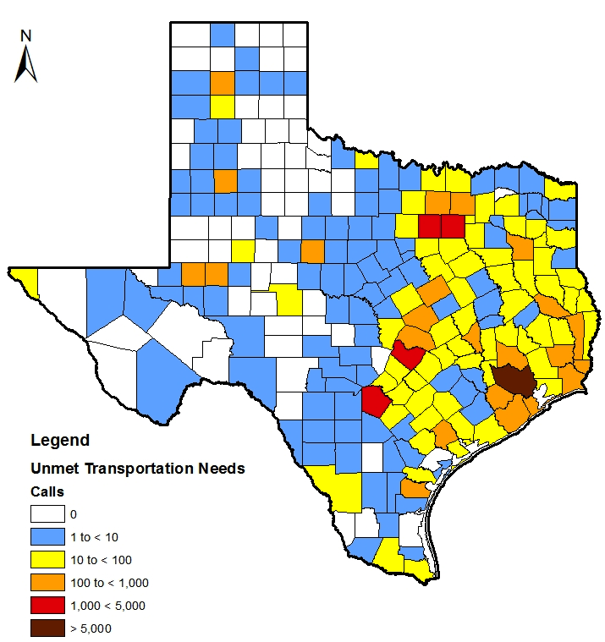

Figure 2. Major highway evacuation routes.
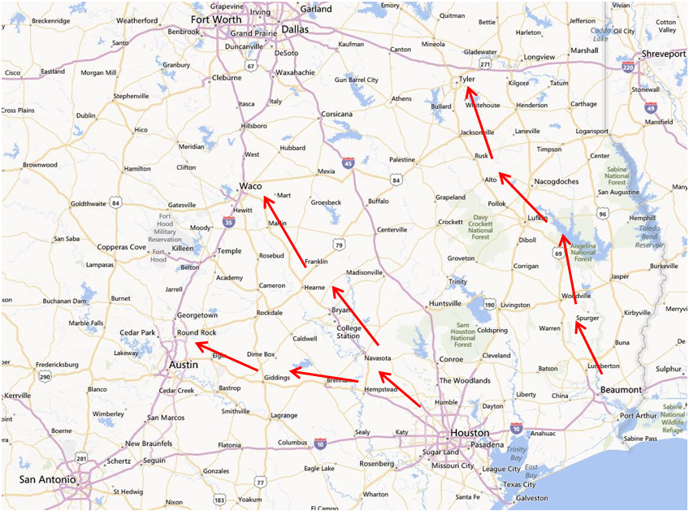

Figure 3. Spatial distribution of 2-1-1 calls by county for unmet transportation needs adjusted by population size (August 1 – December 31, 2005).

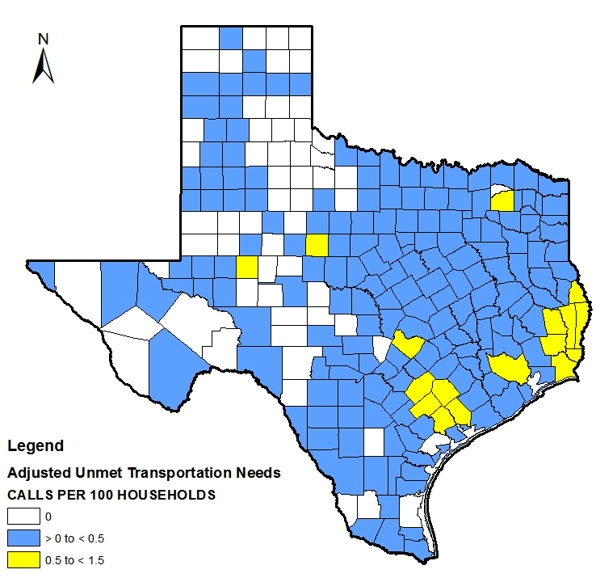

Figure 4. 2-1-1 calls per day for unmet transportation needs in Texas
(August 1 – December 31, 2005).
No. of calls

