Author: Ana Rosa Chagas Cavalcanti
Title: Ph.D Prospective TUDelft
Email: a.r.chagascavalcanti@tudelft.nl

Planning as curating everyday micro-contexts for a better public policy in the Favelas: The case of the Favela School of Architecture
Daily life is taken for granted by Brazilian public policies. Nevertheless this is a crucial coarser grain of the urban dimension, as it is the stage of the assertion of democracy and equality among the different powers and actors in the city. Therefore, transformations and subversions occur in this dimension of the city. Here, the aim is to tackle this broad discussion according to the current needs of Brazilian society. This paper thus scrutinises forms of alternative participatory urbanism which emerged during the past few years and which tackle the housing issue.

A case in the School of Favela Architecture, explore forms of curating the existing social practices of the residents. The thus proceeding proposes a framework willing to better address participatory planning in the context of the open architecture of favelas. Innumerous transcripts and ethnographic tools were applied in order to elaborate guidelines for planning coupled with the context of everyday.

A slum is an indisputable reality in Brazil, and its spatial configurations convey so many complex dimensions of the urban fabric that it cannot be reversed only by policies. The investigation on the curatorial role of architects becomes a crucial aspect for the creation of planning tools, for many reasons.

The current stage of Brazilian policy discussion on Right to Housing, for example, encompasses visions such as the task force and self-management. Technical assistance for low-income people too, referring to the law 11.888/2008. Nevertheless, a lack a deeper understanding of the logic of space we call today Favela, complicates planning processes, for several reasons. Resulting from hat, many times, the interpretation of the law does serve to control the places where residents live, and contribute to forms of planning that produce the results as traditional planning.

Finally, through recognizing the city's informal practices with a more critical look, as these a central aspect of economic production and urban space would be valid because the discourse of housing should be seen a priori a necessity of the human being, not a product. We aim that this article produces guidelines willing to address inhabitants lives.

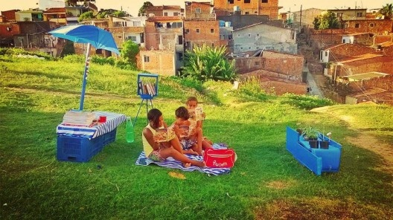
Favela School of Architecture (Photo: Ana Rosa Chagas Cavalcanti, 2015)
Key words: everyday, favelas, planning, public policies

