TERRITORIAL PLANNING OF AFRICA GLOBALIZED CITIES: The informality interference in the metropolisation process of Luanda city.
The rise of precarious megacities in the developing countries in Africa, due to the continuous and rapid population growth, constitutes the most common approach to contemporary territorial planning (Davis, 2013) and (RIBEIRO, 2010). The informality generalization, the socio space conflicts, the aggravation of social inequality and urban poverty of these cities Santos (2004), inserted in the capitalist system of production and global consumption (Harvey, 2006) characterize the factors of a paradoxical rationality of these territories classified by its own logic, as large metropolis. As shown in the following, image (Figure - 1).
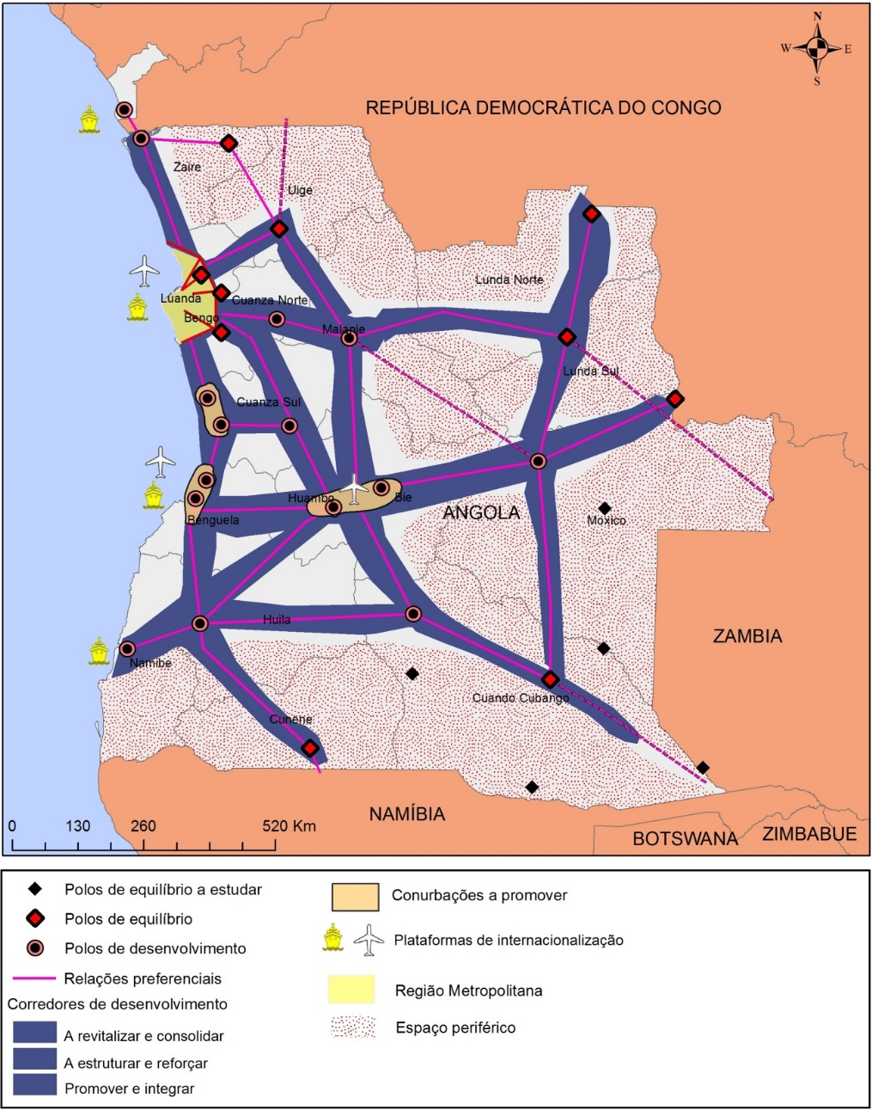
Figure 1 - territorial development strategy
Source: www.mapmaker.com. Preparation of the author. Adapted from the territorial development strategy image of the National Development Plan 2013-2017.

This figure is a synthesis which certifies that Luanda, capital of Angola, is not out of the described reality and it was currently considered by the National Development Plan 2013-2017 as a metropolitan area, figure-1 (PND, 2012). However, to the Angolan capital, recently out of a prolonged war situation, informality is presented as the most common and everyday feature of its urban conformation. Be in mobility, housing, or in the various labor relations (LOPES, 2004).
This work is dedicated to study the process of becoming cities of Luanda, analyzing the state's legal structures relation (through the National Development Plan), with the endogenous structural elements of socio-spatial dynamics of informality. For this analysis, we used the empirical and theoretical research / literature. In addition, there was the use of geo-referenced data for iconographic production and modes of analysis to understand the metropolitan phenomenon’s of expansion.
Its expected that this approach will contribute to the formation of new paradigms in the analysis and understanding of the informality phenomenon and its importance in the territorial conformation of African metropolises. For such, it shall be deemed to be quite focused on some keys elements of great importance in the production and structuring of the metropolis, namely; the use and occupation of land, migration, increasing activities informal services and its implications in the territory extending, as well as the precariousness of life and social space inhabited (RIBEIRO, 2010).
Finally, try to understand the impact and the influence of the relations effects between China and Angola in this territory within the trade. Since China is currently the largest economic partner of Angola (ROCHA, 2014), mainly due to national reconstruction task. It is important to
Emphasize here that the large trade is based on oil supply - higher financial income of the country, which Angola is totally dependent- in exchange for hefty financial credit lines (ROCHA, 2010). Currently, in this respect, China has assumed a dominant role and Angola has with this, a relationship of dependency and a certain neocolonial condition. On the other hand, the relation with China, has serious implications to Angola. Not only by improving their physical infrastructure, but mainly in social disintegration.
The metropolis is a process that changes the territory. Is the density, the complexity of labor division, or the problems that extend the municipalities boundaries. For Luanda, the process of metropolisation was not really a result of the action of a territorial planning on a national project (CASTRO, 2015). Rather, it appears that the demands of socio-spatial dynamics have created conditions for the expansion of peripheral urban fabric, the conurbations, leading to the emergence of cities.
In the capital of Angola, as well as in most large African cities, the State's position as a major player in the regulation of economic and socio-spatial production processes is constant controversy. Despite their dependence on central countries, does not notice the political will in fact aimed at the state's interest in equal territorial development and tackle social problems and urban precariousness (ROCHA, 2014). Moreover, what we see is a constant mobility of public / political agents between informal activities, given its fiscal invisibility. Facilitating this way an individual enrichment over the majority. That is, the maintenance of informal is the state logic that is local elite formed from wars process (Soto, 1987).
These elites are part of the government and rely, according to de Soto (1987) - when referring to the countries of the Third World-, personal enrichment, is consuming and are not interested in improving the metropolis quality life’s situation. Therefore, you can live outside the country (ROCHA, 2014). The Angolan State is based on the patrimonial practice; which on one hand can be explained from their colonial heritage. For a list of the elites, which also constitute the State, it is only in the country's wealth extraction. It is for this reason that the metropolitan development is increasingly short of the majority population. The reflections that we bring, do not just ask for the existence of plans in the process of becoming cities. But to examine what are these plans? Who makes them? And what is the distance between the plans and the application of these?
Finally, we are led to consider that the length of the state in dealing with issues related to social life, contributed to a major regional imbalance in the country where Luanda appears as a real case of urban and informal macrocephaly.
According to the studies, it is concluded that; the sequence of events that permeated the history of Luanda, as well as many cities in the globalized Africa, contributed to the emergence of informal activities and services such as transport and land use occupation. On the other side, there was a large population growth and the increasing precariousness of urban space, given the unpreparedness structural, political and social infrastructure (DEVELOPMENT WORKSHOP, 2005), not only in Luanda, but generally the African cities that share the same difficulties.

Referências.

CASTRO, J. 2015. Configuração sócio espacial como expressão de conflitos: Expansão Urbana de Luanda e o planejamento territorial de Angola. São Paulo, UNIVAP.

DAVIS, M. 2013. Planeta Favela. São Paulo, Boitempo.

DESENVOLVIMENTO M. do P. 2012. Plano Nacional de desenvolvimento 2013-2017. Material Institucional, 101-4.

DEVELOPMENT, W. 2005. Terra: reforma sobre a terra urbana em Angola no período pós-guerra. Pesquisa, advocacia e políticas de desenvolvimento. Luanda, Development Workshop.

HARVEY, D. 2013. A produção capitalista do espaço. São Paulo, Anablume.

LOPES, C. M. 2004 "Luanda, cidade informal." Estudo de caso sobre o bairro Rocha Pinto, CESA: Estudos de Desenvolvimento 8 (2001): 25-40.

MAP MAKER, M. 2013. Map Maker Ltd, The Pier, Carradale, Kintyre, PA28 6SQ, UK, [Em linha]. Disponível em: www.mapmaker.com, [Consult. 20 outubro 2014].

ROCHA, M. J. A. da. 2010. Desigualdades e assimetrias regionais em angola – Os fatores de competitividade territorial. Luanda, CEIC-UCAN.

RIBEIRO, L. C. Q. 2010. As metrópoles e a questão social Brasileira. Rio de Janeiro, Editora Revan.

_________ .2014. As perspectivas de crescimento económico de Angola até 2020. CEIC. Working Paper Nº 02. Luanda, CEIC-UCAN.

﻿SANTOS, M. 2004. O Espaço Dividido: Os Dois Circuitos da Economia Urbana dos Países Subdesenvolvidos. São Paulo, EDUSP.

SOUTO, H. de. 1987. Economia subterrânea: uma análise da realidade Peruana. Rio de Janeiro, Globo.

