Urban revitalization and social control - the case of Praça da Liberdade in Belo Horizonte - Brazil
Diomira M. C. P. Faria
Ana Flavia Machado
Barbara Freitas Paglioto
Larissa Fernandes Dutra

The state capital of Minas Gerais, Belo Horizonte, and the Praça da Liberdade (Liberty Square) were inaugurated in 1897, celebrating the republican values, at the expense of the image represented by the colonial city of Ouro Preto, the former capital. Around the Praça da Liberdade buildings were built to house state institutions such as the Government Palace and the state departments, in addition to the public archive and library. This place, since its inception, was established as the political center of the state of Minas Gerais. Due to the socioeconomic growth of the new capital and the inherent administrative functions, the buildings around the square were shown small to house the volume of administrative services and, in 1997, a project was developed to change the use of buildings, prioritizing cultural activities. The implementation of the project foreseen a partnership with the private sector, and for this would be transferred the management and maintenance of most cultural facilities to be created. After more than a decade of debates, in 2010, it was inaugurated the Cultural Circuit Liberty Square - CCPL, composed by twelve museums and cultural centers.
This research aims to analyze the impact of revitalization actions in the Praça da Liberdade influence area and its appropriation by tourism. To attain the goal were conducted interviews with institutions that make up the CCPL, a structured questionnaire with managers from thirty-five outlets located in the Square influence area and a literature review regarding the formation of cultural territories, urban revitalization with emphasis in cultural facilities and the anthropological critique of urban renewal processes. Of exploratory nature, the research is justified in order to know in depth the effects and impacts of spatial concentration of cultural facilities in a particular place, which occurred within the last five years.
The study explores the concepts of city, square and urban revitalization, considering square a symbolic space of unrestricted access and informal uses (Gastal, 2006) where urban life happens (Carsalade & Lemos, 2011) understanding the city from a lefebvrian perspective, that is, the urban as a way of life (Delgado, 2010). Criticism from sociology considers that the dynamics of urban regeneration follows a neoliberal logic, where the participation of the government as an arbiter in social conflicts and intervening in the economy should be minimal, while its performance for the proper functioning of markets should be prioritized. The association between capital and public policies resulted in the transformation of both human and morphological faces of many cities, thus favoring the revitalization of central or peripheral areas that have been popular and that re-qualify as residential, as commercial areas of high income, or are placed in service of new industries and information technology (Delgado, 2015), including tourism. The intention of urban projects is the control of real urban life.
The role of art and culture in the revitalization process is to improve social conditions, multicultural tolerance, but also to stimulate economic growth through urban cultural development projects anchored in the proliferation of museums for cultural tourism (Yúdice, 2013; Bille & Schulze, 2006).
The survey results showed a transformation around the Praça da Liberdade, we note a specialization based on culture, a cultural territory in which the presence of brands associated with museums were observed, real estate prices increasing and gentrification signs. The image of the city of Belo Horizonte as a cultural metropolis is strengthened, although the presence of tourists is small (11.5%), converging with results presented by other public museums where most visitors is made up of residents (Faria, 2015). It was found that the history and location of the Praça da Liberdade favored and favors a public from higher layers. Urban revitalization anchored in the culture is leading to surrounding gentrification process, turning the Square in a controlled place, with restricted access and uses formalized.

References
BILLE T and SCHULZE G G (2006) “Culture in urban and regional development” in GINSBURGH V A and THROSBY D (editors). Handbook of the Economics of Art and Culture. Oxford: North-Holland Elsevier. vol1, 1051-1099.
CARSALADE F and LEMOS C B (2011). Praça da Liberdade: História, Arte e Cultura. Instituto João Ayres. Belo Horizonte.
DELGADO M (2015) “Lo urbano como fogón de brujas” in ARICÓ G, MANSILLA J A and LUCA M S (coord). Mierda de ciudad: una rearticulación crítica del urbanismo neoliberal desde las ciencias sociales. Barcelona: Pollen Edicions, 5-10.
DELGADO M (2010) La ciudad mentirosa: fraude y miseria del ‘modelo Barcelona’. Madrid: Catarata, 2007. Segunda Edición. 242p.
FARIA D M C P (2015) “Investigação sobre o visitante de museus de arte: uma comparação Brasil e Espanha”, Via@, 2015-1(7), http://viatourismreview.com/pt/2015/07/art5/
GASTAL S (2006) Alegorias Urbanas: O passado como subterfúgio. Campinas, SP: Papirus. (Coleção Turismo). 224p.
YÚDICCE G (2013) A conveniência da cultura: usos da cultura na era global. Tradução Marie-Anne Kremer. 2.ed. Belo Horizonte: Editora UFMG. 651p.

Photo 1 – Praça da Liberdade
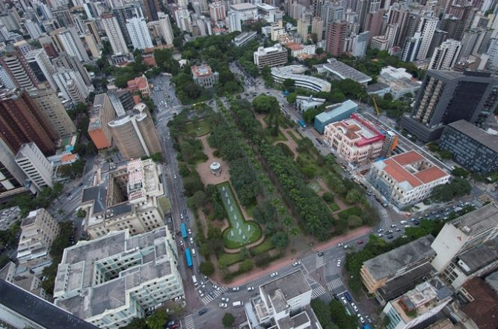
Source: Website Circuito Cultural Praça da Liberdade.

