THE URBAN WINDOWS

Authors
Gabriela Krantz Cesarino
Bachelor in Architecture and Urbanism, Faculdade de Arquitetura e Urbanismo da Universidade de São Paulo (1991), Specialist in Urbanism, also by FAU USP (1993) and Master in City and Regional Planning, University of Pennsylvania, USA (1997).
gcesarino@hotmail.com

Marcia Sandoval Gregori
Bachelor in Architecture and Urbanism, Faculdade de Arquitetura e Urbanismo da Universidade de São Paulo (1992), Master in Architecture and Urbanism, also by FAU USP (2002) and PHD candidate, Faculdade de Arquitetura e Urbanismo da Universidade Presbiteriana Mackenzie.
marciagregori@hotmail.com

São Paulo, September 2015.

INTRODUCTION AND OBJECTIVES
One of the intrinsic characteristics of urban space is change. Change happens fast and acutely, more so in large cities and metropolises, characterized by agglomeration, mass consumption and economic forces that act strategically over the territory. Even though São Paulo’s growth has been slowing down, brisk spatial alterations are still in action. They result from new forms of occupation of public and private spaces; the expansion of new technology; the implementation of infrastructure; the growth of institutions; changes to land use and legislation and, therefore, they are a result of the fast and unceasing reconfiguration of urban spaces. Economic interests and new social and cultural habits modify places and their relationships, transforming the landscape, demolishing buildings, establishing new spatial relationships and local dynamics, with direct impact on people’s lives.

However, there are gaps that resist: buildings that remain, perhaps by obstinacy, resistance or neglect; people that have decided not to leave the place that carries their identity as well as the uses and life that remain as a sign of resilience. Across the gaps and through the windows, one can look learn about the story within and learn about the city and its transformations, establishing possible relationships and interdependences.

The objective of this paper is to observe the window view towards places where significant urban transformations are in process and investigate the complexity of changes, its effects and its relationships with the inside stories. We have selected hybrid places - or liminal places - where new and old stories coexist. With that in mind, we ask: What remains and what changes through the window and in the memory? What gets lost by memory? What are the relations between past and present? What relations between inside and outside can we see through the gaps, through the windows?

Life continues, it changes, the landscape alters, new buildings appear, cars, meeting places, people, relationships; and inside memories, stories and existences follow their own dynamics. The urban processes can be intense and violent, leaving the passive subject vulnerable behind the window, watching life go by with no power to interfere.

The liminality of the window is used here to investigate the spaces in transition through urban processes and their counterpoints: history and identity; experiences and memory. Liminality simultaneously shows and hides, opens and closes upon life beheld through the window and within the interior spaces.

CASE STUDIES
For this article, we selected two different places in the consolidated center of the city of São Paulo, where land uses and occupation have been rapidly changing: an area near Silvio Romero’s Square, in Tatuapé, and an area near the Vila Madalena subway stop, in the Pinheiros region. Both these places are landmarks in their respective regions and have been gradually transformed by urban policies guided by the massive demand for transportation, both car-oriented and, more recently, public transport systems.

The first window analyzes the influence of urban policies that enabled commercial land uses to relocate from the traditional urban cores to enclosed shopping malls. Some of these places still retain some of their functions – such as passage, meeting and trade - obstinately resisting change. At the same time, new actors now use these same places in different ways, embedding them with new significance. The increasing use of public space has brought new meanings, but it has also brought conflicts. Public spaces now host diverse activities such as crafts fairs; sidewalk cafes; food trucks; artistic, musical, political events on and around parks and sidewalks.

The other selected window displays two typical twentieth century urban processes. The first is the global and devastating car-oriented city planning, accompanied by the phenomenon of land speculation, verticalization and class segregation. The second is a locally based process that has led to the physical and social transformation of several traditional neighborhoods in São Paulo. It has been guided by urban policies that supposedly seek democratization of access to urban infrastructure, but at the same time have gentrified established neighborhoods and transferred social interaction to the internet and high-rise elevators.

THEORETIC FRAMEWORK AND METHODOLOGY
This research is based on primary sources. The case studies are composed of interviews with building owners and users as well as field visits. Historical and current photographs, census data and legislation will be included in the analysis of the physical space and its context. Analytical diagrams will also help evaluate each of the window’s neighborhood and regional context.

Considering that urban space is a highly complex matter, a multidisciplinary framework will guide the work, with input from fields of study beyond urban planning, such as history, geography and anthropology.

To understand the relationship between global dynamics and local resilience, we use the concepts of “strategies” and “tactics” developed by the French historian Michel de Certeau. Strategies are understood as mechanisms of economic and political power and the tactics as a means of local resilience. These mechanisms happen through the action of individuals or small groups, often unorganized, with the intention of taking possession of certain places and adapting them for their use.

Sharon Zukin presents the typical process of fragmentation of local places and social relations by the real estate market. It recreates, through a fictional nexus, the city for visual consumption, where identity, local differences and solidarity gradually disappear and allow the global market to take over. In the field of urban geography, David Harvey and Milton Santos highlight the importance of local action of resistance, allowing for solidarity and identity to territorialize and humanize the city, against global homogeneity and fragmentation.

The contribution of this work resides in the recovery of hidden stories behind global and homogenizing processes that take place in large urban centers, especially in the developing world metropolis. The search for a local identity seems to be of utmost importance while dealing with the rapid pace of contemporary urban change.

VILA MADALENA WINDOW VIEW - POTENTIAL CASE STUDY

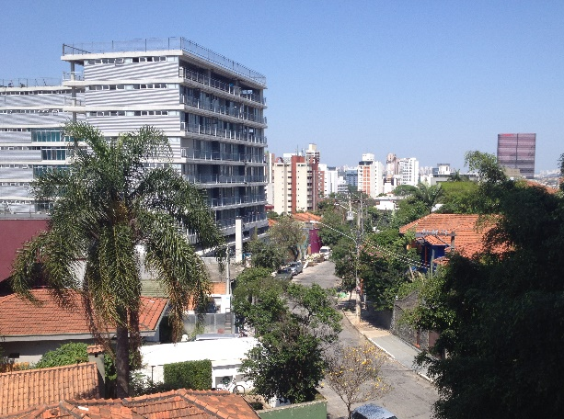
Context, September 2015

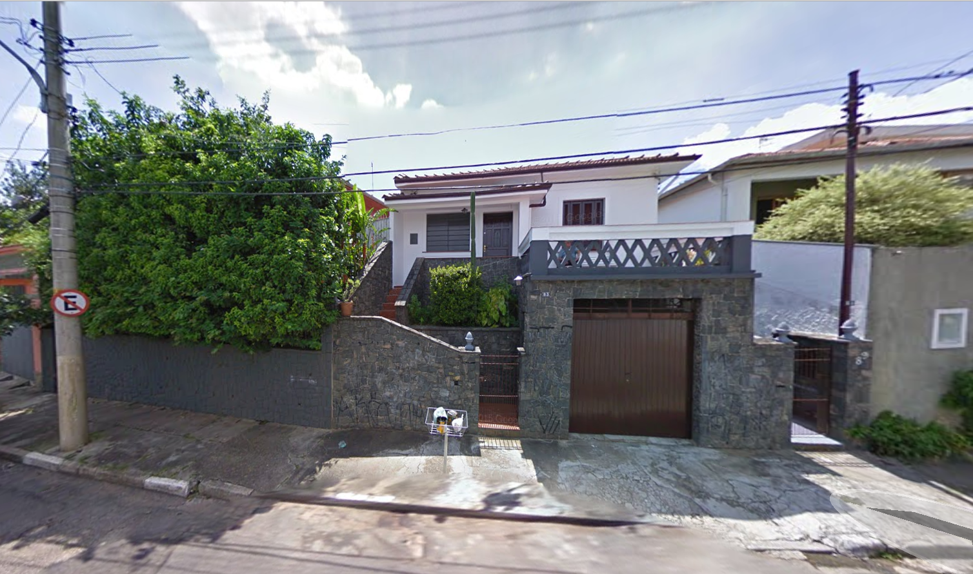
First Window, September 2015

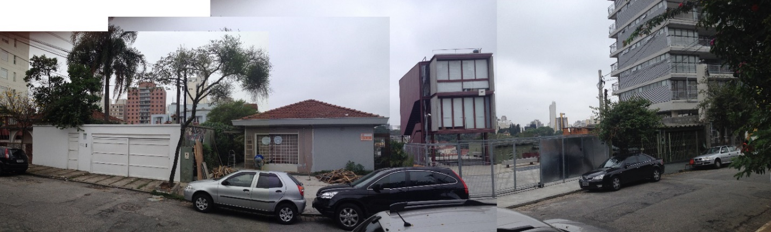
Window view in August 2015

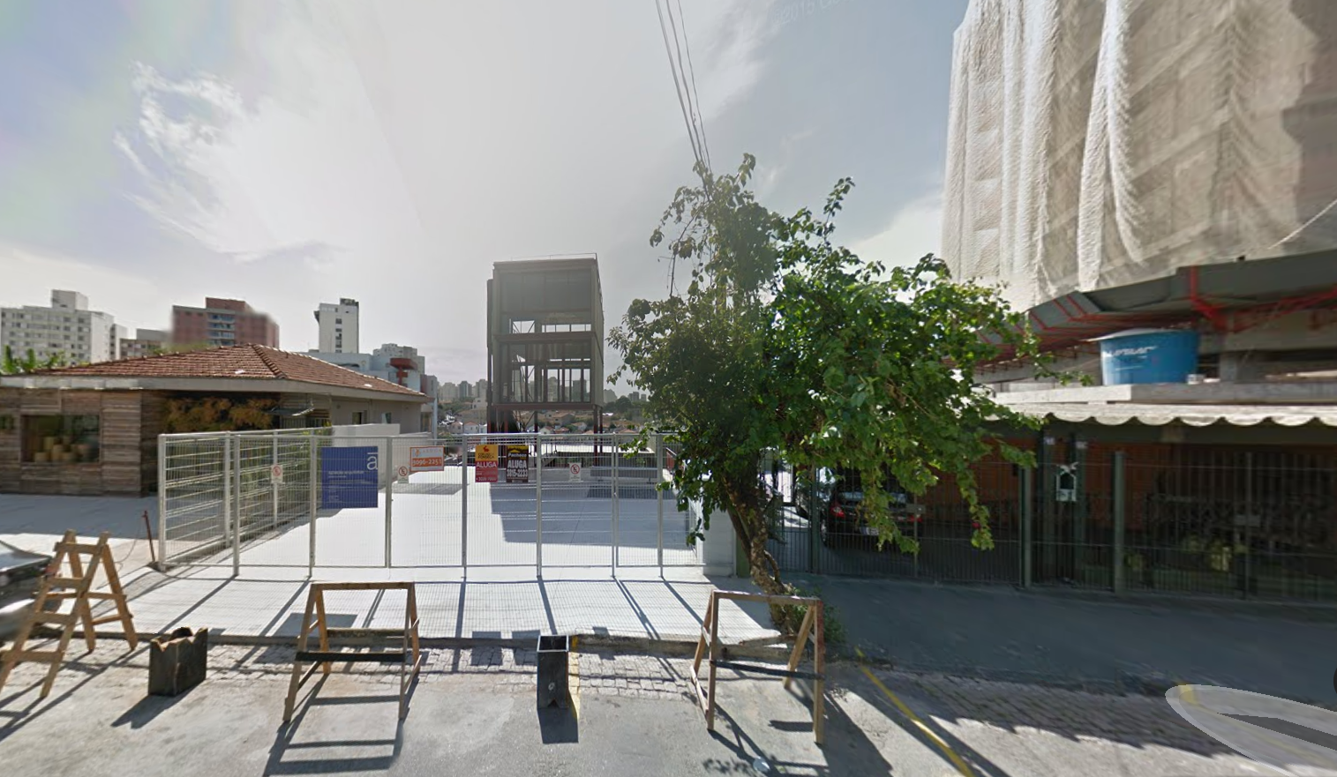
Window view in February 2011 New constructions, November 2014

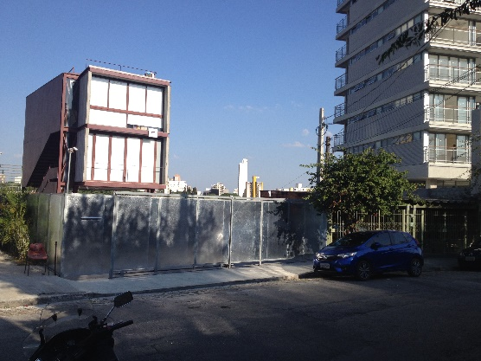
Window view in June 2015: Window view in September 2015:
transparency all enclosed

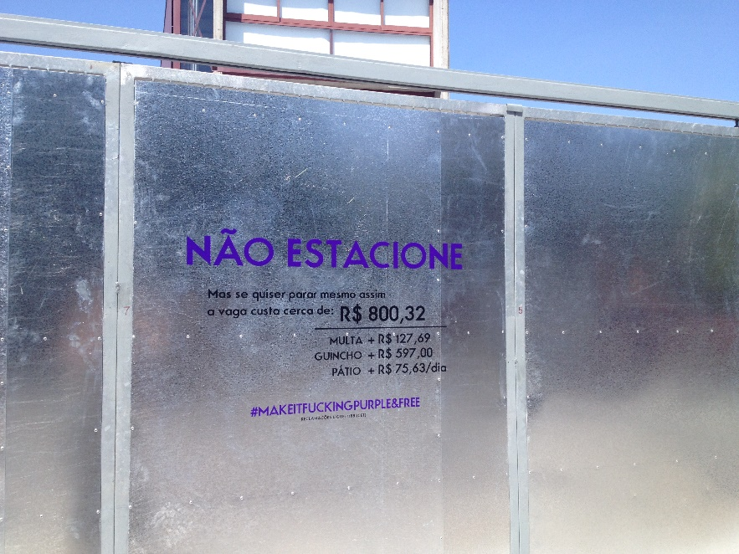
Close up: unfriendly note,
September 2015
BIBLIOGRAPHY

BOURDIEU, Pierre. Contrafogos: táticas para resistir à invasão neoliberal. Rio de Janeiro: Jorge Zahar, 1998.

CAIAFA, Janice. A aventura das cidades, ensaios e etnografias. Rio de Janeiro: FGV, 2007.

CERTEAU, Michel de. A invenção do cotidiano – Vol. 1 Artes de fazer. Petrópolis: Vozes, 1998.

HARVEY, David. Space as a keyword. In: Castree, N. e Gregory, D. (org.) David Harvey: a critical reader. Malden e Oxford: Blackwell. Tradução livre: Letícia Gianella. Revisão técnica: Rogério Haesbaert e Juliana Nunes.

SANTOS, Milton. A natureza do espaço: técnica e tempo, razão e emoção. São Paulo: Hucitec, 1996.

__________ Por uma outra globalização: do pensamento único à consciência universal. Rio de Janeiro: Record, 2000.

__________ Território, Globalização e Fragmentação. São Paulo: Hucitec, 1994.

SASSEN, Saskia. Debate Especial, Fronteiras do Pensamento. Por Bruno Fischer Dimarch, São Paulo, 26/08/2015.

TURNER, Victor. The ritual process: Structure and anti-structure. Ithaca: Cornell University Press, 1966

VILLAÇA, Flávio. Capitalismo transformou a localização da terra em mercadoria, In: Folha de São Paulo, 24/02/2015.

ZUKIN, Sharon. Landscapes of power: from Detroit to Disneyworld, Berkeley: University of California Press, 1991.

