Outdoor spaces and activities in Urban Design

Extended Abstracts
Over past decades, as cities have needed to develop or expand rapidly and automobiles have become increasingly popular, citizens’ lifestyles have changed considerably. Gehl (2011) indicates that residents are cities’ most important aspect but many architects, designers and planners have ignored the human dimension in today’s city functions. Cities have been created from an aerial view rather than considering human contact and social interaction. Furthermore, according to Gehl’s (2011) observations and investigations citizens and people’s activities are the best objects of interest and attention rather than buildings in same space. He illustrates that “even the modest form of contact of merely seeing and hearing or being near to others is apparently more rewarding and more in demand than the majority of other attractions offered in the public spaces of cities and residential areas.” Jacobs (1961) also stated that architects and planners should consider the residents who move to the public spaces, to improve their quality of life through contact and outdoor spaces such as street activities. Therefore, urban designers should focus on understanding human scale in small places because life between and in buildings is more important than the buildings and spaces themselves.
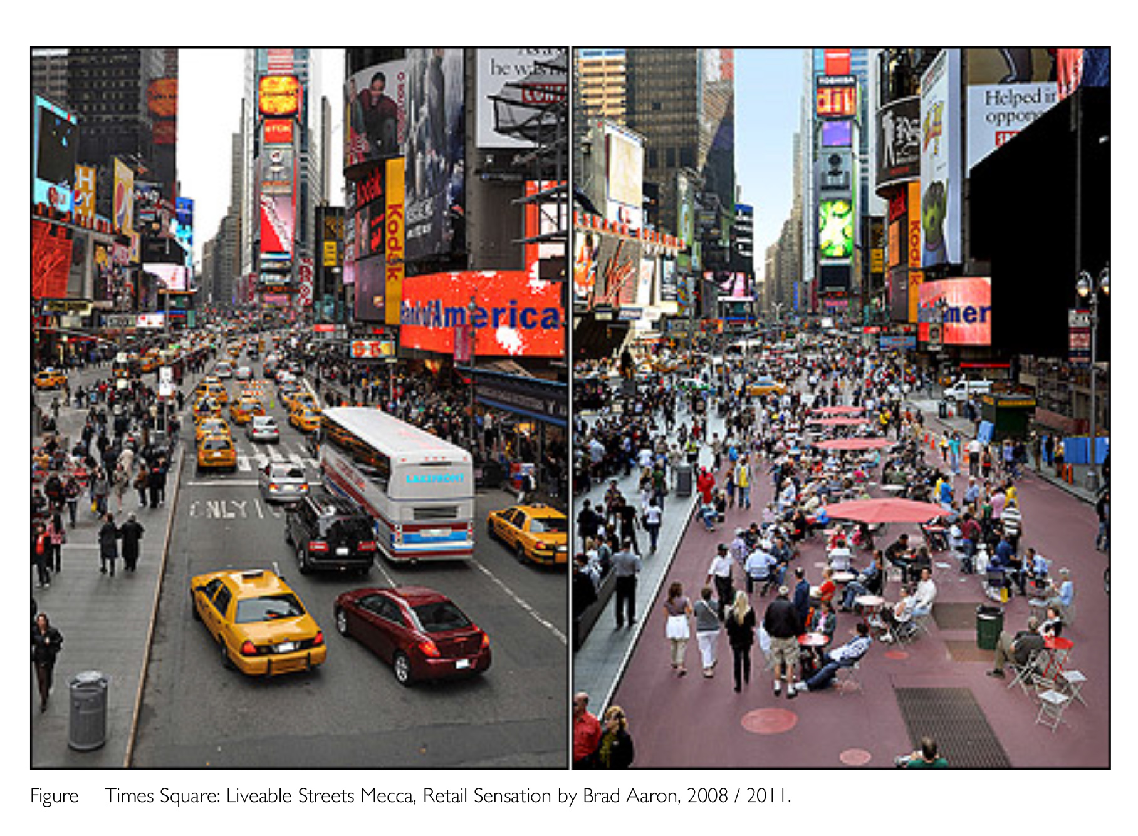
Figure 1 Times Square. Livable Streets Mecca, Retail Sensation by Brad Aaron. 2008/2001

This essay will concentrate on outdoor activities together with the human dimension and perception to understand citizens’ perception and how society interacts. Additionally, it will combine two principles of urban design, which are history and place. In respect of history it will discuss cities with and without planning and changes in outdoor activities, whilst for place it will focus on pedestrian streets and what residents might feel in different places. Learning from the history of the outdoor activities helps to understand how those activities and society changed in cities. Meanwhile the changes of activities in different period can be relevant to the spatial prosperities of the physical environment.
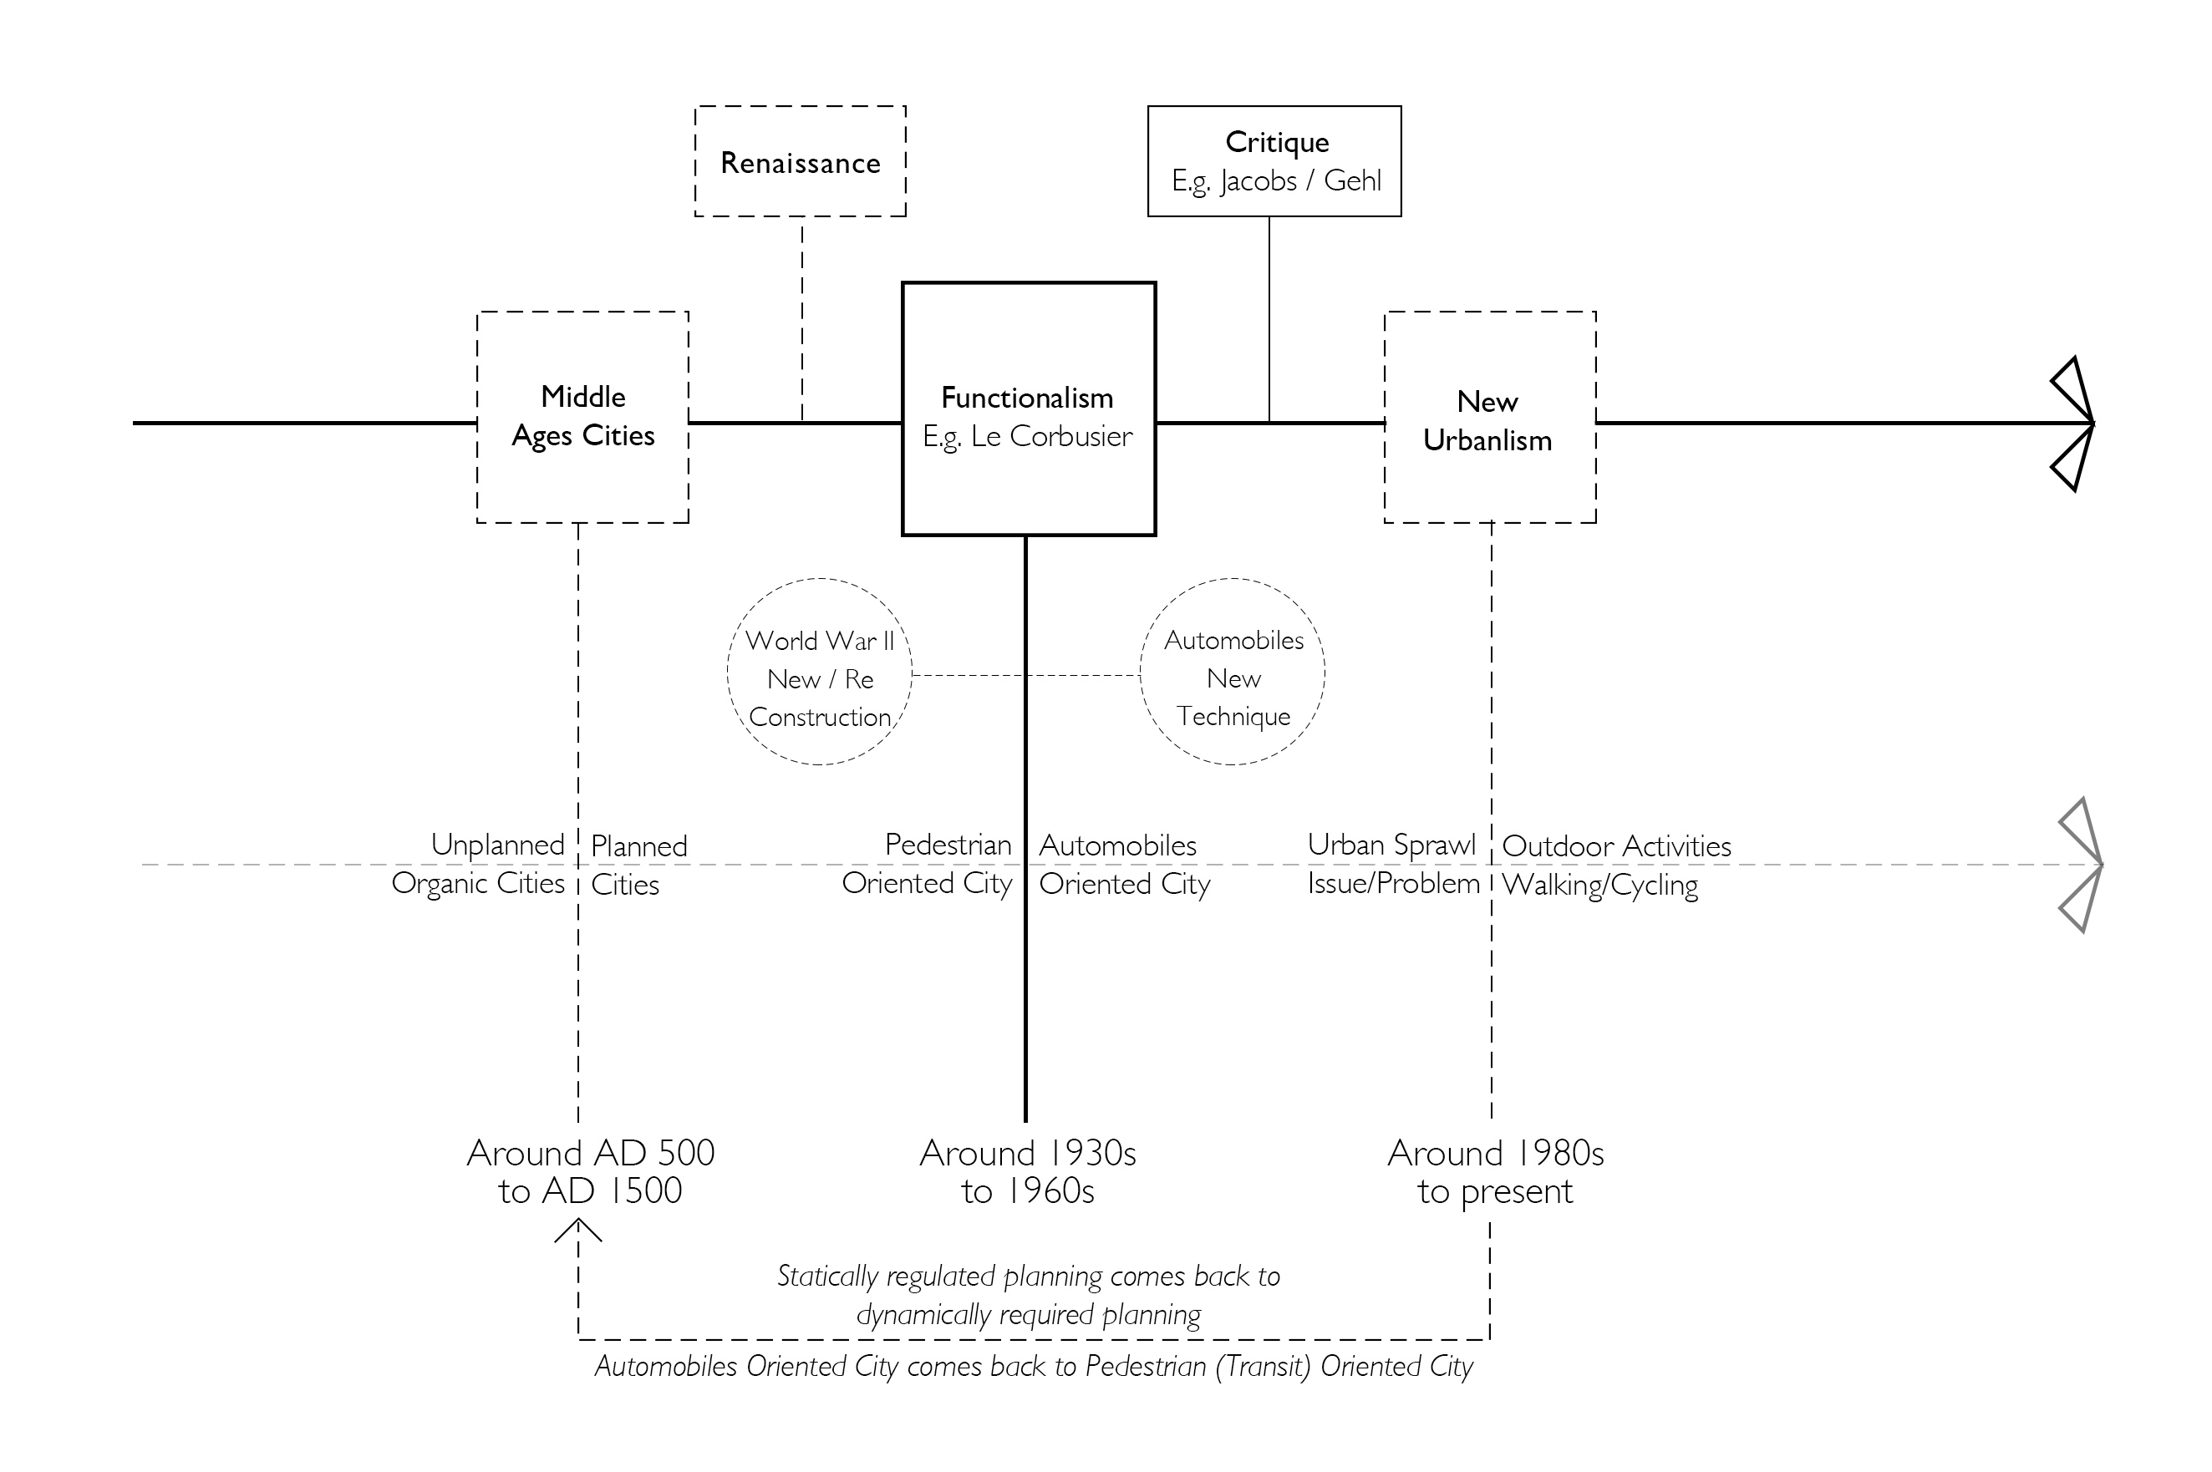
Figure 2 Outdoor activities - influenced by history

Old cities in Middle Ages gathered people in outdoor activities in streets and squares, and also encouraged residents to walk and stay outside. While in the modern cities the outdoor activities are challenged by extensive automobile transportation, underground parking, multi-story buildings, huge squares and long distances between buildings. Besides, some landmark transformation happened during these periods and led to a series of new theories including Le Corbusier who developed geometrical aesthetics in urban planning such as a contemporary city for three million people (Le Corbusier, 1967). Although, World War II saw vast numbers of cities being destroyed this did create opportunities for planners who used new technology and their principles to rebuild these cities. Therefore, numerous cities changed completely and the original movement continues today. However, human scale, including human contact and social interaction, was not considered in the Functionalism period, which meant that outdoor activities were reduced or disappeared. Although these functionalists’ principles improved cities’ quality and supported inhabitants, they neglected residents’ perception of specific places. By contrasting the two diverse examples, designers and architects may study old cities. Despite these medieval cities not having aesthetics or hygiene facilities, they developed and evolved through their residents’ use, essentially a bottom-up-framework and their outdoor activities were better than modern cities (Doina & Constantin, 2012). It could be argued that a bottom-up approach is crucial in urban development. These old cities should be studied within architecture, urban design and planning, especially in terms of residents’ influences, a key aspect in current society.
Placemaking represents the approaches of the bottom-up theory. It has many components. This essay focused on outdoor activities including human contact and social interaction in pedestrian streets. Places can offer different levels of intensity and low intensity can grow. Furthermore, pedestrian street making is crucial in cities because basic human contact happens there, as the core of outdoor activities. In addition, human scale in urban design cannot be ignored. Urban development, has not always considered residents’ viewpoints or social requirements, meaning inhabitants might stay indoors feeling isolated with this impacting on society. Specifically, Gehl (2011) emphasises that pedestrian streets are important in cities as they can create basic contact for residents allowing low intensity to grow to high. Moreover, in neighbourhoods many residents have a high intensity because the outdoor or shared spaces can allow inhabitants to meet each other regularly. As appropriate outdoor activities and spaces can create vibrant cities and harmonious societies, they are crucial in urban design for the human dimension.

Bibliography
Appleton, J. (1975). The Experience of Landscape, Publisher: Wiley; Revised Edition, June 19, 1996. Aristotle. (ed. 2009). The politics. Oxford New York: Oxford University Press.
Corbusier, L. (1967). The Radiant City. London: Faber
Campos, B. (2012). Book Review – Life Between Buildings Using Public Space. Electronic Publication accessed online at: http://www.journalofspacesyntax.org/!
Doina, P & Constantin, P. (2012). R-Urban resilient utopia. Electronic Publication accessed online at: http://www.spatialagency.net/database/aaa
Gehl, J. (ed. 2011). Life Between Buildings: Using Public Space. Washington - Covelo - London: Island Press.
Gehl, J. (2010), Cities for People, Washington - Covelo - London: Island Press.
Jacobs, J. (1961). Death and Life of Great American Cities. New York: Random
House. Lyle, J. (1969). “Tivoli Gardens.” Landscape (Spring / Summer): 5-22.
Lynch, K. (1960). The Image of The City. Cambridge Mass; London: MIT Press Whyte,
W. H. (1980). The Social Life of Small Urban Spaces. Washington D.C.: Conservation Foundation.

