Resilient Initiatives in Zanzibar

—— An Application of Resilience in Zanzibar

Author: Ziwen Sun
Candidate Ph.D of Architecture,
The University of Edinburgh,
The School of Architecture and Landspace Architecture

Co-Author: Weijing Kong
Architect
Beijing, China
Capital Engineering & Research Incorporation Limited
CERI Architects& Engneers

Supported by
Dr. Muhammed Juma,
Director of Department of Urban and Rural Planning, Zanzibar.

Professor Prue Chiles and Lorenza Casini
Studio Support Systems
The University of Sheffield, School of Architecture

Extended Abstracts
Zanzibar is an island on the coast of Tanzania in Africa. Because of the unique location and culture background, Zanzibar in many aspects is totally different from developed countries. Nowadays, as tourism tends to be increasingly popular and the natural environment of Zanzibar is rich and unique, more and more visitors travel to Zanzibar. It results in the constant increasing profits from tourism in Zanzibar. The situation seems to be positive for local development, but it has led to a series of problems and potentially negative impact as well. For example, the GDP growth rates of hotels and restaurants fluctuated enormously from 2006 to 2010, respectively 9.2, 4.5, -0.5, 5.0 and 3.0, because of the economic crisis (Zanzibar Statistical Abstract, 2010). Therefore, resilience strategies are crucial in Zanzibar based on the current situation as well as the possible future problems. This essay tries to explain resilience strategies in the context of Zanzibar.

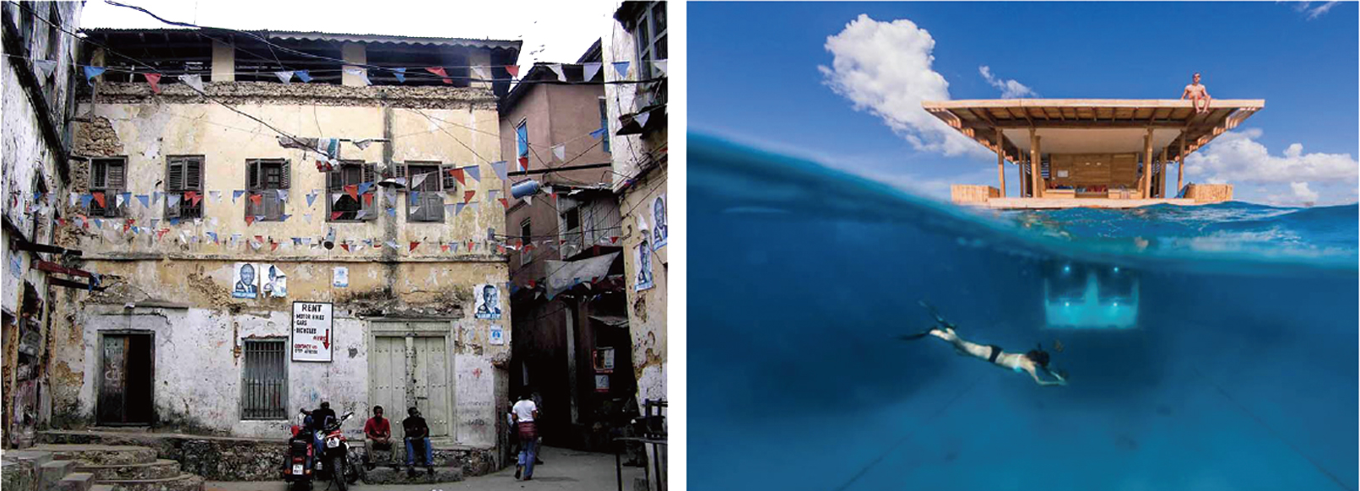
Picture 1 Status quo of Zanzibar – the wealth gap

In this essay, we explore the concept of resilience mainly from the aspects of local society and common economy in Zanzibar. Accordingly, the resilient initiatives centre on how systems accommodate and develop in changing circumstances, how to deal with potential risks, as well as how to make a better future for local citizens.

“Resilience”, according to Oxford dictionary (2014), it is about elasticity or toughness. However, in fact, different person understands resilience in different ways due to its dynamic notion. The resilient initiatives are trying to address problems of the singleness of tourism industry, which is to connect local residents with visitors in Zanzibar. As Petcou and Petrescu (2012) mentions that the resilient notion has the potential to involve issues and contradictions solve in the social ecology aspect. Moreover, the resilience in the society has to consider unique heritage, power, local traditions and democratic principles. In Zanzibar, the resilient systems should engage largest number of inhabitants rather than only focus on tourists and foreign investments. That is because the more citizens are involved, the more stable society would be. According to Vardy (n.d.), the role of an architect should be an agency, a co-manager, and an initiator to lead the social movement and make life better rather than as building designers. As Holloway (2006) advocated the movement against-and-beyond is a movement, which appears from day to day life. It can be seen that architects should lead for a dynamics of social self-determination rather than fighting for power. Therefore, in Zanzibar, we should rethink the assumptions where there are potential problems, how to lead a social movement to reduce the impact of the risks in future, and how to change citizens’ life in constant ways.

For Zanzibar, it needs to look at the long-term development of social resilience and common economy. Despite of the development of GDP from tourism, we analysed four main problems that were hidden behind the current development. The resilient initiatives aim at solving these problems and try to reduce the impact of risks in the future. Through these strategies, we try to focus on creating a self-organised network, reallocating market resources and enriching education. The initiatives focus on different groups of people and formed a complete system. They stand for the benefits of local citizens as well as visitors. They reform the social resilience, strengthen the democratic rights of local people and establish a more resilient way to develop local economy. They change the structure of tourism in Zanzibar, which shares both risks and benefits to locals and makes local economy more stretch and flexible. In this way, they can produce collective participation and local ecological cycles such as self-organised, self-management in the platform. It is a bottom-up framework because they make the grassroots be complementary for tourism. In all, the resilient initiatives are based on local conditions in Zanzibar, and trying to strengthen the economic structure and working for local people. It is essential to take resilience into consideration when designing a suitable urban plan especially as architects.

Bibliography
Appadurai, A. (2004). The capacity to aspire.In V. Rao, & M. Walton (Eds.), Cultural and public action (pp. 59–84). Stamford, CT: Stamford University Press.

Atelier d’architectureautogeree. (n.d.) Spatial Agency AAA.Electronic Publication accessed online at: http://www.spatialagency.net/database/aaa

Acorn and ZATI. (2008). Tourism Industry Growth Strategic Plan.A Study on Tourism Development in Zanzibar for Zanzibar Association of Tourism Investors by Acorn Consulting Partnership Ltd.

Chinese News. (2011). Translated by myself.Electronic Publication accessed online at: http://xm.lieju.com/qitashangwufuwu/951994.htm.

Chiles, P. 20thNovember 2013, Sheffield School of Architecture Theory Forum.

Harvey, D. (2008). The right to the city.New Left Review, 53(9–10), 23–40.

Holloway, J. (2006). Un mouvement “contre-et-au-delà”: À propos du débatsurmonlivreChanger le monde sans prendre le pouvoir[Change the world without taking power]. Variations: Revue internationale de théorie critique, 18(04), 15–30.

Loew, S. (2012).Urban design practice: an international review. Publish:London.

Oxford Dictionary. (2014). Electronic Publication accessed online at: http://www.oed.com

Stiglitz, J. (2010). Freefall: Free markets and the sinking of the global economy. New York: Norton & Company.
Steck, B., Wood, K and Bishop, J. Tourism: More Value for Zanzibar. Value Chain Analysis Summary Report.(Zanti Opening Doors, Norwegian Embassy, SNV Connecting Peoples Capacities, VSO: 2010) Electronic Publication accessed online at: http://www.snvworld.org/download/publications/tourism_-_more_value_for_zanzibar.pdf On Date. P 6 – 10.

Maguire, B., & Cartwright, S. (2008). Assessing a community’s capacity to manage change: A resilience approach to social assessment. Electronic Publication accessed online at: http://www.cedarscenter.com/resources/Community_Capacity_to_manage_change--Resilience_appoach_to_ social_assessment.pdf.

Vardy, S. (n.d.). Spatial Agency: Tactics of Self-Organization. From, University of Sheffield School of Architecture

Xi, J. (2010).CCTV NEWS in Chinese Television.Translated by myself.

Zanzibar Statistical Abstract. (2010). REVOLUTIONARY GOVERNMENT OFFICE OF CHIEF GOVERNMENT OF ZANZIBAR.Electronic Publication accessed online at: http://www.ocgs.go.tz/Documents/Abstract%202011.pdf

Zobel, G. (2013). Alfredo Moser: Bottle light inventor proud to be poor. Electronic Publication accessed online at: http://www.bbc.co.uk/news/magazine-23536914.

ZATI. (2006). Zanzibar Association of Tourism Investors Mid-Term Report.London : RIBA Pub. Zanzibar Planning Department. (2010). This document is a draft from Zanzibar government.

ZANZIBAR STATISTICAL ABSTRACT. (2010). Office of Chief Government Statistician Zanzibar June, 2010

